RAILWAY AND BRIDGE ENGINEERING

History of Indian railway

In the year 1832 the first Railway running on steam engine, was launched in England.
Thereafter on 1st of August, 1849 the Great Indian Peninsular Railways Company was established in India. On 17th of August 1849, a contract was signed between the Great Indian Peninsular Railways Company and East India Company. As a result of the contract an experiment was made by laying a railway track between Bombay and Thane (56 Kms).
- On 16th April, 1853, the first train service was started from Bombay to Thane.
- On 15th August, 1854, the 2nd train service commenced between Howrah and Hubli.
- On the 1st July, 1856, the 3rd train service in India and first in South India commenced between Vyasarpadi and Walajah Road and on the same day the section between Vyasarpadi and Royapuram by Madras Railway Company was also opened.

Subsequently construction of this efficient transport system began simultaneously in different parts of the Country. By the end of 19th Century 24752 Kms. of rail track was laid for traffic. At this juncture the power, capital, revenue rested with the British. Revenue started flowing through passenger as well as through goods traffic.
Organiz tional structure Railway zones
Indian Railways is divided into several zones, which are further sub-divided into divisions. The number of zones in Indian Railways increased from six to eight in 1951, nine in 1952 and sixteen in 2003. Each zonal railway is made up of a certain number of divisions, each having a divisional headquarters. There are a total of sixty-eight divisions. Each of the sixteen zones is headed by a general manager who reports directly to the Railway Board. The zones are further divided into divisions under the control of divisional railway managers (DRM).

Zonal railways details
Sl. No | Name | Abbr | Date Established |  | Route km | Headquarters | Divisions
1. | Central | CR | 5 November 1951 |  | 3905 | Mumbai | Mumbai, Bhusawal, Pune, Solapur, Nagpur
2. | East Central | ECR | 1  2002 | October | 3628 | Hajipur | Danapur, Dhanbad, Mughalsarai, Samastipur, Son pur
3. | East Coast | ECoR | 1 April 2003 |  | 2677 | Bhubaneswar | Khurda Road, Sambalpur and (Visakhapatnam) | Waltair
4. | Eastern | ER | April 1952 |  | 2414 | Kolkata | Howrah, Sealdah, Asansol, Malda
5. | North Central | NCR | 1 April 2003 |  | 3151 | Allahabad | Allahabad, Agra, Jhansi
6. | North Eastern | NER | 1952 |  | 3667 | Gorakhpur | Izzatnagar, Lucknow, Varanasi
7. | North Western | NWR | 1  2002 | October | 5459 | Jaipur | Jaipur, Ajmer, Bikaner, Jodhpur
8. | Northeas t Frontier | NFR | 15  1958 | January | 3907 | Guwahati | Alipurduar, Katihar, Rangia, Lumding, Tinsukia
9. | Northern | NR | 14 April 1952 |  | 6968 | Delhi | Delhi, Ambala, Firozpur, Lucknow, Moradabad
10. | South Central | SCR | 2  1966 | October | 5803 | Secunderabad | Vijayawada, Hyderabad, Guntakal, Guntur, Nand ed, Secunderabad
11. | South  East Central | SEC R | 1 April 2003 |  | 2447 | Bilaspur | Bilaspur, Raipur, Nagpur
12. | South Eastern | SER | 1955 |  | 2631 | Kolkata | Adra, Chakradharpur, Kharagpur, Ranchi
13. | South Western | SWR | 1 April 2003 |  | 3177 | Hubli | Hubli, Bangalore, Mysore
14. | Southern | SR | 14 April 1951 |  | 5098 | Chennai | Chennai, Trichy, Madurai, Salem,[12] Palakkad,T hiruvananthapuram
15. | West Central | WCR | 1 April 2003 |  | 2965 | Jabalpur | Jabalpur, Bhopal, Kota
16. | Western | WR | 5 November 1951 |  | 6182 | Mumbai | Mumbai  central, Ratlam, Ahmedabad, Rajkot, Bhavnaga r, Vadodara
17. | Kolkata Metro Railway | KNR | 29 December 2010 |  |  | Kolkata | Kolkata

Subsidiaries of Indian Railways

There also exist independent organisations under the control of the Railway Board for electrification, modernisation, research and design and training of officers, each of which is headed by an officer of the rank of general manager. A number of Public Sector Undertakings, which perform railway-related functions ranging from consultancy to ticketing, are also under the administrative control of the Ministry of railways.
There are fourteen public undertakings under the administrative control of the Ministry of Railways:

- Bharat Wagon and Engineering Co. Ltd. (BWEL)
- Centre for Railway Information Systems (CRIS)^{[24]}
- Container Corporation of India Limited (CONCOR)
- Dedicated Freight Corridor Corporation of India Limited (DFCCIL)
- Indian Railway Catering and Tourism Corporation Limited (IRCTC)
- Indian Railway Construction (IRCON) International Limited
- Indian Railway Finance Corporation Limited (IRFC)
- Konkan Railway Corporation Limited (KRCL)
- Mumbai Railway Vikas Corporation (MRVC)
- Railtel Corporation of India Limited (Rail Tel)
- Rail India Technical and Economic Services Limited (RITES)
- Rail Vikas Nigam Limited (RVNL)
- High Speed Rail Corporation of India (HSRC)
- Burn Standard Company
- Braithwaite and Co. Ltd

Component parts of railway track
The Typical components are – Rails, – Sleepers (or ties), – Fasteners, – Ballast (or slab track), – Subgrade
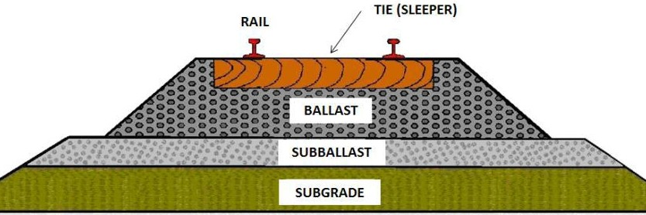

GAUGE
The clear minimum horizontal distance between the inner (running) faces of the two rails forming a track is known as Gauge. Indian railway followed this practice. In European countries, the gauge is measured between the inner faces of two rails at a point 14 mm below the top of the rail.
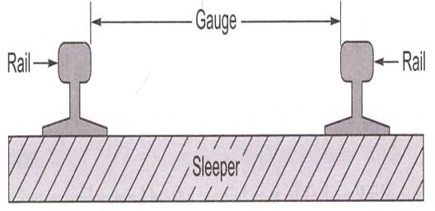

GAUGES ON WORLD RAILWAYS
Various gauges have been adopted by different railways in the world due to historical and other considerations. Initially British Railways had adopted a gauge of 1525 mm (5 feet), but the wheel flanges at that time were on the outside of the rails. Subsequently, in order to guide the wheels better, the flanges were made inside the rails. The gauge then became 1435 mm (4'8.5"), as at that time the width of the rail at the top was 45 mm (1.75 "). The 1435 mm gauge became the standard on most European Railways. The various gauges on world railways are given in Table 2.1.

Various gauges on world railways
Type of gauge | Gauge  (mm) | Gauge  (feet) | % of total  length | Countries
Standard gauge | 1435 | 4'8.5" | 62 | England, USA, Canada, Turkey, Persia, and  China
Broad gauge | 1676 | 5 '6" | 6 | India, Pakistan, Sri Lanka, Brazil,  Argentina
Broad gauge | 1524 | 5'0" | 9 | Russia, Finland
Cape gauge | 1067 | 3 '6" | 8 | Africa, Japan, Java, Australia, and New  Zealand
Metre gauge | 1000 | 3 '3.5" | 9 | India, France, Switzerland, and Argentina
23 various other  gauges | Different  gauges | Different  gauges | 6 | Various countries

DIFFERENT GAUGES ON INDIAN RAILWAYS
The East India Company intended to adopt the standard gauge of 1435 mm in India also. This proposal was, however, challenged by W. Simms, Consulting Engineer to the Government of India, who recommended a wider gauge of 1676 mm (5 '6 "). The Court of Directors of the East India Company decided to adopt Simms's recommendation and 5'6 " finally became the Indian standard gauge. In 1871, the Government of India wanted to construct cheaper railways for the development of the country and 1000 mm metre gauge was introduced. In due course of time, two more gauges of widths 762 mm (2 '6 ") and 610 mm (2 '0 ") were introduced for thinly populated areas, mountain railways, and other miscellaneous purposes. The details of the various gauges existing on Indian Railways are given in Table below.

Various gauges on Indian Railways as on 31.03.2011
Name of gauge | Width (mm) | Route (km) | % of route (km)
Broad gauge (BG) | 1676 | 55,188 | 85.6
Metre gauge (MG) | 1000 | 6809 | 10.6
Narrow gauge (NG) | 762 | 2463 | 3.8
 | 610
Total all gauges |  | 64,460 | 100

Broad Gauge: - When the clear horizontal distance between the inner faces of two parallel rails forming a track is 1676mm the gauge is called Broad Gauge (B.G)
This gauge is also known as standard gauge of India and is the broadest gauge of the world.
The Other countries using the Broad Gauge are Pakistan, Bangladesh, SriLanka, Brazil, Argentine, etc.50% India‘s railway tracks have been laid to this gauge.
Suitability: - Broad gauge is suitable under the following Conditions:-
- When sufficient funds are available for the railway project.
- When the prospects of revenue are very bright.
This gauge is, therefore, used for tracks in plain areas which are densely populated i.e. for routes of maximum traffic, intensities and at places which are centers of industry and commerce.
- Metre Gauge: - When the clear horizontal distance between the inner faces of two parallel rails forming a track is 1000mm, the gauge is known as Metre Gauge (M.G) The other countries using Metre gauge are France, Switzerland, Argentine, etc. 40% of India‘s railway tracks have been laid to this gauge.
Suitability:- Metre Gauge is suitable under the following conditions:-
- When the funds available for the railway project are inadequate.
- When the prospects of revenue are not very bright.
This gauge is, therefore, used for tracks in under-developed areas and in interior areas, where traffic intensity is small and prospects for future development are not very bright.
- Narrow Gauge:- When the clear horizontal distance between the inner faces of two parallel rails forming a track is either 762mm or 610mm, the gauge is known as Narrow gauge (N.G) The other countries using narrow gauge are Britain, South Africa, etc. 10% of India‘s railway tracks have been laid to this gauge.
Suitability: - Narrow gauge is suitable under the following conditions:-
- When the construction of a track with wider gauge is prohibited due to the provision of sharp curves, steep gradients, narrow bridges and tunnels etc.
- When the prospects of revenue are not very bright. This gauge is, therefore, used in hilly and very thinly populated areas. The feeder gauge is commonly used for feeding raw materials to big government manufacturing concerns as well as to private factories such as steel plants, oil refineries, sugar factories, etc.

CHOICE OF GAUGE
The choice of gauge is very limited, as each country has a fixed gauge and all new railway lines are constructed to adhere to the standard gauge. However, the following factors theoretically influence the choice of the gauge:
Cost considerations
There is only a marginal increase in the cost of the track if a wider gauge is adopted. In this connection, the following points are important
- There is a proportional increase in the cost of acquisition of land, earthwork, rails, sleepers, ballast, and other track items when constructing a wider gauge.
- The cost of building bridges, culverts, and runnels increases only marginally due to a wider gauge.
- The cost of constructing station buildings, platforms, staff quarters, level crossings, signals, etc., associated with the railway network is more or less the same for all gauges.
- The cost of rolling stock is independent of the gauge of the track for carrying the same volume of traffic.

Traffic considerations
The volume of traffic depends upon the size of wagons and the speed and hauling capacity of the train. Thus, the following points need to be considered.
- As a wider gauge can carry larger wagons and coaches, it can theoretically carry more traffic.
- A wider gauge has a greater potential at higher speeds, because speed is a function of the diameter of the wheel, which in turn is limited by the width of the gauge. As a thumb rule, diameter of the wheel is kept 75 per cent of gauge width.
- The type of traction and signalling equipment required are independent of the gauge.

Physical features of the country
It is possible to adopt steeper gradients and sharper curves for a narrow gauge as compared to a wider gauge.
Uniformity of gauge
The existence of a uniform gauge in a country enables smooth, speedy, and efficient operation of trains. Therefore, a single gauge should be adopted irrespective of the minor advantages of a wider gauge and the few limitations of a narrower gauge.
PROBLEMS OF MULTI GAUGE SYSTEM
The need for uniformity of gauge has been recognized by all the advanced countries of the world. A number of problems have cropped up in the operation of the Indian Railways because of the multi-gauge system (use of three gauges). The ill effects of change of gauge (more popularly known as break of gauge) are numerous; some of these are enumerated here.

Inconvenience to passengers
Due to change of gauge, passengers have to change trains mid-journey along with their luggage, which causes inconvenience such as the following:
- Climbing stairs and crossing bridges
- Getting seats in the compartments of the later trains
- Missing connections with the later trains in case the earlier train is late
- Harassment caused by porters
- Transporting luggage from one platform to another.

Difficulty in trans-shipment of goods
Goods have to be trans-shipped at the point where the change of gauge takes place. This causes the following problems:
- Damage to goods during trans-shipment
- Considerable delay in receipt of goods at the destination
- Theft or misplacement of goods during trans-shipment and the subsequent claims
- Non-availability of adequate and specialized trans-shipment labour and staff, particularly during strikes

Inefficient use of rolling stock
As wagons have to move empty in the direction of the trans-shipment point, they are not fully utilized. Similarly, idle wagons or engines of one gauge cannot be moved on another gauge.

Hindrance to fast movement of goods and passenger traffic
Due to change in the gauge, traffic cannot move fast which becomes a major problem particularly during emergencies such as war, floods, and accidents.

Additional facilities at stations and yards
Costly sheds and additional facilities need to be provided for handling the large volume of goods at trans-shipment points. Further, duplicate equipment and facilities such as yards and platforms need to be provided for both gauges at trans-shipment points.

Difficulties in balanced economic growth
The difference in gauge also leads to unbalanced economic growth. This happens because industries set up near MG/NG stations cannot send their goods economically and efficiently to areas being served by BG stations.

Difficulties in future gauge conversion projects
Gauge conversion is quite difficult, as it requires enormous effort to widen existing tracks. Widening the gauge involves heavy civil engineering work such as widening of the embankment, bridges and tunnels, as well as tracks; additionally, a wider rolling stock is also required. During the gauge conversion period, there are operational problems as well, since the traffic has to be slowed down and even suspended for a certain period in order to execute the work.

UNI-GAUGE POLICY OF INDIAN RAILWAYS
The problems caused by a multi-gauge system in a country have been discussed in the previous section. The multi-gauge system is not only costly and cumbersome but also causes serious bottlenecks in the operation of the Railways and hinders the balanced development of the country. Indian Railways therefore took the bold decision in 1992 of getting rid of the multi- gauge system and following the uni-gauge policy of adopting the broad gauge (1676 mm) uniformly.

Benefits of Adopting BG (1676 mm) as the Uniform Gauge
The uni-gauge system will be highly beneficial to rail users, the railway administration, as well as to the nation. Following are the advantages of a uni-system:

No transport bottlenecks
There will be no transport bottlenecks after a uniform gauge is adopted and this will lead to improved operational efficiency resulting in fast movement of goods and passengers.

No trans-shipment hazards
There will be no hazards of trans-shipment and as such no delays, no damage to goods, no inconvenience to passengers of transfer from one train to another train.

Provisions of alternate routes
Through a uni-gauge policy, alternate routes will be available for free movement of traffic and there will be less pressure on the existing BG network. This is expected to result in long-haul road traffic reverting to the railways.

Better turnaround
There will be a better turnaround of wagons and locomotives, and their usage will improve the operating ratio of the railway system as a whole. As a result the community will be benefited immensely.

Improved utilization of track
There will be improved utilization of tracks and reduction in the operating expenses of the railway.

Balanced economic growth
The areas currently served by the MG will receive an additional fillip, leading to the removal of regional disparities and balancing economic growth.

No multiple tracking works
The uni-gauge project will eliminate the need for certain traffic facilities and multiple tracking works, which will offset the cost of gauge conversions to a certain extent.

Better transport infrastructure
Some of the areas served by the MG have the potential of becoming highly industrialized; skilled manpower is also available. The uni-gauge policy will help in providing these areas a better transportation infrastructure.

Boosting investor's confidence
With the liberalization of the economic policy, the uni-gauge projects of Indian Railways have come to play a significant role. This will help in boosting the investors' confidence that their goods will be distributed throughout the country in time and without any hindrance. This will also help in setting up industries in areas not yet exploited because of the lack of infrastructure facilities.

Planning of Uni-gauge Projects
The gauge-conversion programme has been accelerated on Indian Railways since 1992. In the eighth Plan (1993-97) itself, the progress achieved in gauge-conversion projects in five years was more than the total progress made in the past 45 years. The progress of gauge-conversion projects is briefly given in Table below.

Progress of gauge-conversion projects

Year | Progress in gauge conversion (kms) | Remarks
1947-1992 | 2500 | Approx. figure
1993-1997 | 6897 | Actual
1998-2004 | 3787 | Actual
2005-2011 | 6564 | Actual

The current position is that the gauge-conversion project still pending on Indian Railways is 8855 kms which is likely to be completed in next five years. Execution of a gauge conversion project is quite a tricky job and lot of planning is to be done for the same.
WHEEL AND AXIS ARRANGEMENTS AND CONING OF WHEELS
Wheels and axles we have the different types of the locomotives under wagons which are used for the hauling of the passengers and freight. All these wagons and locomotives have different specifications depending on the gauges for which they have been used. If you look at the various locomotives from the very starting of our history, we have been using steam locomotives and then they have been replaced by diesel locomotives and finally by the electric locomotives.
In the case of the steam locomotives, the wheels and axles are classified by on the basis of Whyte system. Traditionally, steam locomotives have been classified using either their wheel arrangements or sometimes they are also been classified on the basis of axle arrangements.
In the case of the wheel arrangements classification, they are being classified on the basis of Whyte system and other system locomotives have three different types of wheel basis. They have the wheel basis which are either coupled or which are having the driving conditions or detective power attached to them or the wheel basis on which no attractive power is attached.
In Indian practice, the Indian practice has been taken from the United Kingdom because British were the persons who introduced the Indian railways in our country and in this system we count wheels and we do not count the axles as far as the steam locomotives are concerned. In the case of steam locomotives, one examples is been taken here where it is been shown as 2-4-2. Now this 2-4-2 has the significance in terms of the wheel basis as been defined earlier. The first 2 is the front wheels or the 2 number of wheels have been placed or what we can say is that there is one axle which is being placed in the front condition. Then the 4 part is to the 4 number of wheels which have been placed in the central condition where they are the powered wheels or the driving wheels and therefore they transforms into the 2 axles condition and then there are trailing wheels where we have 2 wheels at the back and again, if it transform them into the actual condition, it will be working to one axle.

The compound locomotive is a condition where there is a more attractive power which is required to haul the passenger or the freight. The heavy amount of the freight which is to be transported and the trailing conditions governs the conditions where we require to provide two locomotives together so as to haul them. Here, this is an example of compound locomotive where two locomotive of
condition 2-8-2 or 2-8-4 have been joined together so as to haul the traffic or the passengers or the freight. Again, if we go by the Whyte condition, Whyte system of classification of the locomotives of the wheel configuration then 2-8-2 means they have 2 front wheels, 8 medium or central wheels and 2 trailer wheels, in case of the first locomotives whereas in the case of the second locomotives we have 2 front wheels, 8 central condition wheels which are electrically driven, which are driven for the movement of the locomotives and then in this case we have 4 trailing wheels.

Coning wheels has the following disadvantages:
- In order to minimize the above below disadvantages the tilting of rails is done. i.e. the rails are not laid flat but tilted inwards by using inclined base plates sloped at 1 in 20 which is also the slope of coned surface of wheels.
- The pressure of the horizontal component near the inner edge of the rail has a tendency to wear the rail quickly.
- The horizontal components tend to turn the rail outwardly and hence the gauge is widened sometimes.
- If no base plates are provided, sleepers under the outer edge of the rails are damaged.
- In order to minimize the above mentioned disadvantages the tilting of rails is done. i.e. the rails are not laid flat but tilted inwards by using inclined base plates sloped at 1 in 20 which is also the slope of coned surface of wheels.

Advantages of Tilting of Rails
- It maintains the gauge properly.
- The wear at the head of rail is uniform.
- It increases the life of sleepers and the rails.
VARIOUS RESISTANCES AND THEIR EVALUATION

Various forces offer resistance to the movement of a train on the track. These resistances may be the result of movement of the various parts of the locomotives as well as the friction between them, the irregularities in the track profile, or the atmospheric resistance to a train moving at great speed. The tractive power of a locomotive should be adequate enough to overcome these resistances and haul the train at a specified speed.

RESISTANCE DUE TO FRICTION
Resistance due to friction is the resistance offered by the friction between the internal parts of locomotives and wagons as well as between the metal surface of the rail and the wheel to a train moving at a constant speed. This resistance is independent of speed and can be further broken down into the following parts.

Journal friction This is dependent on the type of bearing, the lubricant used, the temperature and condition of the bearing, etc. In the case of roll bearings, it varies from 0.5 to 1.0 kg per tonne.
Internal resistance This resistance is consequential to the movement of the various parts of the locomotive and wagons.
Rolling resistance This occurs due to rail-wheel interaction on account of the movement of steel wheels on a steel rail. The total frictional resistance is given by the empirical formula
R₁= 0.0016 W
Where R₁ is the frictional resistance independent of speed and W is the weight of the train in tonnes.

RESISTANCE DUE TO WAVE ACTION
When a train moves with speed a certain resistance develops due to the wave action in the rail. Similarly, track irregularities such as longitudinal unevenness and differences in cross levels also offer resistance to a moving train. Such resistances are different for different speeds. There is no method for the precise calculation of these resistances but the following formula has been evolved based on experience:
R₂ = 0.00008 WV
Where R₂ is the resistance (in tonnes) due to wave action and track irregularities on account of the speed of the train, W is the weight of the train in tonnes, and V is the speed of the train in kmph.

RESISTANCE DUE TO WIND
When a vehicle moves with speed, a certain resistance develops, as the vehicle has to move forward against the wind. Wind resistance consists of side resistance, head resistance, and tail resistance, but its exact magnitude depends upon the size and shape of the vehicle, its speed, and the wind direction as well as its velocity. Wind resistance depends upon the exposed area of the vehicle and the velocity and direction of the wind. In Fig. below, V is the velocity of wind at an angle θ. The horizontal component of wind, V cosθ, opposes the movement of the train. Wind normally exerts maximum pressure when it acts at an angle of 60° to the direction of movement of the train.
Wind resistance can be obtained by the following formula:
R₃ =0.000017AV²
Where A is the exposed area of vehicle (m²) and V is the velocity of wind (kmph).

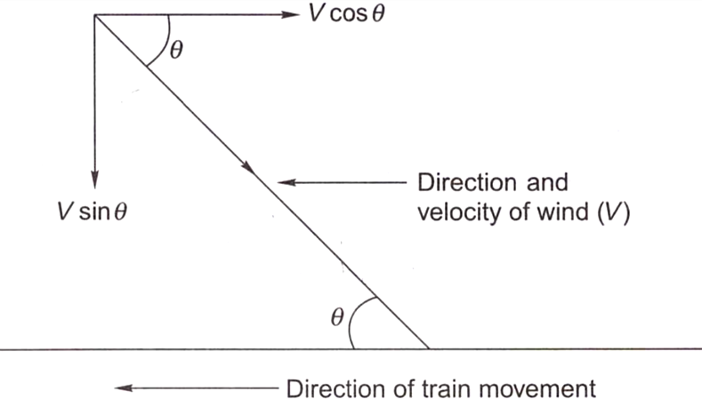

R₃ = 0.0000006 W V²
Where R₃ is the wind resistance in tonnes, Vis the velocity of the train in km per hour, and W is
the weight of the train in tonnes.

RESISTANCE DUE TO GRADIENT
When a train moves on a rising gradient, it requires extra effort in order to move against gravity as shown in Fig. below.
Assuming that a wheel of weight W is moving on a rising gradient OA, the following forces act on the wheel.
- Weight of the wheel (W), which acts downward
- Normal pressure N on the rail, which acts perpendicular to OA
- Resistance due to rising gradient (R₄), which acts parallel to OA
These three forces meet at a common point Q and the triangle QCD can be taken as a triangle of forces. It can also be geometrically proved that the two triangles QCD and AOB are similar.

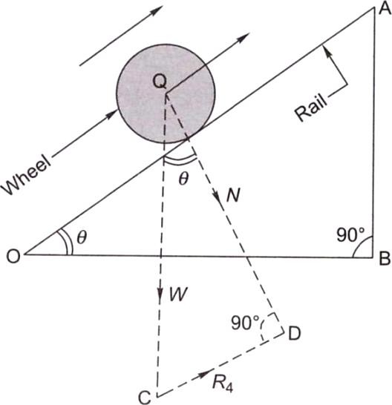

RESISTANCE DUE TO CURVATURE
When a train negotiates a horizontal curve, extra effort is required to overcome the resistance offered by the curvature of the track. Curve resistance is caused basically because of the following reasons (Fig. below):
- The vehicle cannot adapt itself to a curved track because of its rigid wheel base. This is why the frame takes up a tangential position as the vehicle tries to move in a longitudinal direction along the curve as shown in Fig. below. On account of this, the flange of the outer wheel of the leading axle rubs against the inner face of the outer rail, giving rise to resistance to the movement of the train.
- Curve resistance can sometimes be the result of longitudinal slip, which causes the forward motion of the wheels on a curved track. The outer wheel flange of the trailing axle remains clear and tends to derail. The position worsens further if the wheel base is long and the curve is sharp.
- Curve resistance is caused when a transverse slip occurs, which increases the friction between the wheel flanges and the rails.
- Poor track maintenance, particularly bad alignment, worn-out rails, and improper levels, also increase resistance.
- Inadequate superelevation increases the pressure on the outer rail and, similarly, excess superelevation puts greater pressure on the inner rails, and this also contributes to an increase in resistance.
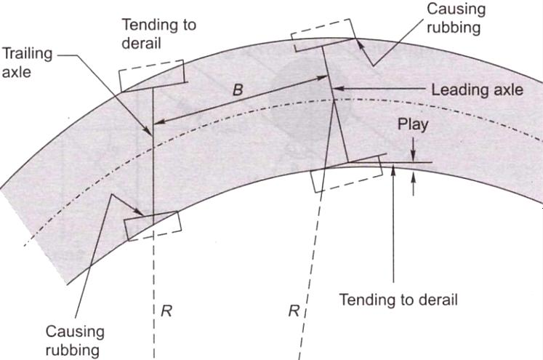
The value of curve resistance can be determined by the following equation:
Curve resistance = C x (FG/R)
where F is the force of sliding friction, G is the gauge of the track, R is the mean radius of the curve, and C is the constant, which is dependent on various factors. This equation indicates that
- curve resistance increases with increase in gauge width and
- resistance is inversely proportional to the radius, i.e., it increases with an increase in the degree of the curve.
Empirical formulae have been worked out for curve resistance, which are as follows:
Curve resistance for BG (R₅) = 0.0004 WD Curve resistance for MG (R₅) = 0.0003 WD Curve resistance for NG (R₅) = 0.0002 WD

Compensated gradient for curvature
Curve resistance is quite often compensated or offset by a reduction in the gradient. In this way, the effect of curve resistance is translated in terms of resistance due to gradient. The compensation is 0.04 per cent on BG, 0.03 per cent on MG, and 0.02 per cent on NG lines for every 1° of the curve. This will be clear through the solved example given below.

RESISTANCE DUE TO STARTING AND ACCELERATING
Trains face these resistances at stations when they start, accelerate, and decelerate. The values of these resistances are as follows:
Resistance on starting, R₆ = 0.15 W₁ + 0.005 W₂

Resistance due to acceleration, R₇ = 0.028 aW
where W ₁ is the weight of the locomotive in tonnes, W₂ is the weight of the trailing vehicles in tonnes, W is the total weight of the locomotive and vehicle in tonnes. i.e. W₁ + W₂, and a is the acceleration, which can be calculated by finding the increase in velocity per unit time, i.e., (V₂ – V₁)/t, where V₂ is the final velocity. V₁ is the initial velocity, and t is the time taken.
Table below summarizes the various resistances faced by a train.

HAULING CAPACITY AND TRACTIVE EFFORT

The tractive effort of a locomotive is the force that the locomotive can generate for hauling the load. The tractive effort of a locomotive should be enough for it to haul a train at the maximum permissible speed. There are various tractive effort. Curves available for different locomotives for different speeds, which enable the computation of the value of tractive effort. Tractive effort is generally equal to or a little greater than the hauling capacity of the locomotive. If the tractive effort:-much greater than what is required to haul the train, the wheels of the locomotive may slip.
A rough assessment of the tractive effort of different types of locomotive.-provided in the following sections.

Steam Locomotive
The tractive effort of a steam locomotive can be calculated by equating the total power generated by the steam engine to the work done by the driving wheels.
Assume P to be the difference in steam pressure between the two sides of the inder, A the area of the piston of the engine, a' the diameter of the piston of the ;ine, L the length of the stroke of the engine, D the diameter of the wheel of locomotive, and Te the mean tractive effort of the locomotive. Work done by /o-cylinder steam engine
= 2 X difference in steam pressure X area of the piston x 2 X length of the stroke = 2P x A x 2L
= 2P x (πd²/4)x 2L = πd²L
work done in one revolution of the driving wheel of the locomotive:
= tractive effort x circumference of the wheel
= T_{c} π D
squaring above two equations, πd²L = T_{c} π D
Tc = d²L/D
is clear from above Equation that tractive effort increases with an increase in n pressure difference and the diameter and length of the piston, but decreases an increase in the diameter of the driving wheel of the locomotive.

Diesel Locomotive
Tractive effort of a diesel-elective locomotive can be assessed by the following empirical formula.
Te = (308 x RHP) / V
where Te is the tractive effort of a diesel-electric locomotive, RHP is the rated horsepower of the engine, and V is the velocity in km per hour.

Electric Locomotive
Tractive effort of an electric locomotive varies inversely with the power of speed. The empirical formulae for calculating the approximate value of tractive effort are as follows
For an dc electric locomotive: Te = a / V³
For an ac electric locomotive: Te = a / V⁵
where a is a constant depending upon the various characteristics of the locomotive.

HAULING POWER OF A LOCOMOTIVE
Hauling power of a locomotive depends upon the weight exerted on the driving s and the friction between the driving wheel and the rail. The coefficient of friction depends upon the speed of the locomotive and the condition of the rail surface. The higher the speed of the locomotive, the lower will be the coefficient of friction, which is about 0.1 for high speeds and 0.2 for low speeds. The condition of the rail surface, whether wet or dry, smooth or rough, etc., also plays an important role in deciding the value of the coefficient of function. If the surface is very smooth, the coefficient of friction will be very low.
Hauling power = number of pairs of driving wheels x weight exerted on each driving axle X coefficient of friction
Thus, for a locomotive with three pairs of driving wheels, an axle load of 20 tonnes, and a coefficient of friction equal to 0.2, the hauling power will be equal to 3 x 20 x 0.2 tonne, i.e., 12 tonnes.
Example : Calculate the maximum permissible load that a BG locomotive with three pairs of driving wheels bearing an axle load of 22 tonnes each can pull on a straight level track at a speed of 80 km/h. Also calculate the reduction in speed if the train has to run on a rising gradient of 1 in 200. What would be the further reduction in speed if the train has to negotiate a 4° curve on the rising gradient? Assume the coefficient of friction to be 0.2.
RAIL

Rails are the members of the track laid in two parallel lines to provide an unchanging, continuous, and level surface for the movement of trains. To be able to withstand stresses, they are made of high-carbon steel. Standard rail sections, their specifications, and various types of rail defects are discussed in this section.

FUNCTION OF RAILS
Rails are similar to steel girders. They perform the following functions in a track:
- Rails provide a continuous and level surface for the movement of trains.
- They provide a pathway which is smooth and has very little friction. The friction between the steel wheel and the steel rail is about one-fifth of the friction between the pneumatic tyre and a metalled road.
- They serve as a lateral guide for the wheels.
- They bear the stresses developed due to vertical loads transmitted to them through axles and wheels of rolling stock as well as due to braking and thermal forces.
- They carry out the function of transmitting the load to a large area of the formation through sleepers and the ballast.

TYPES OF RAILS

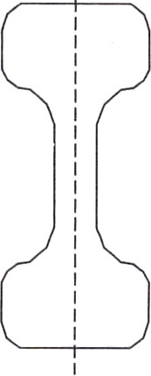 | 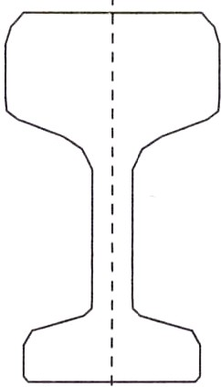 | 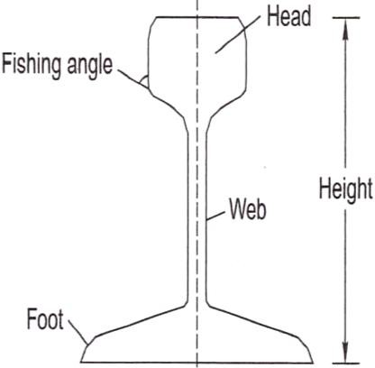
DOUBLE HEADED RAIL | BULL HEADED RAIL | FLAT-FOOTED RAIL
REQUIREMENTS OF AN IDEAL RAIL SECTION
The requirements of an ideal rail section are as follows:
- The rail should have the most economical section consistent with strength, stiffness, and durability.
- The centre of gravity of the rail section should preferably be very close to the mid-height of the rail so that the maximum tensile and compressive stresses are equal.
- A rail primarily consists of a head, a web, and a foot, and there should be an economical and balanced distribution of metal in its various components so that each of them can fulfill its requirements properly.
The requirements, as well as the main considerations, for the design of these rail components are as follows:
Head The head of the rail should have adequate depth to allow for vertical wear. The rail head should also be sufficiently wide so that not only is a wider running surface available, but also the rail has the desired lateral stiffness.
Web The web should be sufficiently thick so as to withstand the stresses arising due to the loads bore by it, after allowing for normal corrosion.
Foot The foot should be of sufficient thickness to be able to withstand vertical and horizontal forces after allowing for loss due to corrosion. The foot should be wide enough for stability against overturning. The design of the foot should be such that it can be economically and efficiently rolled.
Fishing angles These must ensure proper transmission of loads from the rails to the fish plates. The fishing angles should be such that the tightening of the plate does not produce any excessive stress on the web of the rail.
Height of the rail The height should be adequate so that the rail has sufficient vertical stiffness and strength as a beam.

Weight of rails
Though the weights of a rail and its section depend upon various considerations, the heaviest axle load that the rail has to carrv olavs the most important role. The following is the thumb rule for denning the maximum axle load with relation to the rail section:
Maximum axle load = 560 x sectional weight of rail in Ibs per yard or kg per metre
- For rails of 90 Ibs per yard,
Maximum axle load = 560 x 90 Ibs = 50,400 Ibs or 22.5 tonnes
- For rails of 52 kg per m,
Maximum axle load = 560 x 52 kg = 29.12 tonnes
- For rail of 60 kg per m,
Max. axle load for 60 kg/m rail = 560 x 60 kg = 33.60 tonnes

Length of rails
Theoretically, the longer is the rail, the lesser would be the number of joints and fittings required and the lesser the cost of construction and maintenance. Longer rails are economical and provide smooth and comfortable rides. The length of a rail is, however, restricted due to the following factors:
- Lack of facilities for transport of longer rails, particularly on curves
- Difficulties in manufacturing very long rails
- Difficulties in acquiring bigger expansion joints for long rails
- Heavy internal thermal stresses in long rails
Taking the above factors into consideration, Indian Railways has standardized a rail length of 13 m (previously 42 ft) for broad gauge and 12 m (previously 39 ft) for MG and NG tracks. Indian Railways is also planning to use 39 m, and even longer rails in its track system. Now 65 m/78 m long rails are being produced at SAIL, Bhilai and it is planned to manufacture 130 m long rails.

SLEEPERS

Sleepers are the transverse ties that are laid to support the rails. They have an important role in the track as they transmit the wheel load from the rails to the ballast. Several types of sleepers are used on Indian Railways. The characteristics of these sleepers and their suitability with respect to load conditions are described in this section.

FUNCTIONS AND REQUIREMENTS OF SLEEPERS
The main functions of sleepers are as follows:
- Holding the rails in their correct gauge and alignment
- Giving a firm and even support to the rails
- Transferring the load evenly from the rails to a wider area of the ballast
- Acting as an elastic medium between the rails and the ballast to absorb the blows and vibrations caused by moving loads
e) Providing longitudinal and lateral stability to the permanent way
(f) Providing the means to rectify the track geometry during their service life
Apart from performing these functions the ideal sleeper should normally fulfill the following requirements.
- The initial as well as maintenance cost should be minimum.
- The weight of the sleeper should be moderate so that it is convenient to handle.
- The designs of the sleeper and the fastenings should be such that it is possible to fix and remove the rails easily.
- The sleeper should have sufficient bearing area so that the ballast under it is not crushed.
- The sleeper should be such that it is possible to maintain and adjust the gauge properly
- The material of the sleeper and its design should be such that it does not break or get damaged during packing.
- The design of the sleeper should be such that it is possible to have track circuiting.
- The sleeper should be capable of resisting vibrations and shocks caused by the passage of fast moving trains,

- The sleeper should have anti-sabotage and anti-theft features.

SLEEPER DENSITY AND SPACING OF SLEEPERS
Sleeper density is the number of sleepers per rail length. It is specified as (M + x) or (N + x), where M or N is the length of the rail in metres and x is a number that varies according to factors such as
- axle load and speed,
- type and section of rails,
- type and strength of the sleepers,
- type of ballast and depth of ballast cushion, and
- nature of formation.
If the sleeper density is M+ 7 on a broad gauge route and the length of the rail is 13 m, it implies that 13 + 7 = 20 sleepers will be used per rail length of the track on that route. The number of sleepers in a track can also be specified by indicating the number of sleepers per kilometre of the track, for example, 1540 sleepers/km. This specification becomes more relevant particularly in cases where rails are welded and the length of the rail does not have much bearing on the number of sleepers required. This system of specifying the number of sleepers per kilometre exists in many foreign countries and is now being adopted on Indian Railways as well.
The spacing of sleepers is fixed depending upon the sleeper density. Spacing is not kept uniform throughout the rail length. It is closer near the joints because of the weakness of the joints and impact of moving loads on them. There is, however, a limitation to the close spacing of the sleepers, as enough space is required for working the beaters that are used to pack the joint sleepers. The standard spacing specifications adopted for a fish-plated-track on Indian Railways are given in Table below. The notations used in this table are explained in Fig. below.
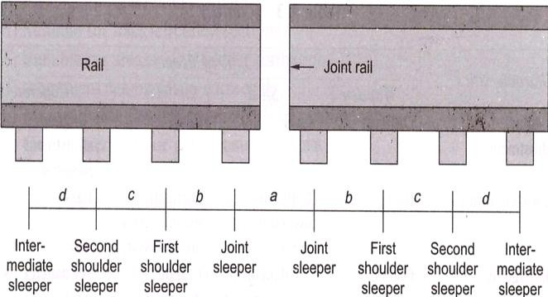

TYPES OF SLEEPERS
The sleepers mostly used on Indian Railways are
  - wooden sleepers,
  - cast iron (CI) sleepers,
  - steel sleepers, and
  - Concrete sleepers.

Comparison of different types of sleepers
Characteristics |  | Type of sleeper
 |  | Wooden |  | Steel | 'CI | Concrete
Service life (years) |  | 12-15 |  | 40-50 | 40-50 | 50-60
Weight of sleeper for  BG (kg) |  | 83 |  | 79 | 87 | 267
Handling |  | Manual handling; no damage to sleeper while handling |  | Manual handling; no damage to sleeper while handling | Manual handling; liable to break by rough handling | No manual handling; gets damaged by rough handling
Type of maintenance |  | Manual  mechanized | or | Manual or mechanized | Manual | Mechanized only
Cost of maintenance |  | High |  | Medium | Medium | Low
Gauge adjustment |  | Difficult |  | Easy | Easy | No gauge possible | adjustment
Track circuiting |  | Best |  | Difficult; insulating pads are necessary | Difficult; insulating pads are necessary | Easy
Damage by white ants and corrosion |  | Can be damaged by white ants |  | No damage by white ants but corrosion is possible | Can be damaged by corrosion | No damage by white ants or corrosion
Suitability  fastening | for | Suitable for  and EF^{f} | CF* | Suitable for CF and EF | Suitable for CF only | Suitable for EF only
Track elasticity |  | Good |  | Good | Good | Best
Creep |  | Excessive |  | Less | Less | Minimum
Scrap value |  | Low |  | Higher than wooden | High | None

BALLAST AND BALLAST REQUIREMENTS
Ballast is a layer of broken stones, gravel, rnoorum, or any other granular material placed and packed below and around sleepers for distributing load from the sleepers to the formation. It provides drainage as well as longitudinal and lateral stability to the track. Different types of ballast materials and their specifications are discussed in this chapter.

FUNCTIONS OF BALLAST
The ballast serves the following functions in a railway track.
- It provides a level and hard bed for the sleepers to rest on.
- It holds the sleepers in position during the passage of trains.
- It transfers and distributes load from the sleepers to a large area of the formation.
- It provides elasticity and resilience to the track for proper riding comfort.
- It provides the necessary resistance to the track for longitudinal and lateral stability.
- It provides effective drainage to the track.
- It provides an effective means of maintaining the level and alignment of the track.

TYPES OF BALLAST
The different types of ballast used on Indian Railways are described here.

Sand ballast
Sand ballast is used primarily for cast iron (CI) pots. It is also used with wooden ir.d steel trough sleepers in areas where traffic densitv is verv low. Coarse sand is preferred in comparison to fine sand. It has good drainage properties, but has the drawback of blowing off because of being light. It also causes excessive wear of the rail top and the moving parts of the rolling stock.

Moorum ballast
The decomposition of laterite results in the formation of moorum. It is red, and sometimes yellow, in colour. The moorum ballast is normally used as the initial ballast in new constructions and also as sub-ballast. As it prevents water from percolating into the formation, it is also used as a blanketing material for black cotton soil.

Coal ash or cinder
This type of ballast is normally used in yards and sidings or as the initial ballast in new constructions since it is very cheap and easily available. It is harmful for steel sleepers and fittings because of its corrosive action.

Broken stone ballast
This type of ballast is used the most on Indian Railways. Good stone ballast is generally procured from hard stones such as granite, quartzite, and hard trap. The quality of stone should be such that neither it should be porous nor it flake off due to the weathering. Good quality hard stone is normally used for high-speed tracks. This type of ballast works out to be economical in the long run.

Other types of ballast
There are other types of ballast also such as the brickbat ballast, gravel ballast, kankar stone ballast, and even earth ballast. These types of ballast are used only in special circumstances.
The comparative advantages, disadvantages, and suitability of different types of ballast are given in Table below.

SIZES OF BALLAST
Previously, 50 mm (2") ballasts were specified for flat-bottom sleepers such as concrete and wooden sleepers, and 40 mm (1.5") ballasts for metal sleepers such as CST-9 and trough sleepers. Now, to ensure uniformity, 50 mm (2") ballasts have been adopted universally for all types of sleepers.
Points and crossings are subjected to heavy blows of moving loads and hence are maintained to a higher degree of precision. A small sized, 25 mm (1") ballast: s. therefore, preferable because of its fineness for slight adjustments, better compaction, and increased frictional area of the ballast. For uniformity sake, the Indian Railways has adopted the same standard size of ballast for the main line as well as for points and crossings.
This standard size of ballast should be as per Indian Railways specification. The specification provides grading of ballast from 25 mm to 65 mm, maximum quantity of ballast being in the range of 40 mm to 50 mm size.
Table Comparison of different types of ballast

Type  ballast |  | of | Advantages |  |  | Disadvantages |  |  |  | Suitability
Sand ballast |  |  | Good drainage properties |  |  | Causes excessive wear |  |  |  | Suitable for  sleeper tracks | CI | pot
 |  |  | Cheap |  |  | Blows off easily |  |  |  | Not suitable for
 |  |  | No noise produced on the  track |  |  | Poor retentivity of packing |  |  |  | high-speed tracks
 |  |  | Good packing material for  CI sleepers |  |  | Track cannot be maintained  to high standards
Moorum ballast |  |  | Cheap, if locally available |  |  | Very soft and turns into dust |  |  |  | Used as a sub-ballast
 |  |  | Prevents  percolating | water | from | Maintenance  difficult | of | track | is | Initial ballast  construction | for | new
 |  |  | Provides good aesthetics |  |  | Quality of track average
Coal  cinder | ash | or | Easy availability  on railways |  |  | Harmful for steel sleepers |  |  |  | Normally used in yards  and sidings
 |  |  | Very cheap |  |  | Corrodes rail bottom and steel sleepers |  |  |  | Suitable for repairs of  formations during floods and emergencies
 |  |  | Good drainage |  |  | Soft and easily pulverized |  |  |  | Not fit for high-speed  tracks
 |  |  |  |  |  | Maintenance is difficult
Broken stone  ballast |  |  | Hard and durable when  procured from hard rocks |  |  | Initial cost is high |  |  |  | Suitable for packing with  track machines
 |  |  | Good drainage properties |  |  | Difficulties in procurement |  |  |  | Suitable for high speed  tracks
 |  |  | Stable and resilient to the  track |  |  | Angular shape may injure  wooden sleepers
. |  |  | Economical in the long run

REQUIREMENTS OF GOOD BALLAST
Ballast material should possess the following properties,
- It should be tough and wear resistant.
- It should be hard so that it does not get crushed under the moving loads,
- It should be generally cubical with sharp edges.
- It should be non-porous and should not absorb water.
- It should resist both attrition and abrasion.
- It should be durable and should not get pulverized or disintegrated under adverse weather conditions
- It should allow for good drainage of water,
- It should be cheap and economical.

DESIGN OF BALLAST SECTION
The design of the ballast section includes the determination of the depth of the ballast cushion below the sleeper and its profile. These aspects are discussed as follows.

Minimum Depth of Ballast Cushion
The load on the sleeper is transferred through the medium of the ballast to the formation. The pressure distribution in the ballast section depends upon the size and shape of the ballast and the degree of consolidation. Though the lines of equal pressure are in the shape of a bulb as discussed in, yet for simplicity, the dispersion of load can be assumed to be roughly 45° to the vertical. In order to ensure that the load is transferred evenly on the formation, the depth of the ballast should be such that the dispersion lines do not overlap each other. For the even distribution of load on the formation, the depth of the ballast is determined by the following formula:
Sleeper spacing = width of the sleeper + 2 x depth of ballast
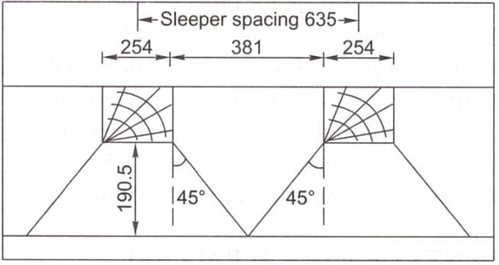

Introduction
FORMATION

Subgrade is the naturally occuring soil which is prepared to receive the ballast. The prepared flat surface, which is ready to receive the ballast, along with sleeps and rails, is called the formation. The formation is an important constituent of the track, as it supports the entire track structure. It has the following functions:
- It provides a smooth and uniform bed for laying the track.
- It bears the load transmitted to it from the moving load through the balla
- It facilitates drainage.
- It provides stability to the track.

GENERAL DESCRIPTION OF FORMATION
The formation can be in the shape of an embankment or a cutting. When formation is in the shape of a raised bank constructed above the natural ground, it is called an embankment. The formation at a level below the natural ground is called a cutting. Normally, a cutting or an excavation is made through a hilly or natural ground for providing the railway line at the required level below the ground level.
The formation (Fig. below) is prepared either by providing additional earthwork over the existing ground to make an embankment or by excavating the existing ground surface to make a cutting. The formation can thus be in the shape of either an embankment or a cutting. The height of the formation depends upon the ground contours and the gradients adopted. The side slope of the embankment depends upon the shearing strength of the soil and its angle of repose. The width of the formation depends upon the number of tracks to be laid, the gauge, and such other factors. The recommended widths of formation as adopted on Indian Railway BG MG. and NG are given in Table below.

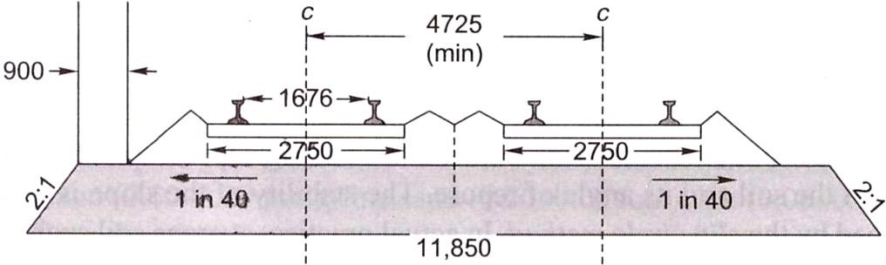
  - Cross section of bank
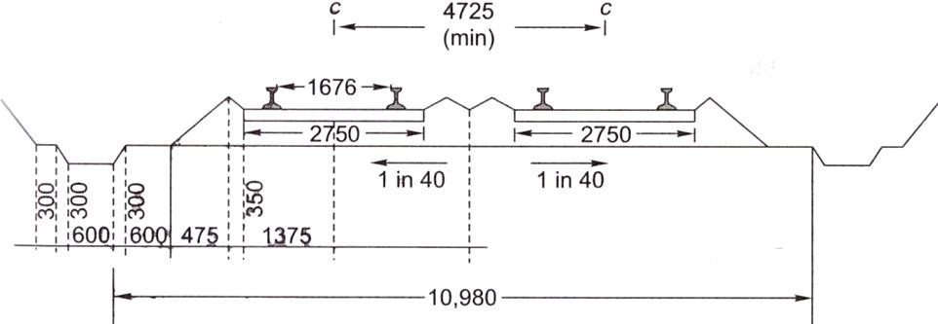
  - Cross section of cutting
Typical cross section of bank and cutting for BG double line (dimensions in mm)

Table. Width of formation for different tracks

Gauge | Type of sleepers | Single-line section |  | Double-line section
Gauge | Type of sleepers | Bank width (m) | Cutting width (m) | Bank width  (m) | Cutting width (m)
BG | W,* ST,! and  concrete | 6.85 | 6.25 | 12.155 | 11.555
MG | W, ST, CST-9, and  concrete | 5.85 | 5.25 | 9.81 | 9.21
NG | W, ST, and CST-9 | 3.70 | 3.35 | 7.32 | 7.01
W stands for wooden sleepers. ST stands for steel trough sleeper.

Slopes of Formation
The side slopes of both the embankment and the cutting depend upon the shearing strength of the soil and its angle of repose. The stability of the slope is generally determined by the slip circle method. In actual practice, average soil such as sand or clay may require a slope of 2:1 (horizontal: vertical) for an embankment and 1:1 or 0.5:1 or even steeper particularly when rock is available for cutting.

To prevent erosion of the side slopes due to rain water, etc., the side slopes are turfed. A thin layer of cohesive soil is used for this purpose. Alternatively, the slopes are turfed with a suitable type of grass. Sometimes the bank also gets eroded due to standing water in the adjoining land. A toe and pitching are provided in such cases.
Permanent way is the generic term for the track (rails, sleepers and ballast) on which railway trains run. Although the configuration of the track today would be recognized by engineers of the 19th century, it has developed significantly over the years as technological improvements became available, and as the demands of train operation increased.

Requirement of Good Track
A permanent way or track should provide comfortable and safe ride at the maximum permissible speed with minimum maintenance cost. To achieve these objectives, a sound permanet way should have the following characteristics:
- The gauge should be correct and uniform.
- The rail should have perfect cross levels. In curves, the outer rail should have proper super elevation to take into account the centrifugal force.
- The alignment should be straight and free of kinks. In the case of curves, a proper transition should be provided between the straight track and the curve.
- The gradient should be uniform and as gentle as possible. The change of gradient should be followed by a proper vertical curve to provide a smooth ride.
- The track should be resilient and elastic in order to absorb the shocks and vibration of running trains.
- The track should have a good drainage system so that the stability of the track is not effected by water logging.
- The track should have good lateral strength so that it can maintain its stability despite variations in temperature and other such factors.
- There should be provisions for easy replacement and renewal of the various track components.
- The track should have such a structure that not only is its initial cost low, but also its maintenance cost is minimum.

REQUIREMENTS OF AN IDEAL PERMANENT WAY
The following are the principal requirements of an ideal permanent way or of a good railway track :-
- The gauge of the permanent way should be uniform, correct and it should not get altered.
- Both the rails should be at the same level on tangent (straight) portion of the track.
- Proper amount of superelevation should be provided to the outer rail above the inner rail on curved portion of the track.
- The permanent way should be sufficiently strong against lateral forces.
- The curves, provided in the track, should be properly designed.
- An even and uniform gradient should be provided through out the length of the track.
- The tractive resistance of the track should be minimum.
- The design of the permanent way should be such that the load of the train is uniformly distributed on both the rails so as to prevent unequal settlement of the track.
- It Should provide adequate elasticity in order to prevent the harshness of impacts between the rails and the moving wheel loads of a train.
- It should be free from excessive rail joints and all the joining should be properly designed and constructed.
- All the components parts such as rails, sleepers, ballast, fixtures and fastenings, etc. should satisfy the design requirements.
- All the fixtures and fastenings such as chairs, bearing plates, fish plates, fish bolts, spikes
etc. should be strong enough to withstand the stresses occurring in the track.
- All the *points and crossings, laid in the permanent way, should be properly designed and carefully constructed.
- It should be provided with fence near level crossings and also in urban areas.
- It should be provided with proper drainage facilities so as to drain off the rain water quickly away from the track.
- It should be provided with safe and strong bridges coming in the alignment of the track.
- It should be provided with safe and strong bridges coming in the alignment of the track.
- It should be so constructed that repairs and renewals of any of its portion can be carried out without any difficulty.
WEAR AND FAILURE IN RAILS
Due to the passage of moving loads and friction between the rail and the wheel, the rail head gets worn out in the course of service. The impact of moving loads, the effect of the forces of acceleration, deceleration, and braking of wheels, the abrasion due to rail-wheel interaction, the effects of weather conditions such as changes in temperature, snow, and rains, the presence of materials such as sand, the standard of maintenance of the track, and such allied factors cause considerable wear and tear of the vertical and lateral planes of the rail head. Lateral wear occurs more on curves because of the lateral thrust exerted on the outer rail by centrifugal force. A lot of the metal of the rail head gets worn out, causing the weight of the rail to decrease. This loss of weight of the rail section should not be such that the stresses exceed their permissible values. When such a stage is reached, rail renewal is called for.
In addition, the rail head should not wear to such an extent that there is the possibility of a worn flange of the wheel hitting the fish plate.

Types of Wear on Rails
A rail may face wear and tear in the following positions:
  - On top of the rail head (vertical wear)
  - On the sides of the rail head (lateral wear)
  - On the ends of the rail (battering of rail ends)
Wear is more prominent at some special locations of the track. These locations are normally the following:
- On sharp curves, due to centrifugal forces
- On steep gradients, due to the extra force applied by the engine
- On approaches to railway stations, possibly due to acceleration and deceleration
- In tunnels and coastal areas, due to humidity and weather effects

Measurement of Wear
Wear on rails can be measured using any of the following methods:
- By weighing the rail
- By profiling the rail section with the help of lead strips
- By profiling the rail section with the help of needles
- By using special instruments designed to measure the profile of the rail and record it simultaneously on graph paper

Methods to Reduce Wear
Based on field experience, some of the methods adopted to reduce vertical wear and lateral wear on straight paths and curves are as follows-
- Better maintenance of the track to ensure good packing as well as proper alignment and use of the correct gauge
- Reduction in the number of joints by welding
- Use of heavier and higher UTS rails, which are more wear resistant
- Use of bearing plates and proper adzing in case of wooden sleepers
- Lubricating the gauge face of the outer rail in case of curves
- Providing check rails in the case of sharp curves
- Interchanging the inner and outer rails
- Changing the rail by carrying out track renewal

Rail End Batter
The hammering action of moving loads on rail joints batters the rail ends in due course of time. Due to the impact of the blows, the contact surfaces between the rails and sleepers also get worn out, the ballast at places where the sleepers are joined gets shaken up, the fish bolts become loose, and all these factors further worsen the situation, thereby increasing rail end batter.
Rail end batter is measured as the difference between the height of the rail at the end and at a point 30 cm away from the end. If the batter is up to 2 mm, it is classified 'average', and if it is between 2 and 3 mm, it is classified as 'severe'. When rail end batter is excessive and the rail is otherwise alright, the ends can be cropped and the rail reused.

OTHER DEFECTS IN RAILS
Rail wear and battering of rail ends are the two major defects in rails. However some other types of defects may also develop in a rail and necessitate its removal in extreme cases. These are as follows:

Hogging of rails
Rail ends get hogged due to poor maintenance of the rail joint, yielding format, loose and faulty fastenings, and other such reasons. Hogging of rails causes the quality of the track to deteriorate. This defect can be remedied by measured she packing.

Scabbing of rails
The scabbing of rails occurs due to the falling of patches or chunks of metal from the rail table. Scabbing is generally seen in the shape of an elliptical depression; whose surface reveals a progressive fracture with numerous cracks around it.

Wheel burns
Wheel burns are caused by the slipping of the driving wheel of locomotives on the rail surface. As a consequence, extra heat is generated and the surface of the rail gets affected, resulting n a depression on the rail table. Wheel burns are generally noticed on steep gradients or where there are heavy incidences of braking or near water columns.

Shelling and black spots
Shelling is the progressive horizontal separation of metal that occurs on the gauge side, generally at the upper gauge corner. It is primarily caused by heavy bearing pressure on a small area of contact, which produces heavy internal shear stress.

Corrugation of rail:
Corrugation consists of minute depressions on the surface of rails, varying in shape and size and occurring it irregular intervals. The exact cause of corrugation is not yet known, though many theories have been put forward. The factors which help in the formation of rail corrugation, however, are briefly enumerated here,
a) Metallurgy and age of rails
- High nitrogen content of the rails
- Effect of oscillation at the time of rolling and straightening of rails
- Physical and environment conditions of track
(i) Steep gradients (ii) Yielding formation (iii) Long tunnels (iv) Electrified sections
- Train operations
(i) High speeds and high axle loads (ii) Starting locations of trains (iii) Locations where brakes are applied to stop the train
- Atmospheric effects
(i) High moisture content in the air particularly in coastal areas (ii) Presence of sand

RAIL FAILURE
A rail is said to have failed if it is considered necessary to remove it immediately from the track on account of the defects noticed on it. The majority of rail failures originate from the fatigue cracks caused due to alternating stresses created in the rail section on account of the passage of loads. A rail section is normally designed to take a certain minimum GMT of traffic, but sometimes due to reasons such as an inherent defect in the metal, the section becomes weak at a particular point and leads to premature failure of the rail.
- Physical and environment conditions of track
(i) Steep gradients (ii) Yielding formation (iii) Long tunnels (iv) Electrified sections
- Train operations
(i) High speeds and high axle loads (ii) Starting locations of trains (iii) Locations where brakes are applied to stop the train
- Atmospheric effects
(i) High moisture content in the air particularly in coastal areas (ii) Presence of sand
The corrugation of rails is quite an undesirable feature. When vehicles pass over corrugated rails, a roaring sound is produced, possibly due to the locking of air in the corrugation. This phenomenon is sometimes called 'Roaring of rails'. This unpleasant and excessive noise causes great inconvenience to the passengers. Corrugation also results in the rapid oscillation of rails, which in turn loosens the keys, causes excessive wear to fittings, and disturbs the packing.

Causes of Rail Failures
The main causes of failure of rails are as follows:
Inherent defects in the rail These are due to manufacturing defects in the rail, such as faulty chemical composition, harmful segregation, piping, seams, laps, and guide marks.
Defects due to fault of the rolling stock and abnormal traffic effects Flat soots in tvres, engine burns, skidding of wheels, severe braking, etc.
Excessive corrosion of rails This generally takes place due to weather conditions, the presence of corrosive salts such as chlorides and constant exposure of the rails to moisture and humidity in locations near water columns, ashpits, tunnels, etc. Corrosion normally leads to the development of cracks in regions with a high concentration of stresses.
Badly maintained joints Poor maintenance of joints such as improper packing of joint sleepers and loose fittings.
Defects in welding of joints These defects arise either because of improper composition of the thermit weld metal or because of a defective welding technique.
Improper maintenance of track Ineffective or careless maintenance of the track or delayed renewal of the track.
Derailments The rails are damaged during derailment.

Classification of Rail Failures
The classification of rail failures on Indian Railways has been codified for easy processing of statistical data. The code is made up of two portions—the first portion consisting of three code letters and the second portion consisting of three or four code digits.
First portion of the code The three code letters make up the first portion and denote the following.
(i) Type of rail being used (O for plain rail and X for points and crossing rails) (ii) Reasons for withdrawal of rail (F for fractured, C for cracked, and D for defective)
(iii) Probable cause failure (S for fault of rolling stock, C for excessive corrosion, D for derailment, and O for others)
Second portion of code The second portion consisting of three or four digits gives the following information, (i) First digit indicate the location of the fracture on the length of the rail (1 for
within fish plate limits and 2 for other portions on the rail), (ii) Second digit indicate the position in the rail section from where the failure started (0 for unknown, 1 for within rail head, 2 for surface of rail head, 3 for web, and 4 for foot).
(iii) Third digit indicate the direction of crack or fracture (0 to 9). (iv) Any other information about the fracture, where it is necessary to provide further subdivision. No specific system is recommended for this code.

Metallurgical Investigation
The following types of defective rails should normally be sent for metallurgical investigation, (i)
Rails that have been removed from the track as a result of visual or ultrasonic detection
(ii) Rail failures falling in categories in which cracks or surface defects develop at specified locations

RAIL JOINTS

Although a rail joint has always been an integral part of the railway track, it is looked upon as a necessary evil because of the various problems that it presents. Earlier, rails were rolled in short lengths due to difficulties in rolling and the problem of transportation. With increase in temperature, rails expand and this expansion needs to be considered at the joints. It was, therefore, felt that the longer the rail, the larger the required expansion gap, and this too limited the length of the rail. A rail joint is thus an inevitable feature of railway tracks, even though it presents a lot of problems in the maintenance of the permanent way. This chapter discusses the various types of rail joints and their suitability on a railway track.

ILL EFFECTS OF A RAIL JOINT
A rail joint is the weakest link in the track. At a joint, there is a break in the continuity of the rail in both the horizontal and the vertical planes because of the presence of the expansion gap and imperfection in the levels of rail heads. A severe jolt is also experienced at the rail joint when the wheels of vehicles negotiate the expansion gap. This jolt loosens the ballast under the sleeper bed, making the maintenance of the joint difficult. The fittings at the joint also become loose, causing heavy wear and tear of the track material. Some of the problems associated with the rail joint are as follows.

Maintenance effort
Due to the impact of moving loads on the joint, the packing under the sleeper loosens and the geometry of the track gets distorted very quickly because of which the joint requires frequent attention. It is generally seen that about 30 per cent extra labour is required for maintenance of a joint.

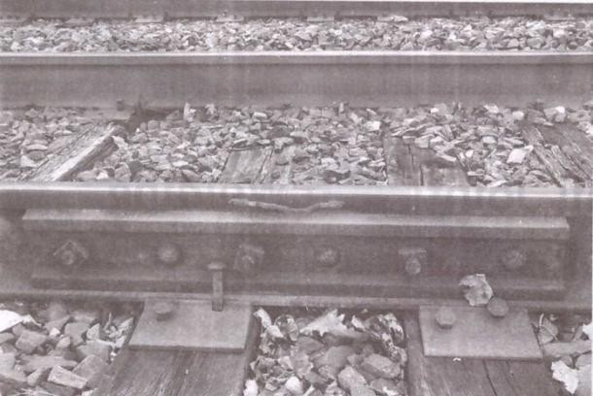

Bonded main line 6-bolt rail joint on a segment of 76.9 kg/m rail. Note how bolts are oppositely oriented to prevent complete separation of the joint in the event of being struck by a wheel during a derailment.

Lifespan
The life of rails, sleepers, and fastenings gets adversely affected due to the extra stresses created by the impact of moving loads on the rail joint. The rail ends particularly get battered and hogged and chances of rail fracture at joints are considerably high due to fatigue stresses in the rail ends. Noise effect
A lot of noise pollution is created due to rail joints, making rail travel uncomfortable.

Sabotage chances
Wherever there is a rail joint, there is a potential danger of the removal of fish plates and rails by miscreants and greater susceptibility to sabotage.

Impact on quality
The quality of the track suffers because of excessive wear and tear of track components and rolling stock caused by rail joints.

Fuel consumption
The presence of rail joints results in increased fuel consumption because of the extra effort required by the locomotive to haul the train over these joints.

REQUIREMENTS OF AN IDEAL RAIL JOINT
An ideal rail joint provides the same strength and stiffness as the parent rail. The characteristics of an ideal rail joint are briefly summarized here.
Holding the rail ends:An ideal rail joint should hold both the rail ends in their precise location in the horizontal as well as the vertical planes to provide as much continuity in the track as possible. This helps in avoiding wheel jumping or the deviation of the wheel from its normal path of movement.
Strength: An ideal rail joint should have the same strength and stiffness as the parent rails it joins.
Expansion gap:The joint should provide an adequate expansion gap for the free expansion and contraction of rails caused by changes in temperature
Flexibility It should provide flexibility for the easy replacement of rails, whenever required. Provision for wear:It should provide for the wear of the rail ends, which is likely to occur under normal operating conditions.
Elasticity:It should provide adequate elasticity as well as resistance to longitudinal forces so as to ensure a trouble-free track.
Cost:The initial as well as maintenance costs of an ideal rail joint should be minimal.

TYPES OF RAIL JOINTS
The nomenclature of rail joints depends upon the position of the sleepers or the joints.
Classification According to Position of Sleepers Three types of rail joints come under this category. Supported joint
In this type of joint, the ends of the rails are supported directly on the sleeper. It was expected that supporting the joint would reduce the wear and tear of the rails, as there would be no cantilever action. In practice, however, the support tends to slightly raise the height of the rail ends. As such, the run on a supported joint is normally hard. There is also wear and tear of the sleeper supporting the joint and its maintenance presents quite a problem. The duplex sleeper is an example of a supported joint (Fig. below).
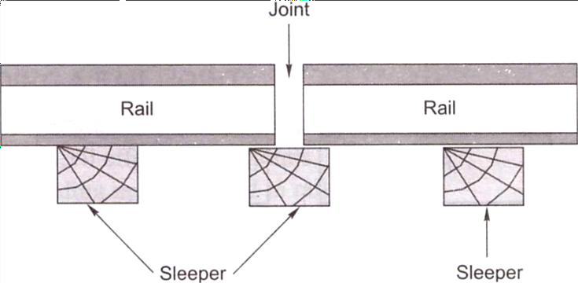
Fig. Supported rail joint

Suspended joint
In this type of joint, the ends of the rails are suspended between two sleepers and some portion of the rail is cantilevered at the joint. As a result of cantilever action, the packing under the sleepers of the joint becomes loose particularly due to the hammering action of the moving train loads. Suspended joints are the most common type of joints adopted by railway systems worldwide, including India (Fig. 16.2).

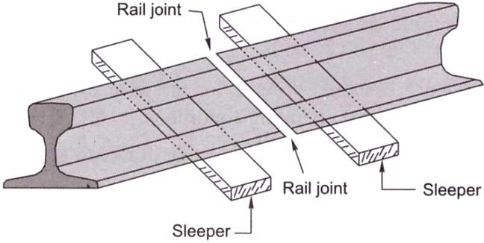

Fig. Suspended joint

Bridge joints
The bridge joint is similar to the suspended joint except that the two sleepers on either side of a bridge joint are connected by means of a metal flat [Fig. (a)] or a corrugated plate known as a bridge plate [Fig. 16.3(b)]. This type of joint is generally not used on Indian Railways.
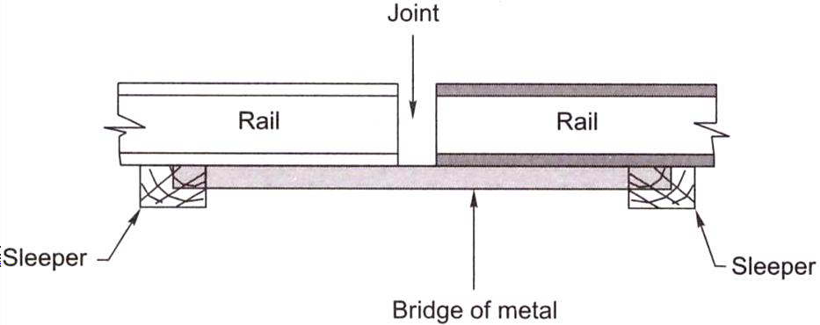
Fig. (a) Bridge joint with metal flat Joint
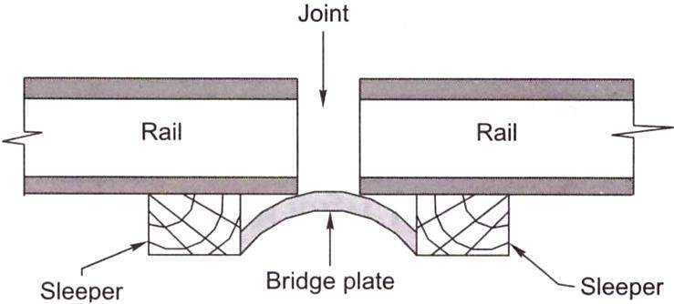
Fig. (b) Bridge joint with bridge plate

Classification Based on the Position of the Joint
Two types of rail joints fall in this category.
Square joint In this case, the joints in one rail are exactly opposite to the joints in the other rail. This type of joint is most common on Indian Railways (Fig. below).
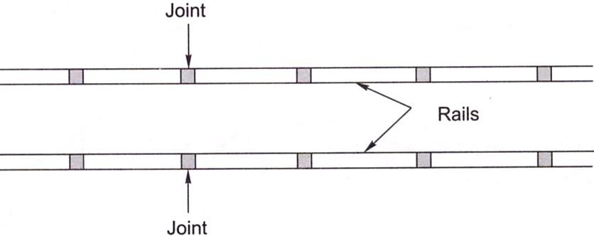
Staggered joint In this case, the joints in one rail are somewhat staggered and are not opposite the joints in the other rail. Staggered joints are normally preferred on curved tracks because they hinder the centrifugal force that pushes the track outward (Fig. below).
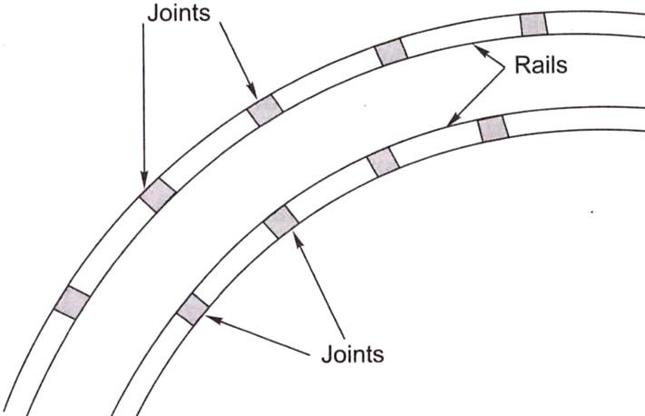

WELDING A RAIL JOINT
The purpose of welding is to join rail ends together by the application of heat and thus eliminate the evil effects of rail joints.
There are four welding methods used in railways.
- Gas pressure welding
- Electric arc or metal arc welding
- Flash butt welding
- Thermit welding

BEARING PLATES, ANTI-CREEP DEVICES

ADJUSTMENT OF CREEP
When creep is in excess of 150 mm resulting in maintenance problems, the same should be adjusted by pulling the rails back. This work is carried out after the required engineering signals have been put up and the necessary caution orders given. The various steps involved in the adjustment of creep are as follows:
- A careful survey of the expansion gaps and of the current position of rail joints is carried out.
- The total creep that has been proposed to be adjusted and the correct expansion gap that is to be kept are decided in advance.
- The fish plates at one end are loosened and those at the other end are removed. Sleeper fittings, i.e., spikes or keys, are also loosened or removed.
- The rails are then pulled back one by one with the help of a rope attached to a hook. The pulling back should be regulated in such a way that the rail joints remain central and suspended on the joint sleepers.
The pulling back of rails is a slow process since only one rail is dealt with at a time and can be done only for short isolated lengths of a track. Normally, about 40-50 men are required per kilometre for adjusting creep. When creep is required to be adjusted for longer lengths, five rail lengths are tackled at a time. The procedure is almost the same as the preceding steps except that instead of pulling the rails with i rope, a blow is given to them using a cut rail piece of a length of about 5 m.

CREEP ADJUSTER
A creep adjuster is normally used when extensive work is involved. The creep adjuster is set at the centre of the length of the track, to be tackled, with the wide joints behind it and the jammed joints ahead of it. The following steps are adopted while using a creep adjuster:
- Expansion liners of the correct size are put in all the expansion gaps,
- All the keys on the side (with wide joints) of the creep adjuster are removed and all fish bolts loosened,
- The creep adjuster is then used to close up the gaps to the required extent by pushing the rails forward. A gap of a few inches is left between the rail ends opposite the adjuster,
- The corrected rails are then fastened with keys. After that, the rails on the other side of the adjuster are tackled,
- The operation leaves some of the expansion gaps too wide which are tackled by the creep adjuster when it is set in the next position,
- The corrected rails are then fastened and the adjuster is shifted to the new position,
- The whole process is repeated again and again till the requisite attention has been paid to the entire length of the rail. In the end it may be necessary to use a rail with the correct size of closure (bigger or smaller) to complete the work.

PORTIONS OF TRACK SUSCEPTIBLE TO CREEP
The following locations of a track are normally more susceptible to creep.
- The point where a steel sleeper track or CST-9 sleeper track meets a wooden sleeper track
- Dips in stretches with long gradients
- Approaches to major girder bridges or other stable structures
- Approaches to level crossings and points and crossings
- Steep gradients and sharp curves

MEASURES TO REDUCE CREEP
To reduce creep in a track, it should be ensured that the rails are held firmly to the sleepers and that adequate ballast resistance is available. All spikes, screws, and keys should be driven home. The toe load of fastenings should always be slightly more than the ballast resistance. Creep anchors can effectively reduce the creep in a track. At least eight of these creep anchors must be provided per panel. Out of the large number of creep anchors tried on Indian Railways, the 'fair T' and 'fair V anchors, have been standardized for use. The fair 'V anchor, which is more popular, is shown in Fig. below. The creep anchor should fit snugly against the sleeper for it to be full;- effective. The following measures are also helpful in reducing creep,
- The track should be well maintained—sleepers should be properly packed and the crib and shoulder ballast should be well compacted.
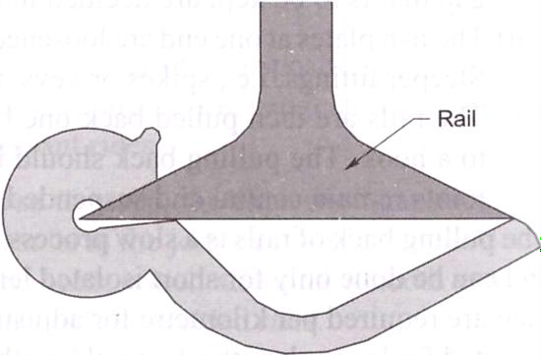

- A careful lookout should be kept for jammed joints that exist in series. In the case of a fish- plated track, more than six consecutive continuously jammed joints should not be permitted. In the case of SWR tracks, more than two consecutive jammed joints should not be permitted at rail temperatures lower than the maximum daily temperature (Tm) in the case of zones I and II and lower than (Tm - 5°C) in the case of zones III and IV. Regular adjustment may be necessitated on girder bridges.
- Anticreep bearing plates should be provided on wooden sleepers to arrest creep, but joints sleepers should have standard canted bearing plates with rail screws.
RAILWAY ALIGNMENT
Geometric design of a railway track discusses all those parameters which affect the geometry of the track. These parameters are as follows:
- Gradients in the track, including grade compensation, rising gradient, and falling gradient
- Curvature of the track, including horizontal and vertical curves, transition curves, sharpness of the curve in terms of radius or degree of the curve, cant or superelevation on curves, etc.
- Alignment of the track, including straight as well as curved alignment
It is very important for tracks to have proper geometric design in order to ensure the safe and smooth running of trains at maximum permissible speeds, carrying the heaviest axle loads. The speed and axle load of the train are very important and sometimes are also included as parameters to be considered while arriving at the geometric design of the track.

NECESSITY FOR GEOMETRIC DESIGN
The need for proper geometric design of a track arises because of the following considerations:
- To ensure the smooth and safe running of trains
- To achieve maximum speeds
- To carry heavy axle loads
- To avoid accidents and derailments due to a defective permanent way
- To ensure that the track requires least maintenance
- For good aesthetics

DETAILS OF GEOMETRIC DESIGN OF TRACK
The geometric design of the track deals with alignment of railway track and Curves Details regarding curves and their various aspects.

GRADIENTS
Gradients are provided to negotiate the rise or fall in the level of the railway track. A rising gradient is one in which the track rises in the direction of movement of traffic and in a down or falling gradient the track loses elevation the direction of movement of traffic.
A gradient is normally represented by the distance travelled for a rise or fall of one unit. Sometimes the gradient is indicated as per cent rise or fall. For example, if there is a rise of 1 m in 400 m, the gradient is 1 in 400 or 0.25 per cent.
Gradients are provided to meet the following objectives:
- To reach various stations at different elevations
- To follow the natural contours of the ground to the extent possible
- To reduce the cost of earthwork
The following types of gradients are used on the railways:
- Ruling gradient
- Pusher or helper gradient
- Momentum gradient
- Gradients in station yards

Ruling Gradient
The ruling gradient is the steepest gradient that exists in a section. It determines the maximum load that can be hauled by a locomotive on that section. While deciding the ruling gradient of a section, it is not only the severity of the gradient, but also its length as well as its position with respect to the gradients on both sides that have to be taken into consideration. The power of the locomotive to be put into service on the track also plays an important role in taking this decision, as the locomotive should have adequate power to haul the entire load over the ruling gradient at the maximum permissible speed.
In plain terrain: 1 in 150 to 1 in 250
In hilly terrain: 1 in 100 to 1 in 150
Once a ruling gradient has been specified for a section, all other gradients provided in that section should be flatter than the ruling gradient after making due compensation for curvature.

Pusher or Helper Gradient
In hilly areas, the rate of rise of the terrain becomes very important when trying to reduce the length of the railway line and, therefore, sometimes, gradients steeper than the ruling gradient are provided to reduce the overall cost. In such situations, one locomotive is not adequate to pull the entire load, and an extra locomotive is required.

When the gradient of the ensuing section is so steep as to necessitate the use of an extra engine for pushing the train, it is known as a pusher or helper gradient. Examples of pusher gradients are the Budni-Barkhera section of Central Railway and the Darjeeling Himalayan Railway section.

Momentum Gradient
The momentum gradient is also steeper than the ruling gradient and can be overcome by a train because of the momentum it gathers while running on the section. In valleys, a falling gradient is sometimes followed by a rising gradient. In such a situation, a train coming down a falling gradient acquires good speed and momentum, which gives additional kinetic energy to the train and allows it to negotiate gradients steeper than the ruling gradient. In sections with momentum gradients there are no obstacles provided in the form of signals, etc., which may bring the train to a critical juncture.

Gradients in Station Yards
The gradients in station yards are quite flat due to the following reasons:
- It prevents standing vehicles from rolling and moving away from the yard due to the combined effect of gravity and strong winds.
- It reduces the additional resistive forces required to start a locomotive to the extent possible. It may be mentioned here that generally, yards are not levelled completely and certain flat gradients are provided in order to ensure good drainage. The maximum gradient prescribed in station yards on Indian Railways is 1 in 400, while the recommended gradient is 1 in 1000.

GRADE COMPENSATION ON CURVES
Curves provide extra resistance to the movement of trains. As a result, gradients are compensated to the following extent on curves:
- On BG tracks, 0.04 per cent per degree of the curve or 70/R, whichever is minimum
- On MG tracks, 0.03 per cent per degree of curve or 52.5/R, whichever is minimum
- On NG tracks, 0.02 per cent per degree of curve or 35/R, whichever is minimum
where R is the radius of the curve in metres. The gradient of a curved portion of the section should be flatter than the ruling gradient because of the extra resistance offered by the curve.
HORIZONTAL CURVES
Curves are introduced on a railway track to bypass obstacles, to provide longer and easily traversed gradients, and to pass a railway line through obligatory or desirable locations. Horizontal curves are provided when a change in the direction of the track is required and vertical curves are provided at points where two gradients meet or where a gradient meets level ground. To provide comfortable ride on a horizontal curve, the level of the outer rail is raised above the level of the inner rail. This is known as super elevation.

CIRCULAR CURVES
This section describes the defining parameters, elements, and methods of setting out circular curves.

Radius or degree of a curve
A curve is denned either by its radius or by its degree. The degree of a curve (D) is the angle subtended at its centre by a 30.5 m or 100 ft arc.
The value of the degree of the curve can be determined as indicated below. Circumference of a circle = 2πR
Angle subtended at the centre by a circle with this circumference = 360°
Angle subtended at the centre by a 30.5 m arc, or degree of curve = 360°/2πR x30.5
= 1 750/R (approximately R is in meter)
In cases where the radius is very large, the arc of a circle is almost equal to the chord connecting the two ends of the arc. The degree of the curve is thus given by the following formulae:
D = 1750/R (when R is in metres)
D = 5730/ R (when R is in feet) A 2° curve, therefore, has a radius of 1750/2 = 875 m.

Relationship between radius and versine of a curve
Versine is the perpendicular distance of the midpoint of a chord from the arc of a circle. The relationship between the radius and versine of a curve can be established as shown in Fig. Below. Let R be the radius of the curve, C be the length of the chord, and V be the versine of a chord of length C.
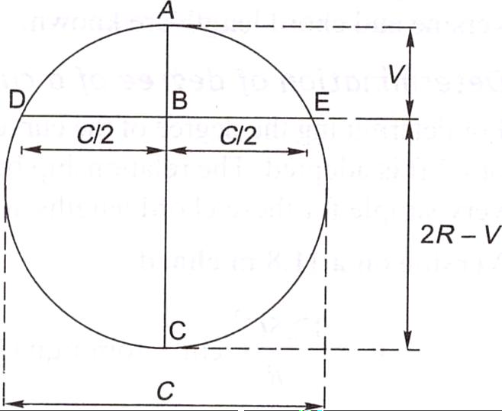
AC and DE being two chords meeting perpendicularly at a common point B, simple geometry can prove that

Fig. Relation between radius and versine of a curve AB x BC = DB x BE or V(2R-V) =(C/2) x (C/2) or 2RV- V² = C²/4
V being very small, V²can be neglected. Therefore,
2RV = C²/4 or V = C²/8R
In above Eqn V, C, and R are in the same unit, say, metres or centimetres. This general equation can be used to determine versines if the chord and the radius of a curve are known.

Maximum degree of a curve
The maximum permissible degree of a curve on a track depends on various factors such as gauge, wheel base of the vehicle, maximum permissible superelevation, and other such allied factors. The maximum degree or the minimum radius of the curve permitted on Indian Railways for various gauges is given in Table below.

 | Max. degree | Min. radius (m) | Max. degree | Min. radius (m)
BG | 10 | 175 | 8 | 218
MG | 16 | 109 | 15 | 116
NG | 40 | 44 | 17 | 103

Elements of a circular curve
In Fig. below, AO and BO are two tangents of a circular curve which meet or intersect at a point O, called the point of inter section or apex. T₁ and T₂ are the points where the curve touches the tangents, called tangent points (TP). OT₁ and OT₂ are the tangent lengths of the curve and are equal in the case of a simple curve. T₁T₂ is the chord and EF is the versine of the same. The angle AOB formed between the tangents AO and OB is called the angle of intersection (∟1) and the angle BOO₁, is the angle of deflection (∟ ϕ). The following are some of the important relations between these elements:
∟1 + ∟ ϕ =180⁰
Tangent OT₁ = OT₂ = R tan (ϕ/2)
T₁T₂ = length of long cord = 2R sin (ϕ/2) Length of the curve = 2πR/360 x ϕ = πR ϕ / 180
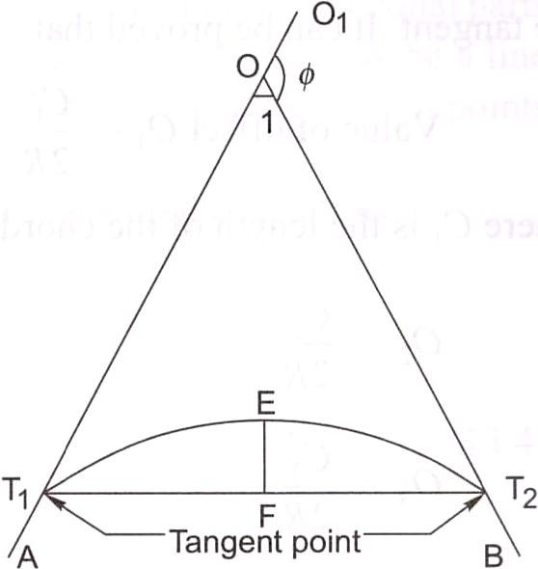

Fig. Elements of a circular curve

SUPERELEVATION

The following terms are frequently used in the design of horizontal curves.
Superelevation or cant (C_{a}) It is the difference in height between the outer and the inner rail on a curve. It is provided by gradually raising the outer rail above the level of the inner rail. The inner rail, also known as the gradient rail, is taken as the reference rail and is normally maintained at its original level. The main functions of superelevation are the following:
- To ensure a better distribution of load on both rails
- To reduce the wear and tear of the rails and rolling stock
- To neutralize the effect of lateral forces
- To provide comfort to passengers
Equilibrium speed When the speed of a vehicle negotiating a curved track is such that the resultant force of the weight of the vehicle and of radial acceleration is perpendicular to the plane of the rails, the vehicle is not subjected to any unbalanced radial acceleration and is said to be in equilibrium. This particular speed is called the equilibrium speed.
Maximum permissible speed This is the highest speed permitted to a train on a curve taking into consideration the radius of curvature, actual cant, cant deficiency, cant excess, and the length of transition. On curves where the maximum permissible speed is less than the maximum sectional speed of the section of the line, permanent speed restriction becomes necessary.
Cant deficiency (C_{d}) It occurs when a train travels around a curve at a speed higher than the equilibrium speed. It is the difference between the theoretical cant required for such high speeds and the actual cant provided.
Cant excess (C_{e}) It occurs when a train travels around a curve at a speed lower than the equilibrium speed. It is the difference between the actual cant provided and the theoretical cant required for such a low speed.
Cant gradient and cant deficiency gradient These indicate the increase or decrease in the cant or the deficiency of cant in a given length of transition. A gradient of 1 in 1000 means that a cant or a deficiency of cant of 1 mm is attained or lost in every 1000 mm of transition length.
Rate of change of cant or cant deficiency This is the rate at which cant deficiency increases while passing over the transition curve, e.g., a rate of 35 mm per second means that a vehicle will
experience a change in cant or a cant deficiency of 35 mm in each second of travel over the transition when travelling at the maximum permissible speed.

CENTRIFUGAL FORCE ON A CURVED TRACK
A vehicle has a tendency to travel in a straight direction, which is tangential to the curve, even when it moves on a circular curve. As a result, the vehicle is subjected to a constant radial acceleration. Radial acceleration = a = V²/R
where V is the velocity (metres per second) and R is the radius of curve (metres). This radial acceleration produces a centrifugal force which acts in a radial direction away from the centre. The value of the centrifugal force is given by the formula:
Force = mass * acceleration, F = m x (V²/R) = (W/g)x (V²/R)
where F is the centrifugal force (Kilo newton), W is the weight of the vehicle (tonnes), V is the speed (m/s), g is the acceleration due to gravity (m/s²), and R is the radius of the curve in metres. To counteract the effect of the centrifugal force, the outer rail of the curve is elevated with respect to the inner rail by an amount equal to the superelevation. A state of equilibrium is reached when both the wheels exert equal pressure on the rails and the superelevation is enough to bring the resultant of the centrifugal force and the force exerted by the weight of the vehicle at right angles to the plane of the top surface of the rails. In this state of equilibrium, the difference in the heights of the outer and inner rails of the curve is known as equilibrium superelevation.
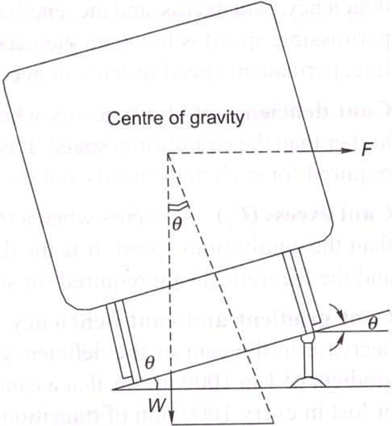
Fig. Equilibrium superelevation

Equilibrium Superelevation
In Fig. above, if θ is the angle that the inclined plane makes with the horizontal line, then superelevation
tan θ = Superelevation / Gauge = e/ G tan θ = Centrifugal force/weight = F/W From these equations
e/ G = F/W e = f x G/W
e = W/g x V²/R x G/R = GV² / gR
Here, e is the equilibrium superelevation, G is the gauge, Vis the velocity, g is the acceleration due to gravity, and R is the radius of the curve. In the metric system equilibrium superelevation is given by the formula:
e = GV² / 127R
where e is the superelevation in millimetres, V is the speed in km per hour, R is the radius of the curve in metres, and G is the dynamic gauge in millimetres, which is equal to the sum of the gauge and the width of the rail head in millimetres. This is ermal to 1750 mm for BG tracks and 1058 mm for MG tracks.

MAXIMUM VALUE OF SUPERELEVATION
The maximum value of superelevation has been laid down based on experiments carried out in Europe on a standard gauge for the overturning velocity, taking into consideration the track maintenance standards. The maximum value of superelevation generally adopted on on many railways around the world is one-tenth to one-twelfth of the gauge. The values of maximum superelevation prescribed on Indian Railways are given in Table below.
Table Maximum value of superelvation

Gauge | Group | Limiting value of cant (mm)
Gauge | Group | Under normal conditions | With special permission of CE
BG | A | 165 | 185
BG | B and C | 165 | -
BG | D and E | 140 | -
MG | All routes | 90 | 100
NG |  | 65 | 75

CANT DEFICIENCY AND NEGATIVE SUPERELEVATION

Introduction
Cant deficiency is the difference between the equilibrium cant that is necessary for the maximum permissible speed on a curve and the actual cant provided. Cant deficiency is limited due to two considerations:
- Higher cant deficiency causes greater discomfort to passengers
- Higher cant deficiency leads to greater unbalanced centrifugal force, which in turn leads to the requirement of stronger tracks and fastenings to withstand the resultant greater lateral forces. The maximum values of cant deficiency prescribed on Indian Railways are given in Table below. Table Allowable cant deficiency
Gauge | Group | Normal cant  deficiency (mm) | Remarks
BG | AandB | 75 | For BG group
BG | C, D, and E | 75 | For A and B routes; 1 00 mm cant deficiency permitted only for nominated rolling stock and routes with the  approval of the CE
MG | All routs | 50
NG | - | 40
The limiting values of cant excess have also been prescribed. Cant excess should not be more than 75 mm on BG and 65 mm on MG for all types of rolling stock. Cant excess should be worked out taking into consideration the booked speed of the trains running on a particular section. In the case of a section that carries predominantly goods traffic, cant excess should be kept low to minimize wear on the inner rail. Table below lists the limiting values of the various parameters that concern a curve.

NEGATIVE SUPERELEVATION
When the main line lies on a curve and has a turnout of contrary flexure leading to a branch line, the superelevation necessary for the average speed of trains running over the main line curve cannot be provided. In Fig. below, AB, which is the outer rail of the main line curve, must he higher than CD. For the branch line, however CF should be higher than AE or point C should be higher than point A. These two contradictory conditions cannot be met within one layout. In such cases, the branch line curve has a negative superelevation and, therefore, speeds on both tracks must be restricted, particularly on the branch line.
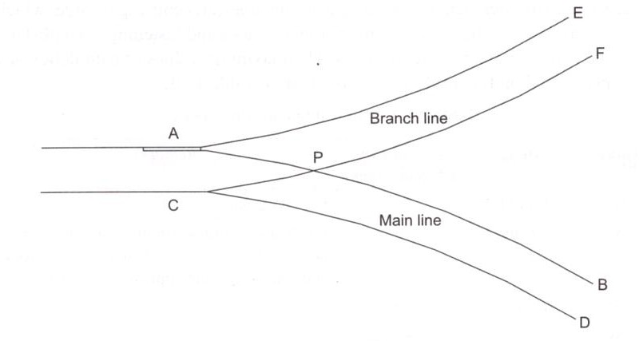
Fig: Negative superelevation
The provision of negative superelevation for the branch line and the reduction in speed over the main line can be calculated as follows:
- The equilibrium superelevation for the branch line curve is first calculated using the formula
e = GV² / 127R
- The equilibrium superelevation e is reduced by the permissible cant deficiency C_{d} and the resultant superelevation to be provided is
x = e - C_{d}
where x is the superelevation, e is the equilibrium superelevation, and C_{d} is 75 mm for BG and 50 mm for MG. The value of C_{d} is generally higher than that of e, and, therefore, x is normally negative. The branch line thus has a negative superelevation of x.
- The maximum permissible speed on the main line, which has a superelevation of x, is then calculated by adding the allowable cant deficiency (x + C_{d}). The safe speed is also calculated and the smaller of the two values is taken as the maximum permissible speed on the main line curve. SAFE SPEED ON CURVES
For all practical purposes safe speed refers to a speed which protects a carriage from the danger of overturning and derailment and provides a certain margin of safety. Earlier it was calculated empirically by applying Martin's formula:
For BG and MG Transitioned curves
V = 3.65(R -6)^{1/2}
where V is the speed in km per hour and R is the radius in metres.

Non-transitioned curves
Safe speed = four-fifths of the speed calculated using Eqn. above
For NG Transitioned curves
V = 3.65(R – 6)^{1/2} (subject to a maximum of 50 kmph).

Non-transitioned curves
V = 2.92(R – 6)^{1/2} (subject to a maximum of 40 kmph).
Indian Railways no longer follows this concept of safe speed on curves or the stipulations given here.
New Formula for Determining Maximum Permissible Speed on Transitioned Curves Earlier, Martin's formula was used to work out the maximum permissible speed or safe speed on curves. This empirical formula has been changed by applying a formula based on theoretical considerations as per the recommendations of the committee of directors, chief engineers, and the ACRS. The maximum speed for transitioned curves is now determined as per the revised formulae given below:

ForBG
V = ((C_{a} + C_{d}) x R/ 13.76)^{1/2} = 0.27((C_{a} + C_{d}) x R)^{1/2}
where V is the maximum speed in km per hour, C_{a} is the actual cant in millimetres, C_{d} is the permitted cant deficiency in millimetres, and R is the radius in millimetres. This equation is derived from Eqn for equilibrium superelevation and is based on the assumption that G = 1 750 mm, which is the centre-to-centre distance between the rail heads of a BG track with 52 g rails.

For MG
V = 0.347((C_{a} + C_{d}) x R)^{1/2}
This is based on the assumption that the centre-to-centre (c/c) distance between the rail heads of an MG track is 1058 mm.
For NG (762 mm.)
V = 3.65(R – 6 )^{1/2} (subject to a maximum of 50 kmph)

- Maximum sanctioned speed of the section This is the maximum permissible speed authorized by the commissioner of railway safety. This is determined after an analysis of the condition of the track, the standard of interlocking, the type of locomotive and rolling stock used, and other such factors.
- Maximum speed of the section based on cant deficiency This is the speed calculated using the formula given in Table above. First, the equilibrium speed is decided after taking various factors into consideration and the equilibrium superelevation (C_{a}) calculated. The cant deficiency (C_{d}) is then added to the equilibrium superelevation and the maximum speed is calculated as per this increased superelevation (C_{a} + C_{d}).

Maximum speed taking into consideration speed of goods train and cant
excess Cant (C_{a}) is calculated based on the speed of slow moving traffic, i.e., goods train. This speed is decided for each section after taking various factors into account, but generally its value is 65 km per hour for BG and 50 km per hour for MG.
The maximum value of cant excess (C_{e}) is added to this cant and it should be ensured that the cant for the maximum speed does not exceed the value of the sum of the actual cant + and the cant excess (C_{a} + C_{e}).
- Speed corresponding to the length of the transition curves This is the least value of speed calculated after considering the various lengths of transition curves given by the formulae listed in Table below.

Example 1: Calculate the superelevation and maximum permissible speed for a 2° BG transitioned curve on a high-speed route with a maximum sanctioned speed of 110 kmph. The speed for calculating the equilibrium superelevation as decided by the chief engineer is 80 kmph and the booked speed of goods trains is 50 kmph.

Example 2: Calculate the superelevation, maximum permissible speed, and transition length for a 3° curve on a high-speed BG section with a maximum sanctioned speed of 110 kmph. Assume the equilibrium speed to be 80 kmph and the booked speed of the goods train to be 50 kmph.

LENGTH OF TRANSITION CURVES

Introduction
As soon as a train commences motion on a circular curve from a straight line track, it is subjected to a sudden centrifugal force, which not only causes discomfort to the passengers, but also distorts the track alignment and affects the stability of the rolling stock. In order to smoothen the shift from the straight line to the curve, transition curves are provided on either side of the circular curve so that the centrifugal force is built up gradually as the superelevation slowly runs out at a uniform rate (Fig. below). A transition curve is, therefore, the cure for an uncomfortable ride, in which the degree of the curvature and the gain of superelevation are uniform throughout its length, starting from zero at the tangent point to the specified value at the circular curve. The following are the objectives of a transition curve.
- To decrease the radius of the curvature gradually in a planned way from infinity at the straight line to the specified value of the radius of a circular curve in order to help the vehicle negotiate the curve smoothly.

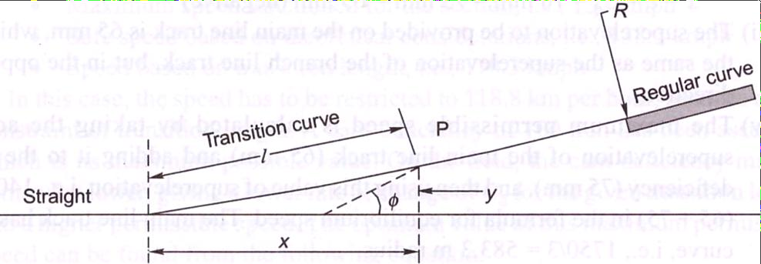

- To provide a gradual increase of the superelevation starting from zero at the straight line to the desired superelevation at the circular curve.
- To ensure a gradual increase or decrease of centrifugal forces so as to enable the vehicles to negotiate a curve smoothly.

Requirements of an Ideal Transition Curve
The transition curve should satisfy the following conditions.
- It should be tangential to the straight line of the track, i.e., it should start from the straight part of the track with a zero curvature.
- It should join the circular curve tangentially, i.e., it should finally have the same curvature as that of the circular curve.
- Its curvature should increase at the same rate as the superelevation.
- The length of the transition curve should be adequate to attain the final superelevation, which increases gradually at a specified rate.

Types of Transition Curves
The types of transition curves that can be theoretically provided are described here. The shapes of these curves are illustrated in Fig. below.

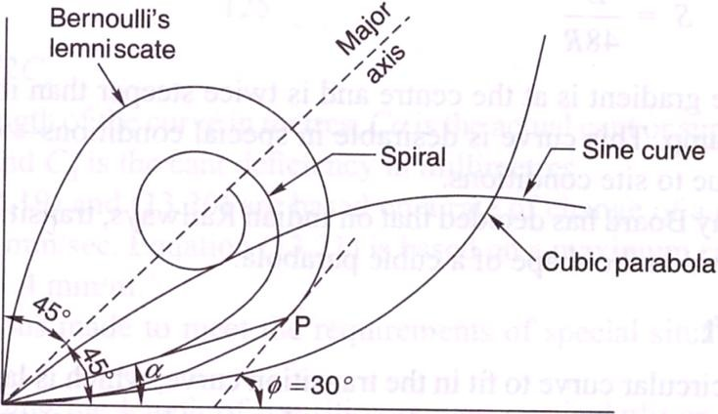

Euler's spiral This is an ideal transition curve, but is not preferred due to mathematical complications. The equation for Euler's spiral is:

𝜙 =
𝑙2
2𝑅𝐿

Cubical spiral This is also a good transition curve, but quite difficult to set on the field.
𝑙2

𝑦 =
6𝑅𝐿

Bernoulli's lemniscate In this curve, the radius decreases as the length increases and this causes the radial acceleration to keep on falling. The fall is, however, not uniform beyond a 30° deflection angle. This curve is not used on railways.

Cubic parabola Indian Railways mostly uses the cubic parabola for transition curves. The
equation of the cubic parabola is: 𝑦 = 𝑥 3
6𝑅𝐿
In this curve, both the curvature and the cant increase at a linear rate. The can: of the transition curve from the straight to the curved track is so arranged that the inner rail continues to be at the same level while the outer rail is raised in the linear form throughout the length of the curve. A straight line ramp is provided for such transition curves.
The notations used in above Eqs are as follows: 𝜙 is the angle between the straight line track and
the tangent to the transition curve, l is the distance of any point on the transition curve from the take-off point, L is the length of the transition curve, x is the horizontal coordinate on the transition curve, y is the vertical coordinate on the transition curve, and R is the radius of the circular curve.

S-shaped transition curve In an S-shaped transition curve, the curvature and superelevation assume the shape of two quadratic parabolas. Instead of a straight line ramp, an S-type parabola ramp is provided with this transition curve. The special feature of this curve is that the shift required ('shift' is explained in the following section) in this case is only half of the normal shift provided for a straight line ramp. The value of shift is:
S = L²/48R
Further, the gradient is at the centre and is twice steeper than in the case of a straight line ramp. This curve is desirable in special conditions—when the shift is restricted due to site conditions.
The Railway Board has decided that on Indian Railways, transition curves will normally be laid in the shape of a cubic parabola.

LENGTH OF TRANSITION CURVE
The length of the transition curve is length along the centre line of the track from its meeting point with the straight to that of the circular curve. This length is inserted at the junction half in the straight and half in the curve. Let, L = Length of transition curve in metres e = Actual cant or superelevation in cm. D = Cant deficiency for maximum speed in cm and V = Maximum speed in kmph.
Indian Railways specify that greatest of the following lengths should be taken as the length of the transition curve.
L = 7.20 e
where e = actual superelevation in centimetres. This is based on Arbitrary gradient (1 in 720)
L = 0.073 D x V_{max}
The length of the transition curve prescribed on Indian Railways is the maximum of the following three values:
L = 0.008C_{a} x V_{m}= C_{a} x V_{m} /125 L =0. 008C_{d} x V_{m}= C_{d} x V_{m} /125 L =0.72C_{a}
Where L is the length of the curve in metres, C_{a}is the actual cant or superelevation in millimetres, and C_{d} is the cant deficiency in millimetres. Above first two equations are based on a rate of change of a cant or cant deficiency of 35 mm/sec. Third equation is based on a maximum cant gradient of 1 in a 720 or 1.4 mm/m.
.
Example: A curve of 600 m radius on a BG section has a limited transition of 40 m length. Calculate the maximum permissible speed and superelevation for the same. The maximum sectional speed (MSS) is 100 kmph.

VERTICAL CURVES

Vertical Curves. They are of two types :
(i) Summit curves. (ii) Sag or Valley curves.
Whenever, there is a change in the gradient of the track, an angle is formed at the junction of the gradients. This vertical kink at the junction is smoothened by the use of curve, so that bad lurching is not experienced. The effects of change of gradient cause variation in the draw bar pull of the locomotive.
When a train climbs a certain upgrade at a uniform speed and passes over the summit of the curve, an acceleration begins to act upon it and makes the trains to move faster and increases the draw bar pull behind each vehicle, causing a variation in the tension in the couplings.

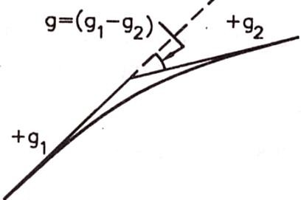
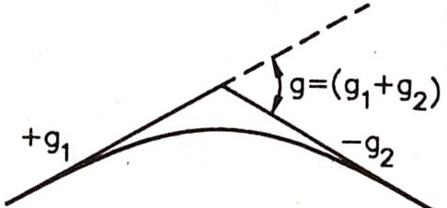
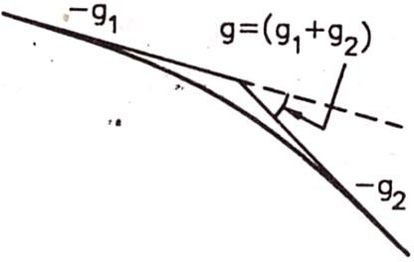
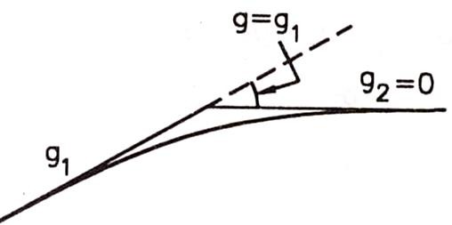
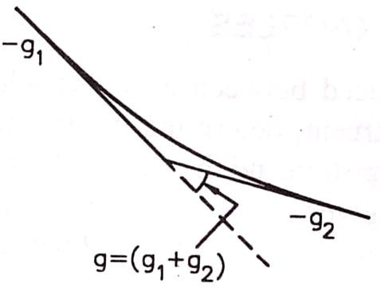
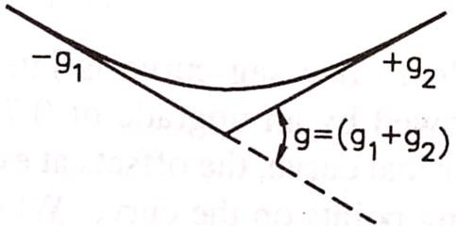

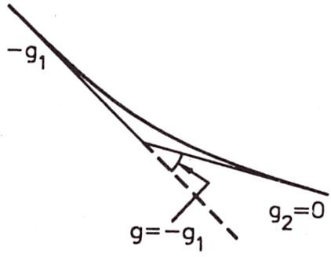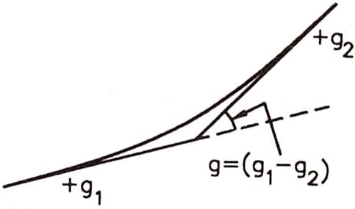

When a train passes over a sag, the front of the train ascends an up-grade while rear vehicles tend to compress the couplings and buffers, and when the whole train has passed the sag, the couplings are again in tension causing a jerk. Due to above reasons, it is essential to introduce a vertical curve at each sag and at each summit or apex.
A parabolic curve is set out, tangent to the two intersecting grades, with its apex at a level halfway between the points of intersection of the grade line and the average elevation of the two tangent points. The length of the vertical curve depends upon the algebraic difference in grade as shown in figure above and determined by the rate of change gradient of the line.

POINT AND CROSSING-I
Points and crossings are provided facilitates the change of railway vehicles from one track to another. The tracks may be parallel, diverging, or converging to each other. Points and crossings are necessary due to the inside flanges of wheels of railway vehicles and, therefore require special arrangement to navigate their way on the rails. The points or switches aid in diverting the vehicles and the crossings provide gaps in the rails so as to help the flanged wheels to roll over them. A complete set of points and crossings, along with lead rails, is called a turnout.

IMPORTANT TERMS
The following terms are often used in the design of points and crossings.
Turnout It is an arrangement of points and crossings with lead rails by means of which the rolling stock may be diverted from one track to another. Figure (a) shows the various constituents of a turnout. The details of these constituents are given in Table below.
Table: Parts of a turnout

Name of the main assembly | Various constituents of the assembly
Set of switches | A pair of stock rails, a pair of tongue rails, a pair of heel blocks,  several slide chairs, two or more stretcher bars, and a gauge tie plate
Crossing | A nose consisting of a point rail and splice rails, two wing rails, and  two check rails
Lead rails | Four sets of lead rails

Direction of a turnout A turnout is designated as a right-hand or a left-hand turnout depending on whether it diverts the traffic to the right or to the left. In Fig. (a), the turnout is a right-hand turnout because it diverts the traffic towards the right side. Figure (b) shows a left-hand turnout. The direction of a point (or turnout) is known as the facing direction if a vehicle approaching the turnout or a point has to first face the thin end of the switch. The direction is trailing direction if the vehicle has to negotiate a switch in the trailing direction, that is, the vehicle first negotiates the crossing and then finally traverses on the switch from its thick end to its thin end. Therefore, when standing at the toe of a switch, if one looks in the direction of the crossing, it is called the facing direction and the opposite direction is called the trailing direction.
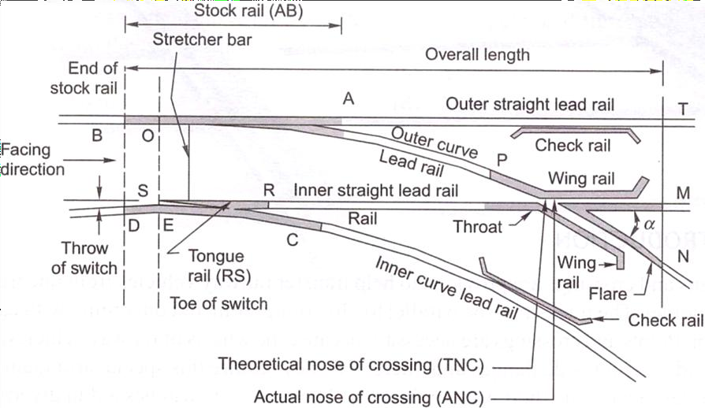
Fig. (a) Constituents of a turnout
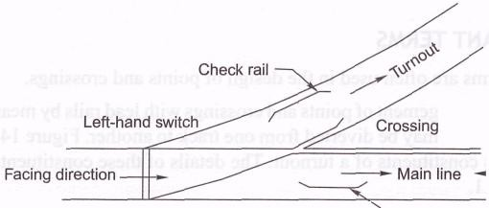

Fig. (b) Left-hand turnout

Tongue rail It is a tapered movable rail, made of high-carbon or -manganese steel to withstand wear. At its thicker end, it is attached to a running rail. A tongue rail is also called a switch rail.
Stock rail It is the running rail against which a tongue rail operates.
Points or switch A pair of tongue and stock rails with the necessary connections and fittings forms a switch.
Crossing It is a device introduced at the junction where two rails cross each other to permit the wheel flange of a railway vehicle to pass from one track to another.

SWITCHES
A set of points or switches consists of the following main constituents (Fig. below).

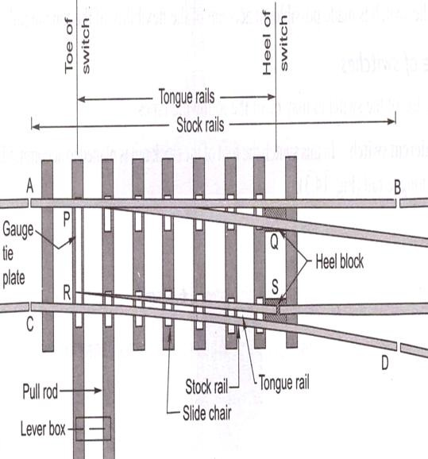
Fig. Details of a switch

- A pair of stock rails, AB and CD, made of medium-manganese steel.
- A pair of tongue rails, PQ and RS, also known as switch rails, made of medium-manganese steel to withstand wear. The tongue rails are machined to a very thin section to obtain a snug fit with the stock rail. The tapered end of the tongue rail is called the toe and the thicker end is called the heel.
- A pair of heel blocks which hold the heel of the tongue rails is held at the standard clearance or distance from the stock rails.
- A number of slide chairs to support the tongue rail and enable its movement towards or away from the stock rail.
- Two or more stretcher bars connecting both the tongue rails close to the toe, for the purpose of holding them at a fixed distance from each other.
- A gauge tie plate to fix gauges and ensure correct gauge at the points.

Types of Switches
Switches are of two types, namely stud switch and split switch. In a stud type of switch, no separate tongue rail is provided and some portion of the track is moved from one side to the other side. Stud switches are no more in use on Indian Railways. They have been replaced by split switches. These consist of a pair of stock rails and a pair of tongue rails. Split switches may also be of two types—loose heel type and fixed heel type. These are discussed below.

Loose heel type Fixed heel type

The toe of the switches may be of the following types.
Undercut switch In this switch the foot of the stock rail is planned to accommodate the tongue rail (Fig. below).
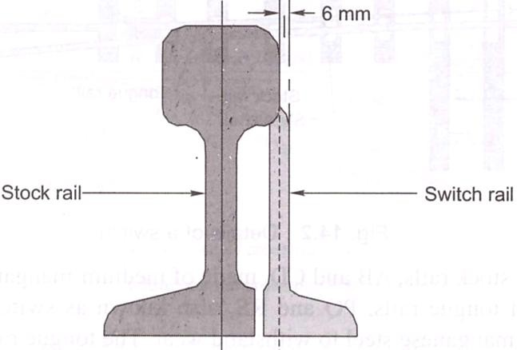
Fig. Undercut switch

Overriding switch In this case, the stock rail occupies the full section and the tongue rail is planed to a 6 mm (0.25")-thick edge, which overrides the foot of the stock rail (Fig. below).
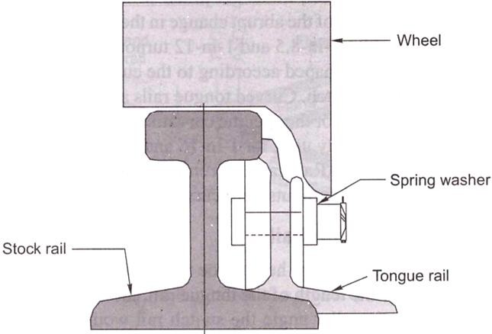

Fig. Overriding switch

POINT AND CROSSING-II

A tongue rail may be either straight or curved. Straight tongue rails have the advantage that they are easily manufactured and can be used for right-hand as well as left-hand turnouts. However, trains get jolted while negotiating with tongue rail turnouts because of the abrupt change in the alignment. Straight rails are normally used for l-in-8.5 and l-in-12 turnouts on Indian Railways.
Curved tongue rails are shaped according to the curvature of the turnout ft the toe to the heel of the switch. Curved tongue rails allow for smooth trains, but can only be used for the specific curvature for which they are Curved switches are normally used for 1-in-16 and 1-in-20 IRS (Indian Standard) turnouts on Indian Railways. Recently Indian Railways has also laying 1-in-
8.5 and 1-in-12 turnouts with curved switches on important li

Length of Tongue Rails
The length of a tongue rail from heel to toe varies with the gauge and the switch. The longer the length of the tongue rail, the smoother the entry to the switch because of the smaller angle the switch rail would make with the fixed heel divergence. The longer length of the tongue rail, however, occupies too much layout space in station yards where a number of turnouts have to be laid in space. The length of the tongue rail should be more than the rigid wheel a four-wheeled wagon to preclude the possibility of derailment in case the move from their position when a train is running on the switch. Table below the standard lengths of switches (tongue rails) for BG and MG tracks.

Table: Length of tongue rail

Gauge and type | Length of tongue rail (mm)
 | 1-in-8.5 straight | 1-in-12 straight | 1-in-12 curved | 1-in-16 Curved
BG (90 R) | 4725 | 6400 | 7730 | 9750 | 1.1150
MG (75 R) | 4116* | 5485* | 6700
* These dimensions hold good for NG tracks also.

CROSSING
A crossing or frog is a device introduced at the point where two gauge faces across each other to permit the flanges of a railway vehicle to pass from one tract to another (Fig. below). To achieve this objective, a gap is provided from the throw to the nose of the crossing, over which the flanged wheel glides or jumps. In order to ensure that this flanged wheel negotiates the gap properly and does not strike the nose, the other wheel is guided with the help of check rails. A crossing consists of the following components, shown in Fig. below.

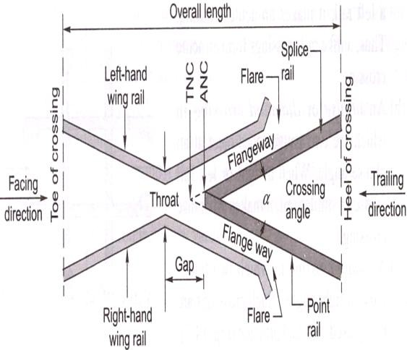
Fig. Details of a crossing
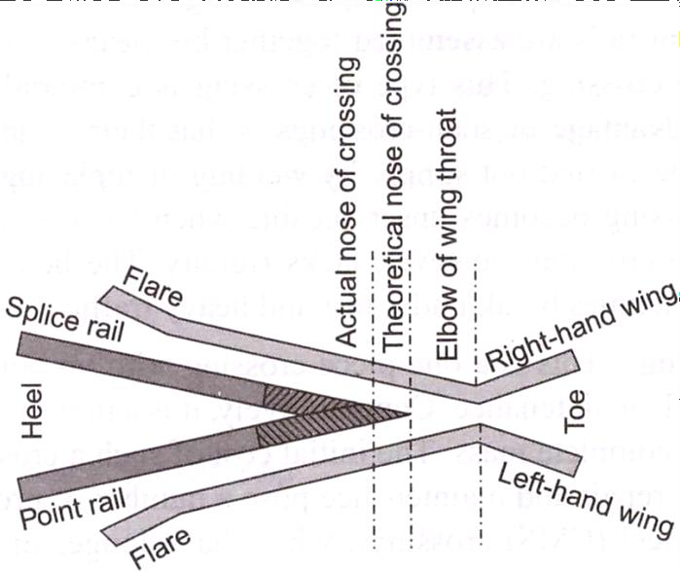

Fig. Point rail and splice rail
- Two rails, point rail and splice rail, which are machined to form a nose. Tic point rail ends at the nose, whereas the splice rail joins it a little behind the nose. Theoretically, the point rail
should end in a point and be made as thin as possible, but such a knife edge of the point rail would break off under the movement of traffic. The point rail, therefore, has its fine end slightly cut off form a blunt nose, with a thickness of 6 mm (1/4"). The toe of the blunt nose is called the actual nose of crossing (ANC) and the theoretical point where the gauge faces from both sides intersect is called the theoretical nose of crossing (TNC). The 'V rail is planed to a depth of 6 mm (1/4") at the nose and runs out in 89 mm to stop a wheel running in the facing direction from hitting the nose.
- Two wing rails consisting of a right-hand and a left-hand wing rail that converge to form a throat and diverge again on either side of the nose. Wing rails are flared at the ends to facilitate the entry and exit of the flanged wheel in the gap.
- A pair of check rails to guide the wheel flanges and provide a path for them, thereby preventing them from moving sideways, which would otherwise may result in the wheel hitting the nose of the crossing as it moves in the facing direction.

Types of Crossings
A crossing may be of the following types.
- An acute angle crossing or 'V crossing

An obtuse or diamond crossing.
- A square crossing (Fig. below).
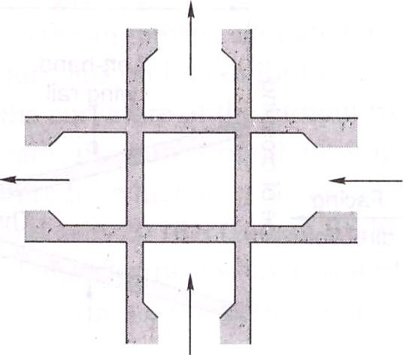

Fig. Square crossing also be classified as follows.

For manufacturing purposes, crossings can also be classified as follows.
  - Built-up crossing
  - Cast steel crossing
  - Combined rail and cast crossing

NUMBER AND ANGLE OF CROSSING
A crossing is designated either by the angle the gauge faces make with each other or, more commonly, by the number of the crossing, represented by N. There are three methods of measuring the number of a crossing, and the value of N also depends upon the method adopted. All these methods are illustrated below.

Centre line method
This method is used in Britain and the US. In this method, N is measured along the centre line of the crossing.
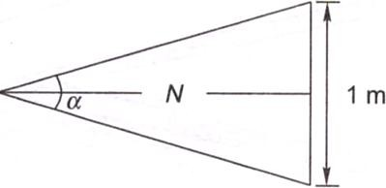

Right angle method
This method is used on Indian Railways. In this method, N is measured along the base of a right- angled triangle. This method is also called Coles method.
Cot α/2 – N = N /1/2 or N = 1/2 Cot α/2
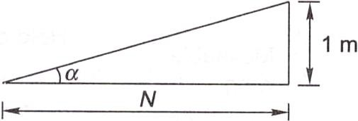

Cot α = N /1 or N = Cot α
Isosceles triangle method
In this method, N is taken as one of the equal sides of an isosceles triangle.

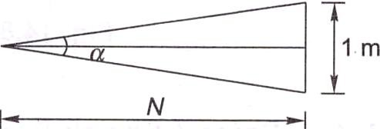
Sin α/2 = ½ /N or N = 1/2N Cosec α/2 = 2N
N = ½ Cosec α/2
The right angle method used on Indian Railways, in which TV is the cotangent of the angle formed by two gauge faces, gives the smallest angle for the same value of N.
To determine the number of a crossing-on site, the point where the offset gauge face of the turnout track is 1 m is marked. The distance of this point (in metres) from the theoretical nose of crossing gives N.

TURNOUTS
The simplest arrangement of points and crossing can be found on a turnout taking off from a straight track. There are two standard methods prevalent for designing a turnout. These are the
- Coles method and (b) IRS method.
These methods are described in detail in the following sections.
The important terms used in describing the design of turnouts are defined as follows:
Curve lead (CL) This is the distance from the tangent point (T) to the theoretical nose of crossing (TNC) measured along the length of .the main track.
Switch lead (SL) This is the distance from the tangent point (T) to the heel of the switch (TL) measured along the length of the main track.
Lead of crossing (L) This is the distance measured along the length of the main track as follows: Lead of crossing (L) = curve lead (CL) - switch lead (SL)
Gauge (G) This is the gauge of the track.
Heel divergence (d) This is the distance between the main line and the turnout side at the heel. Angle of crossing (a) This is the angle between the main line and the tangent of the turnout line. Radius of turnout (R) This is the radius of the turnout. It may be clarified that the radius of the turnout is equal to the radius of the centre line of the turnout (/?,) plus half the gauge width.
R = R}+ 0.5,G
As the radius of a curve is quite large, for practical purposes, R may be taken to be equal to .ft,.

Special fittings with turnouts
Some of the special fittings required for use with turnouts are enumerated as follows:
Distance blocks Special types of distance blocks with fishing fit surfaces are provided at the nose of the crossing to prevent any vertical movement between the wing rail and the nose of the crossing.
Flat bearing plates As turnouts do not have any cant, flat bearing plates are provided under the sleepers
Spherical washers These are special types of washers and consist of two pieces with a spherical point of contact between them. This permits the two surfaces to lie at any angle to each other.
These washers are used for connecting two surfaces that are not parallel to one another. Normally, tapered washers are necessary for connecting such surfaces. Spherical washers can adjust to the uneven bearings of the head or nut of a bolt and so are used on all bolts in the heel and the distance blocks behind the heel on the left-hand side of the track.
Slide chairs These are provided under tongue rails to allow them to move laterally. These are different for ordinary switches and overriding switches.
Grade off chairs These are special chairs provided behind the heel of the switches to give a suitable ramp to the tongue rail, which is raised by 6 mm at the heel.
Gauge tie plates These are provided over the sleepers directly under the toe of the switches, and under the nose of the crossing to ensure proper gauge at these locations.
Stretcher bars These are provided to maintain the two tongue rails at an exact distance.

Coles method
This is a method used for designing a turnout taking off from a straight track (Fig. 14.11). The curvature begins from a point on the straight main track ahead of the toe of the switch at the theoretical toe of switch (TTS) and ends at the theoretical nose of crossing (TNC). The heel of the switch is located at the point where the offset of the curve is equal to the heel divergence. Theoretically, there would be no kinks in this layout, had the tongue rail been curved as also the wing rail up to the TNC. Since tongue rails and wing rails are not curved generally, there are the following three kinks in this layout.
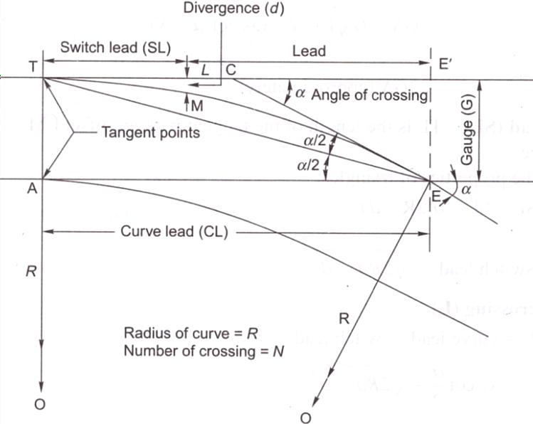

Standard turnouts and permissible speeds
On Indian Railways, normally 1-in-8.5 turnouts are used for goods trains while 1-in-12 and 1-in- 16 turnouts are used for passenger trains. Recently 1-in-20 and 1 -in-24 turnouts have also been designed by the RDSO, to be used to permit higher speeds for fast trains on the turnout side. The maximum speeds permitted on these turnouts are given in Table below.
Table: Permissible speeds on turnouts

Gauge | Type of  turnout | Switch angle | Permissible speed (kmph)
BG | 1 in 8.5 | 1°34'27" | 10* for straight switch and 15 for curved switch for 52/60 kg  rails on PSC sleepers
BG^{f} | l-in-8.5 | Symmetrical split  (SS) 0°27'35" | 30 for curved switch as well as SS with 52/60 kg on PSC  sleepers; 15* for curved switch for 52/60 kg on PSC sleepers*
BG | l-in-16 | 1°8'0" 0°24'27" | 50 or 60¹
MG | l-in-8.5 | 1°35'30" 0°29'14" | 10 for straight as well as curved switch
MG^{f} | l-in-12 | 1°09'38" 0°24'27" | 1 5 for straight switch and 1 5 for partly curved switch
MG | l-in-16 | 0°24'27" | 30

DESIGN OF TURNOUTS

A turnout, after branching off from the main track, may run into various directions of which running parallel to the original track is most common. The design calculation of various turnout are based on following three factors:
  - Method of calculating various leads
  - Method employed for crossing angle (iii)Type of tongue rail used

Notation used in design calculation
Following notation have been used in various methods for design of turnouts: CL = Curve lead
= Distance between theoretical nose of the crossing (T.N.C.) and the tangent point ―T‖ measured along the length of main track.
SL = Switch lead
= Distance between tangent point ―T‖ and the heel of the switch (H.S.) measured along the length of the track
L = Lead or crossing lead
= Distance between T.N.C. and the heel of the switch (H.S.) measured along the length of the track
Lead rails, being curved rails, are not measured along their curve length, long their projected length along the straight rail.
Therefore, CL, SL and L, it is clear that
CL = SL + L or L = CL - SL
β = Angle of the switch, i.e. the angle between the gauge faces of switch rail and stock rail α = Angle of the crossing
d = Heel divergence or clearance R₀ = Radius of the outer turnout
R = Radius of centre line of the turnout G = Gauge of the track
N = Number of the crossing
D = Distance between T.N.C. and tangent point of crossing curve

Different method of the turnout design Three methods are used for design of turnouts Method-I
The important steps of this method are
- All three leads, CL, SL, and L are calculated. The CL and SL are particularly calculated in this method.
- Crossing angle (α) calculated using right angle method
- Crossing curve is considered to start from an imaginary tangent point ahead of actual toe of the switch and end at T.N.C. This arrangement results formation of three kinks,
  - Kinks at the toe of the switch. Due to straight tongue rail.
  - Kink at heel of the switch. Due to non tangential of tongue rail to the curve.
  - Kinks at toe of the crossing. Because the curve is carried theoretically upto T.N.C. but crossing actually is straight.
This design method all three kinds of kinks and was common in the past. But now a days used in unimportant lines and sidings.

Design calculation of method I
Value of gauge (G), Heel divergence (d) and Angle of the crossing (α) are given
Curve lead (CL) CL= 2GN

R-Radius
Hence R = R₀ – G/2 R₀ = 1.5G + 2GN²
SL = (2 R₀d)^{1/2} AS d² is very small Comair to 2R₀d

Lead or crossing lead (L)
L = CL – SL
= G cot α/2 – (2 R₀d)^{1/2} = (2 R₀G)^{1/2}– (2 R₀d)^{1/2}
= 2GN - (2 R₀d)^{1/2}

Heel Divergence (d)
From equation SL = (2 R₀d)^{1/2} d = (SL)² / 2 R₀

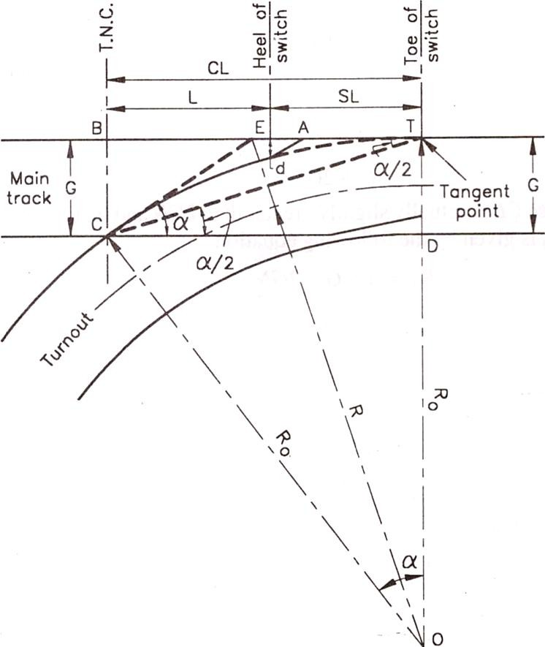

Method II
The important features of this method are
- Only the cross lead ―L‖ is calculated
- The curve is tangential to the tongue rail. It springs up from heel of switch and ends at T.N.C.
- Out of three kinks, kinks formed at heel of the switch is removed
This method was common in UK in past

With given value of gauge (G), d, β (angle of switch) and α, the turnout is designed:

Lead or crossing lead (L):
L = (G - d)/ tan (α + β)/2 = (G - d) cot (α + β)/2

R-Radius:
R₀ = (G – d) / 2 sin (α + β)/2 sin (α - β)/2 = (G – d) / (cot β - cot α) and R = R₀ – G/2
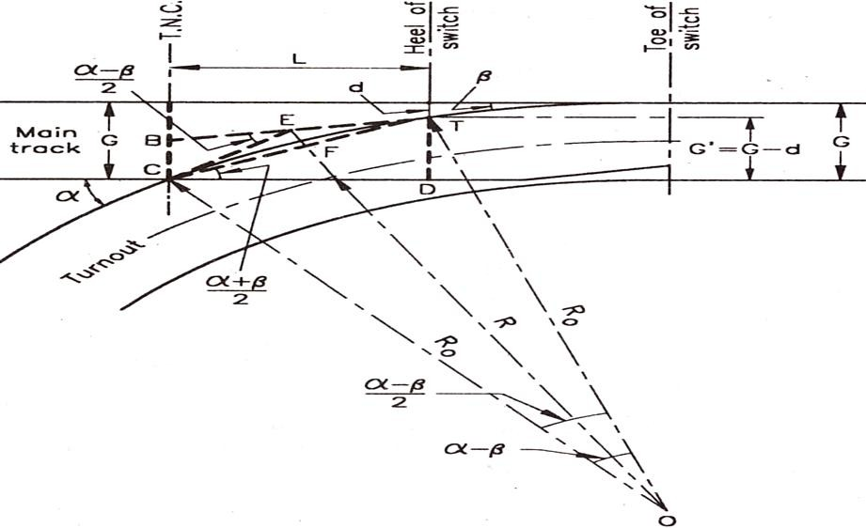

Method III
The important features of this method are
- This method is very similar to method II. But here the straight length at crossing is provided.
- So one end of the curve is tangential to tongue rail and spring up from the toe of the crossing and is tangential to the straight length of the crossing.
- In this method kinks at toe of the switch and kinks at heel of the switch are removed. (iv)It is suitable where tongue rails and crossing are straight. This method permits the
Let the straight length of the arms at crossing be x = T’C

R-Radius:
With given G, D, α, β and x
R₀ = (G – d – x sin α)/( cos β – cosα) R = R₀ – G/2
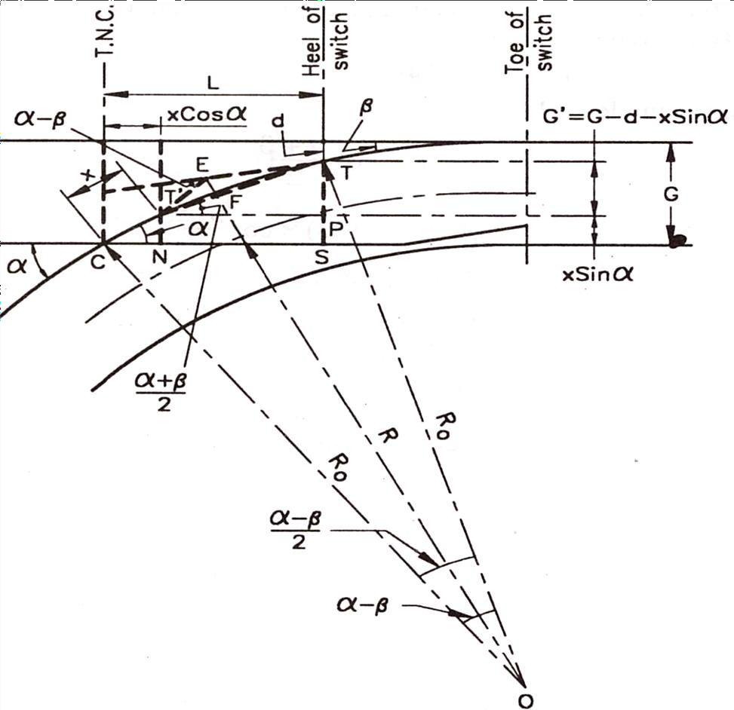

Crossing Lead (L)
L = CN + NS = ON + T’P = x cos α + TP cot (^{𝛼+} ^{𝛽})
2

L = x cos α + G’ cot (^{𝛼+} ^{𝛽}) = x cos α + (G – d – x sin α) cot (^{𝛼+} ^{𝛽})
2 2

d = x sin α - G – ((L– x cos α) / cot (^{𝛼+} ^{𝛽}))
2

To get value of method II put x =0

Bridge engineering
INTRODUCTION
The bridge, a connecting structure, creates bonding between different disconnected parts of a country, two banks of the ocean or parts of two countries. A Bridge is a structural marvel which is generally used to pass any type of obstruction that can slow the life of people. From the very beginning, engineers were trying to win over nature and consequently, they have invented bridge structure which can use to overcome the mentioned natural obstacles.

Main Parts of a Bridge
There are different types of bridge. Different bridge types contain different parts. FOllowings are the main parts of a bridge:

- Deck
- Abutment
- Pile
- Pier
- Girder
- Rail Track

To give a preliminary idea of these bridge parts a brief description of each part is given below.
Deck
A deck is a fundamental part of any bridge to pass vehicle, goods, people etc. from one side to another.
Abutment
The support provided at the two ends of a bridge is known as an abutment.
Pile
For the bridge with pier, the pile is a fundamental component. Pile type foundation is generally needed when the upper soil layer is loose. Pile depth depends on the soil layer. To find the hard soil layer which will make the structure stable, the pile is usually extended to some depth into the hard soil layer.
Pier
Pier is the compression member which stay above the pile and make the structure stable. Pier generally provides for span at intermediate points.
Piers perform two main functions:

- Transferring superstructure vertical loads to the foundation.
- Resisting to the horizontal forces acting on the bridges.

For bridge pier to pier, distance is the span. Water pressure is the extra pressure which acts onto the pier laterally.

Girder (Box or I-joist)
Just like the beam, girder is used in the bridge. It can be two types I-joist and Box. This name has been given because of their shape. I-joist girder type is commonly used in bridges. Box girder can be precast or cast in place and it is generally existing in prestressed condition.
Rail Track
Normally Road traffic is the main vehicle onto the bridge but if the train needs to be passed through that bridge rail track is the extra component.

Types of Bridges
Followings are the main types of bridges.

- Truss Bridge
- Arch Bridges
- Suspension Bridges
- Cable-Stayed Bridges
- Slab Bridges
- Box Girder Bridges

A brief description of these bridge types is given below.
Truss Bridges
Bridges with truss are made by steel two force member with only tension and compression. No bending moment is allowed in this structure. Most stable structural shape for truss is triangular.
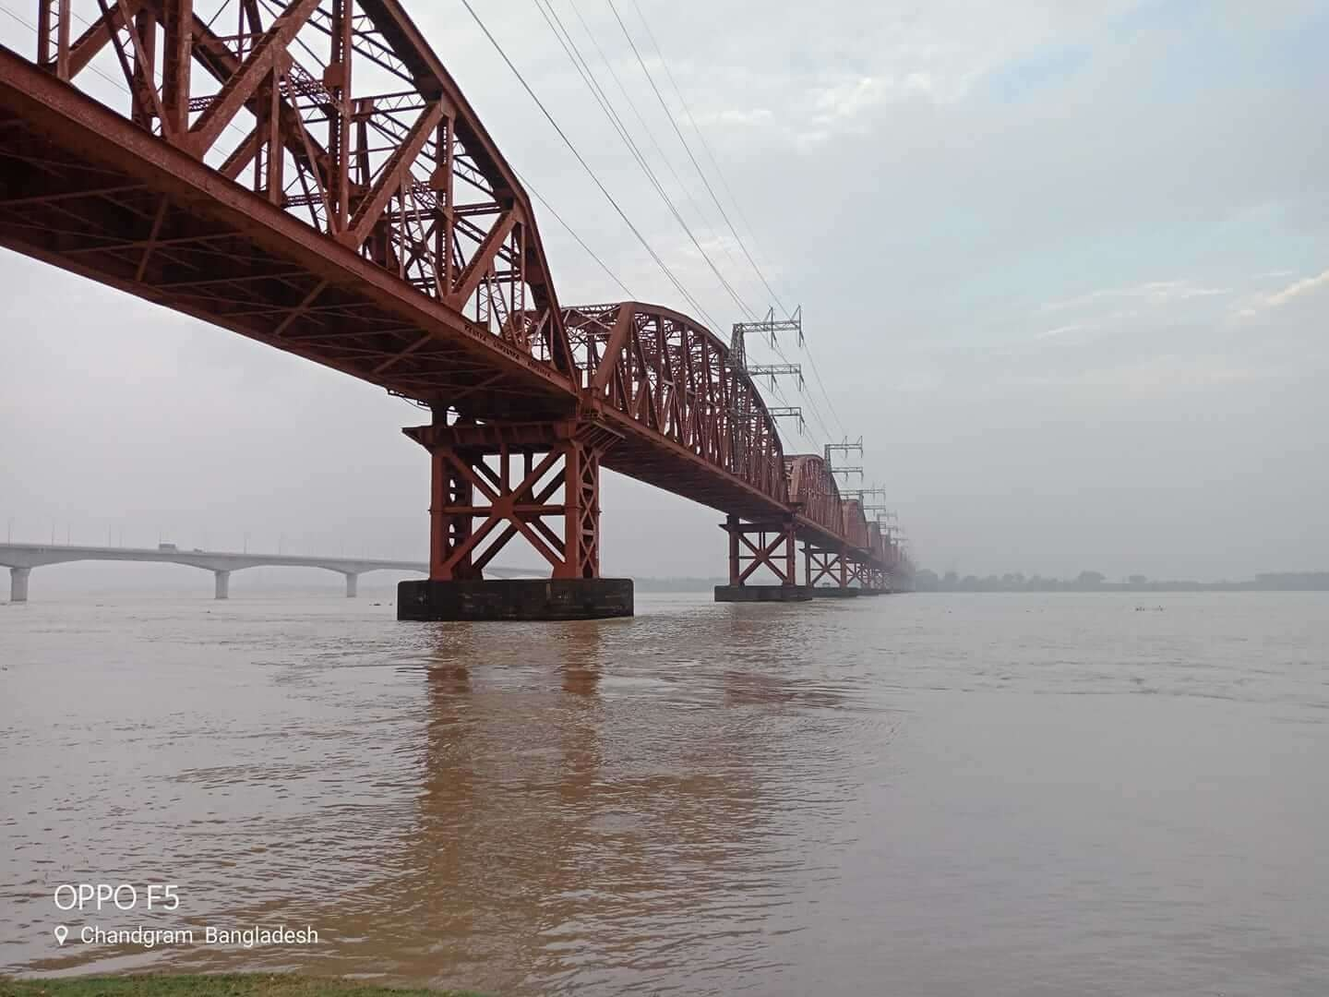
Truss Bridge Bungladesh

Arch Bridges
Arch bridge mainly exists in compression. Utilizes an aerodynamic system with torsional rigidity.

The Sydney Harbour Bridge Australia
Suspension Bridges
In suspension bridges, long spans can be provided which is essential in many situations. It gives freedom to the engineer to provide a long span with the help of a cable. Followings are the Basic components of a suspension bridge Structural system:

- Stiffening Girder/ Trusses: Longitudinal structures support and distribute moving vehicle loads. Secure aerodynamic stability of the structure.
- Main Cables: Main cables are connected to girders through hanger rope. These hanger ropes transfer the loads from girder to the main cables. The main function of these main cables to carry these loads to the main towers.
- Main Towers: Main cables are supported by these intermediate vertical structures and transfer the total load of the bridge to the foundation.


Suspension Bridge at Golden Gate
Cable-Stayed Bridges
It has a lot of similarities to the suspension bridge. But there are few differences between a suspension bridge and cable-stayed bridge. In this case, bridge mainly carries the vertical loads acting on the girder. The purpose of the stay cables is to provide intermediate support for the girder and it helps to span a long distance.

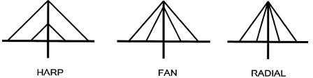
Cable
Arrangements in Cable Bridge


Sunshine Skyway Bridge Tampa Bay Florida
Slab Bridges
It is the most common type of bridge. Use in every place where the span is not so long.
Box Girder Bridges
It's a box type girder different from normal I girder and it can easily resist more amount of torsion. This type of bridge contains top deck, vertical web, bottom slab. Box girder bridge can be subdivided into three basic categories:

- Single cell box.
- Multicell box.
- Box with struts supporting a cantilever deck.

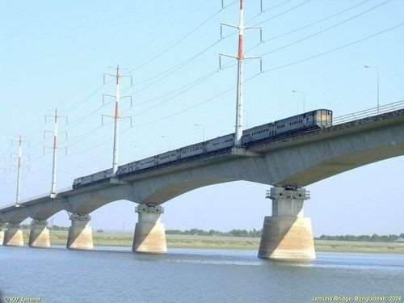
Bangabandhu Jamuna Bridge Bangladesh

Types of Bridges based on Type of Super Structure
- Arch bridge
- Girder bridge
- Truss bridge
- Suspension bridge

Arch Bridge
Arch bridge is curve shaped bridge, in which horizontal thrust is developed and is restrained by the abutments at each end of the bridge. There are many types of arch bridges are there. In some cases, the arch may be under the deck slab also.

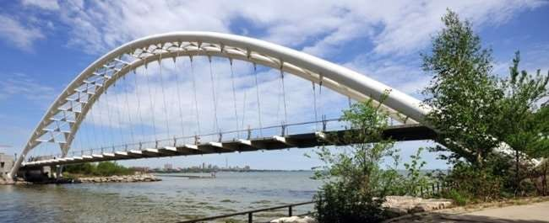

Girder Bridge
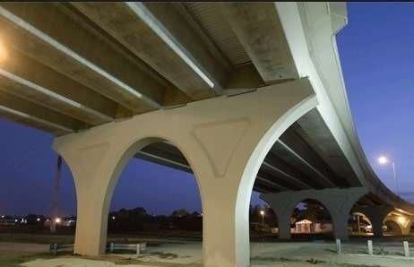
In case of Girder Bridge, the deck slab is supported by means of girders. The girder may be of rolled steel girder or plate girder or box girder. Load coming from the deck are taken by girder and transferred them to the piers and abutments.

Truss Bridge

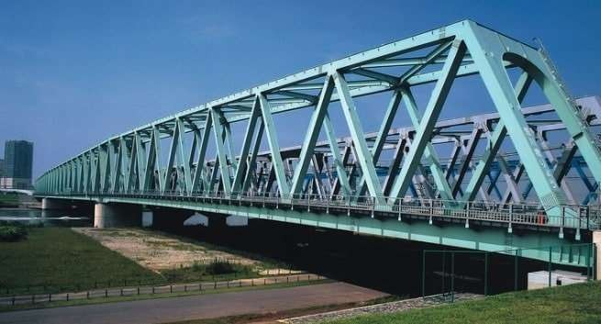
Truss is member consisting connected elements to form triangular units. In case of truss bridge the super structure is provided with trusses. Generally, trusses are made of steel. There are several types of trusses are available.

Suspension Bridge
In case of Suspension bridge, deck slab is suspended with the help of cables and suspenders. These will give good appearance. For long span bridges, this type of suspension is suitable.



Types of Bridges based on Materials
- Timber bridge
- Masonry bridge
- Steel bridge
- R.C.C bridge
- Pre stressed concrete bridge

Timber Bridge
Bridges constructed using timber are called timber bridges. These are generally constructed for short spans or as temporary bridges. They are not useful for heavy loads.

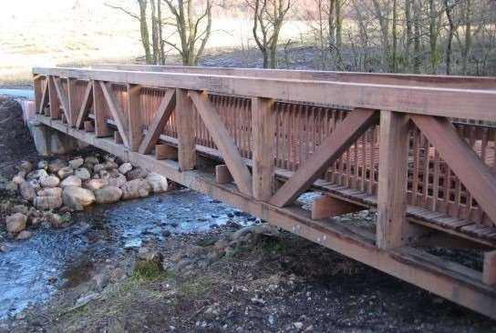

Masonry Bridge
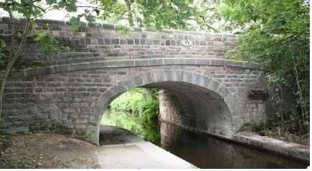
Masonry Bridge constructed by using bricks or stones. These are generally constructed for short spans and in low depth canals.

Steel Bridge
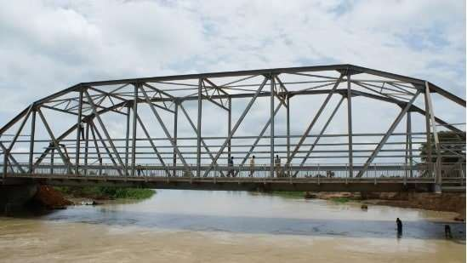
Steel bridges are constructed using steel bars or trusses or steel cables. These are more durable and bear heavy loads.

R.C.C Bridge
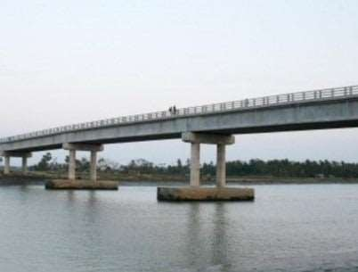
    - bridges are constructed using reinforced cement concrete. These are more stable and durable. They can bear heavy loads and are widely using nowadays.

Prestressed Concrete Bridge
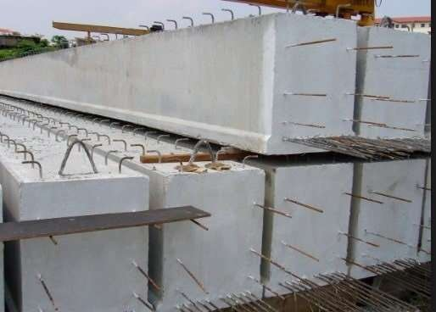
If concrete material is placed under compression before applying the loads, then it is called as prestressed concrete. To construct pre stressed concrete bridge, pre-stressed concrete blocks are arranged as deck slab with the help of girders. These blocks are suitable for shorter span to longer span bridges.

Types of Bridges based on Span
      - Culvert bridge
      - Minor bridge
      - Major bridge
      - Long span bridge

Culvert Bridge
When the bridge span length is below 6meters then it is called as Culvert Bridge.

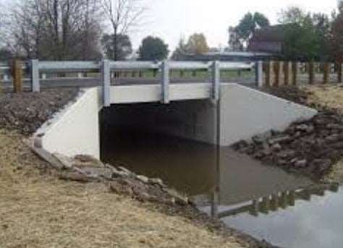

Minor Bridge
If the bridge span length is in between 8 to 30 meters, then it is called minor bridge.
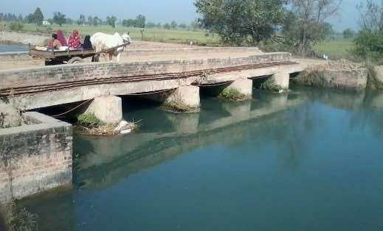

Major Bridge
For major bridge, the span is generally about 30 to 120 meters.
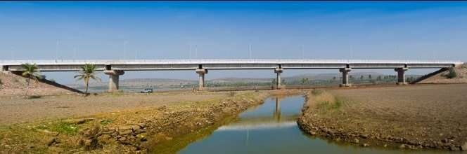

Long Span Bridge
When the span of bridge is more than 120 meters then it is termed as long span bridge.


Types of Bridges based on Level of Crossing
      - Over bridge
      - Under bridge

Over Bridge
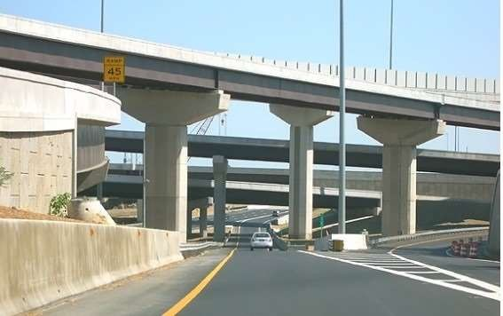
To pass over another route (railway or highway), a bridge is constructed to allow traffic. This is called over bridge or fly over bridge.

Under Bridge
If over bridge is not possible, an underground type bridge is constructed to pass another route. This is called under bridge.

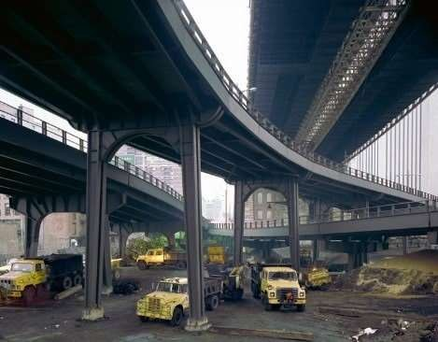

Types of Bridges based on Function
      - Foot bridge
      - Highway bridge
      - Rail way bridge
      - Aqueduct bridge
      - Road cum railway bridge

Foot Bridge
Foot Bridge is generally constructed for humans to cross the roads or rail route or any canal by foot. Vehicles are not allowed in this bridge.

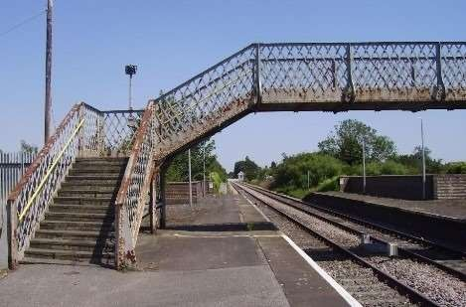

Highway Bridge
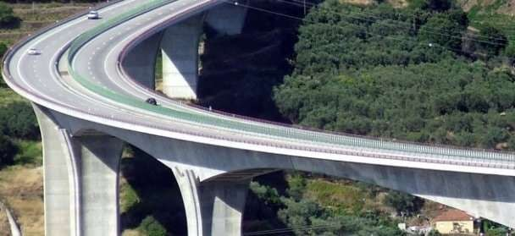
High way or road Way Bridge is used for road transportation. These are constructed over rivers or another routes to allow road way traffic. Girder type bridges are used as highway bridges over rivers or canals.

Railway Bridge
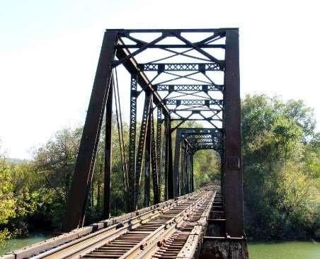
Rail bridges are constructed for rail transportation. Truss type bridges are preferred for railways but how ever r.c.c bridges are also used.

Aqueduct Bridge
Aqueduct bridges are nothing but water carrying bridges which are constructed to0 transport water from source to system.

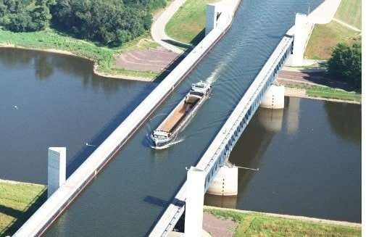

Road cum Railway Bridge
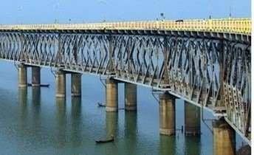
This type of bridge is useful for both road way and railway transport. It may be of one floor or two floors. If one floor is there then, rail and road way are arranged side by side. Otherwise roadway on top deck and railway in bottom deck is preferred.

Types of Bridges based on Inter Span Relation
      - Simple bridge
      - Continuous bridge
      - Cantilever bridge

Simple Bridge
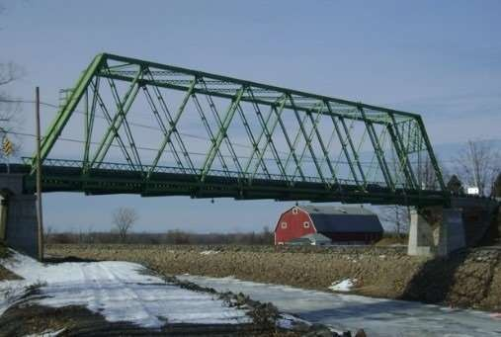
Simple bridge is like simply supported beam type which consist two supports at its ends. For shorter spans, simple bridges are suitable.

Continuous Bridge
If the bridge span is very long, then we have to build more supports in between end supports. This type of bridge is termed as continuous bridge.

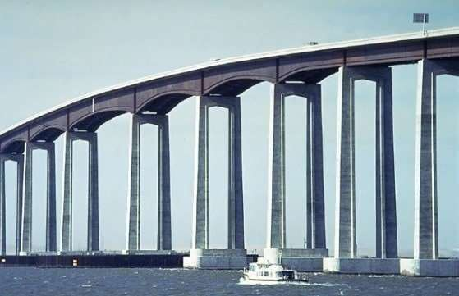

Cantilever Bridge
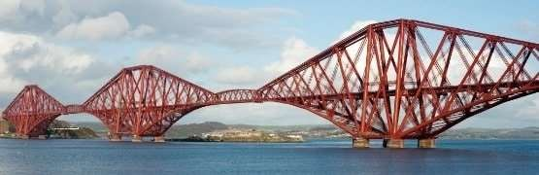
Cantilever type of bridge have only supported at one end and another end is free to space. Generally, two cantilever portions are joined to make way to the vehicles or humans.

Types of Bridges based on Utility
      - Temporary bridge
      - Permanent bridge

Temporary Bridge
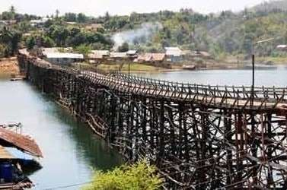
During construction of dams or bridges or during floods, temporary bridges are constructed at low cost for temporary usage. These bridges are maintained at low cost. After construction of original structure temporary bridges are dismantled. Generally timber is used to construct temporary bridges.

Permanent Bridge
These bridges are constructed for long term use and maintained at high level. Steel or R.C.C bridges are come under this category.

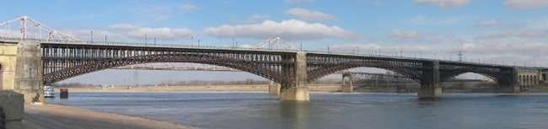

Types of Bridges based on Position of Floor
      - Deck bridge
      - Through bridge
      - Semi-through bridge

Deck Bridge

In case of Deck Bridge, super structure or floor of bridge is positioned in between the high flood level and formation level.

Through Bridge
In case of through bridge, Super structure of bridge is completely above the formation level.

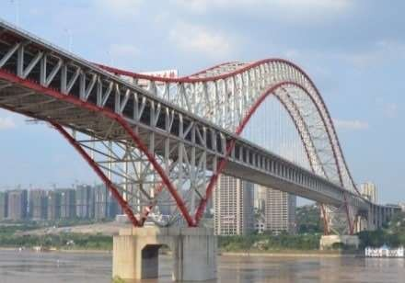

Semi-Through Bridge
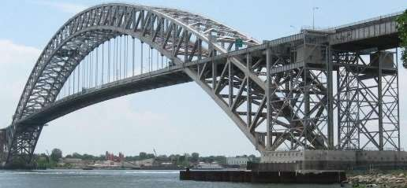
If the super structure of bridge is partly above and partly below the formation level, then it is called as semi-through bridge.

Types of Bridges based on High Flood Level (HFL)
      - Low level bridge
      - High level bridge

Low Level Bridge
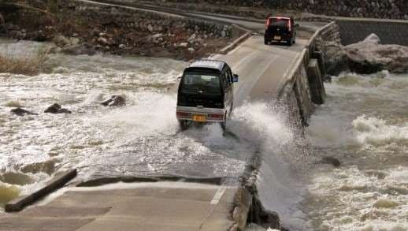
The super structure of bridge is generally below high flood level. So, whenever floods occurred these are submersed in water. So, these are also called as submersible bridges. These are generally constructed for unimportant routes with low cost.

High Level Bridge
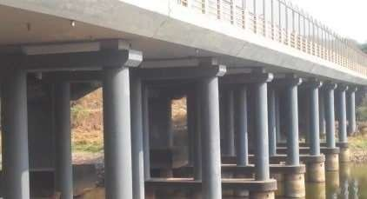
High level bridge is non submersible against floods. It is well above the high flood level and constructed in important routes.

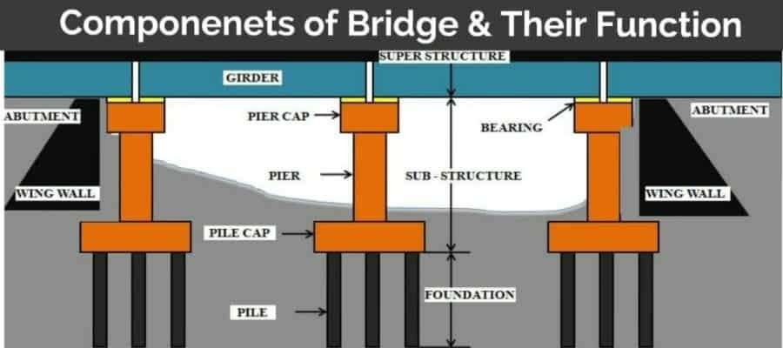

Importance of bridges:
- Road or railway traffic can run uninterrupted in monsoon
- Saving in time and fuel.
- It improves the aesthetic of a road.
- Distance between two places can be reduced.
- Agriculture products, industrial products, and raw materials can reach the industries quickly which helps in the economic development of the area.
- Construction of a bridge on railway alignment at level crossing reduces the number of accidents.
- Bridges are important from a military point of view.

Bridge Components and Their Function:
The main components of a bridge are

- Substructure
- Superstructure
- Adjoining structure

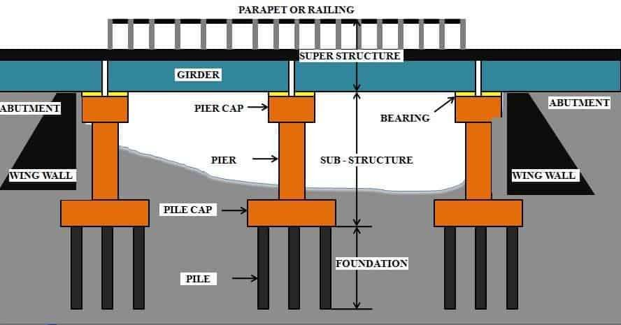

  - Substructure:

The components of the bridge below the level of bearings is known as Substructure. It consists of the following.

The function of the substructure is to support the superstructure components and transmit their loads safely to the subsoil,

  - Abutments:

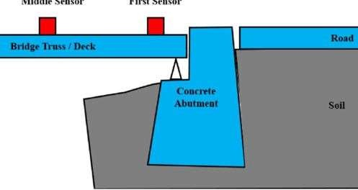
It is a structure mostly used for bridge and dam as substructure at the ends of a bridge s pan or d am and on that superstructure is rest. Bridge with a single span has two abutments that offer vertical and lateral support. It also plays the role of retaining walls to resist lateral movement of the earthen fill of the bridge approach.

Abutment of Bridge

The abutment can also be defined by the structure supporting one side of an arch, or masonry used to resist the lateral forces.

  - Piers:

Piers provide intermediate support between two bridge spans. Bridge piers mainly support the bridge superstructure element and transfer the load to the foundation.

Pier must be strong to handle the horizontal as well as lateral. Piers are known as compression members of the bridge.

  - Wing walls:

It is one of the earth retaining structures in the bridge. They are located adjacent to the abutments and act as retaining walls. Wing wall retains soil for abutment, roadway and approach embankment, which can be at a right angle to the abutment or splayed at different angles.
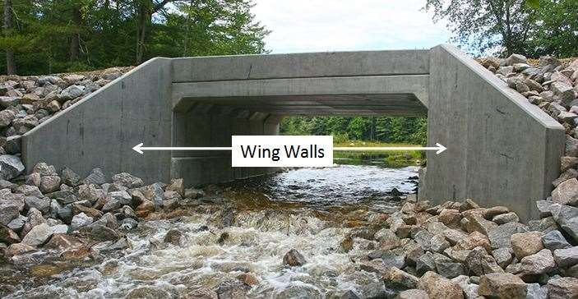
Wing Walls

(2) Superstructure: ( Bridge Components )
The components of the bridge above the bearing are known as superstructure. It consists of the following.
- Beams, girders:

Both have a similar function to support the roadway and prevent bending. Girder is also one type of beam support. Where loads are heave girders are used instead of beam support.

Beam has a rectangle cross-section, whereas girders have composed of I-shaped cross-sections with two load-bearing flanges and web for stabilization.

- Bearing:

A bearing is provided between bridge girder and pier cap. The main function of bearing to allow free movement or vibration of the top superstructure and reduce effect stress to reach the bridge foundation.
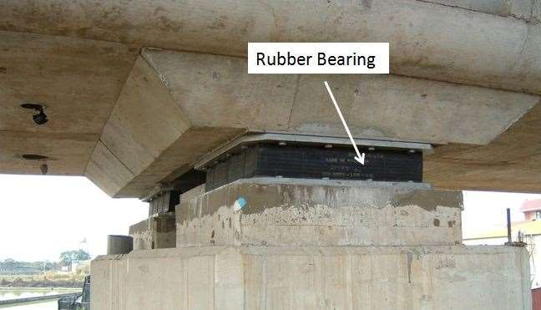
Bearing in Bridge
- Arch, Cables:

Arched and Cable both have specified used. Arched are used for arch bridge construction and cable are used for suspension, cable-stayed bridge, etc. For different types of bridge construction arches and cable play a vital role.

- Parapet wall, handrail:

The parapet is one of safety component of any bridge which prevent the vehicle from falling off where there is a drop. It is also useful for restricting views, to prevent rubbish from passing below, and to act as noise barriers.

- Flooring:

Its top surface of bridge roadway on vehicle travel. It is made of concrete or bituminous road.

3) Adjoining structures:
It consists of the followings:

- Approaches:

It is a structured constructed at the starting or ending of any bridge. Its main function is to provide smooth and easy entry or exit from bridge.

- Guard stones:

They are used to restrict traffic on the particular lane or sometimes as road railing but are generally positioned to protect a specific object, such as a corner of a street or the side of a gate.
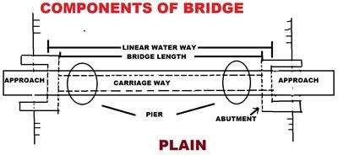

Requirements of bridge
Bridges are required to connect big towns and cities. It provides communication between two cities and provide business aspects. It also helps in the war time for the mobility of the Army. Bridges are required in the road or rail projects. where large numbers of accuracy are required. These projects take longer time for completing and required more accuracy and large number of planning and consideration. The economy of bridges depends upon the material used at the time of construction.

SELECTION OF BRIDGE SITE
The following factors have to be considered in selecting a ideal bridge site.
- Connected with roads:
If you are going to select a site for bridge construction then you should have good roads which are connected with each others. The road should be connected either side of the river or any dam. The bed end of the approaches should be dry and hard.
- Strong embankment on both sides:
The bridges are constructed where the embankment present on the both sides of the river. The embankment should be firm on both the upstream and downstream side of the river. The firm should be strong, solid, permanent, straight and well defined. The embankment should not disturb at the time of the flood.
- Type of foundation:
Good foundations is required to make a bridge. At the bed of the river, the foundation should be good and have reasonable depth for the substructure. The property of soil should be good.
- Requirement of material and labour:
In bridge construction, it is the important point to the requirement of good material and labour near the site. Material and labour should be easily available near the site. Due to this the transportation charges for labour and material goes minimum. So, if you are doing planning for bridge construction, then this point will help you more. Always search for good material and labour near the site.
- Flow of water:
The flow of water should be perpendicular to the center line of the bridge. These types of crossings are also known as the right angle crossing or square crossing. Sometime it is also known as the normal crossing. Following points are kept in mind while measuring the flow of water.
- There should be a smooth flow of water.
- The proper arrangement of segmental wing wall and return wall near the bridge construction. It permits the formation of eddies and cross currents are avoided.
- It also provides the shortest length of the bridge span as well as the length of the pier.
- The skew bridges are difficult to construct as compared to normal bridges.

- The depth of bridge foundation is depends upon the type of design.
- Skew bridges are complicated in design. The maintenance of these types of bridges is also difficult.
- The passage of water under the skew bridges are not smooth. The piers have also resisted excessive water pressure.
- Straight stretch of river:
The river should be a straight stretch at the upstream side and downstream side. It also allows the smooth and uniform flow of water. The curve stretch of river provides an irregular flow of water. So, the river should be a straight stretch at the upstream or downstream of the bridge. It creates many problems during the time of maintenance and construction.
- Flow of river:
The construction of the bridge also depends on the flow of the river. If the velocity of flow is less than the particular value, the silting will occur and more particular value occurs in the river bed. The velocity of flow in the river should be medium according to the particular value. It also depends on the nature of the river bed. So, it is very important to check the river bed first, then start construction on it.
- Width of river:
The width of the river also affects the construction of the bridge. If the width of the river is less, then you can construct economy and cheaper bridge on it. If the width of the river is more than you have to pay more for it.
- Hydrologic parameters:
Study about the low water level, highest flood level , slope of surface of water, flood velocity and discharge of river. Data obtained from local enquiries or from the data available for the nearest gauging site from irrigation or flood control dept.
- Geo-technical and seismic data
Study perform to get the stability of the river, location of faults, their activity and their likely repercussions on a major structure to be put up and particulars of past earthquakes in the site vicinity. Study perform also to get soil classification, grain size and depth at which hard strata is likely to be met with.
- Navigational requirements
Some kind of navigation will exist on almost all major rivers. Study investigate about the size, density and volume of traffic of vessels and boats so that it can be safely cross the river without any nuisance to both the vessels and bridge.

Bridge: Horizontal and Vertical Alignment
Curved Horizontal Alignments
If possible, avoid locating bridges on curved horizontal alignments, since curved structures are more expensive to fabricate and are more difficult to construct than straight structures. If a bridge falls within a curved roadway
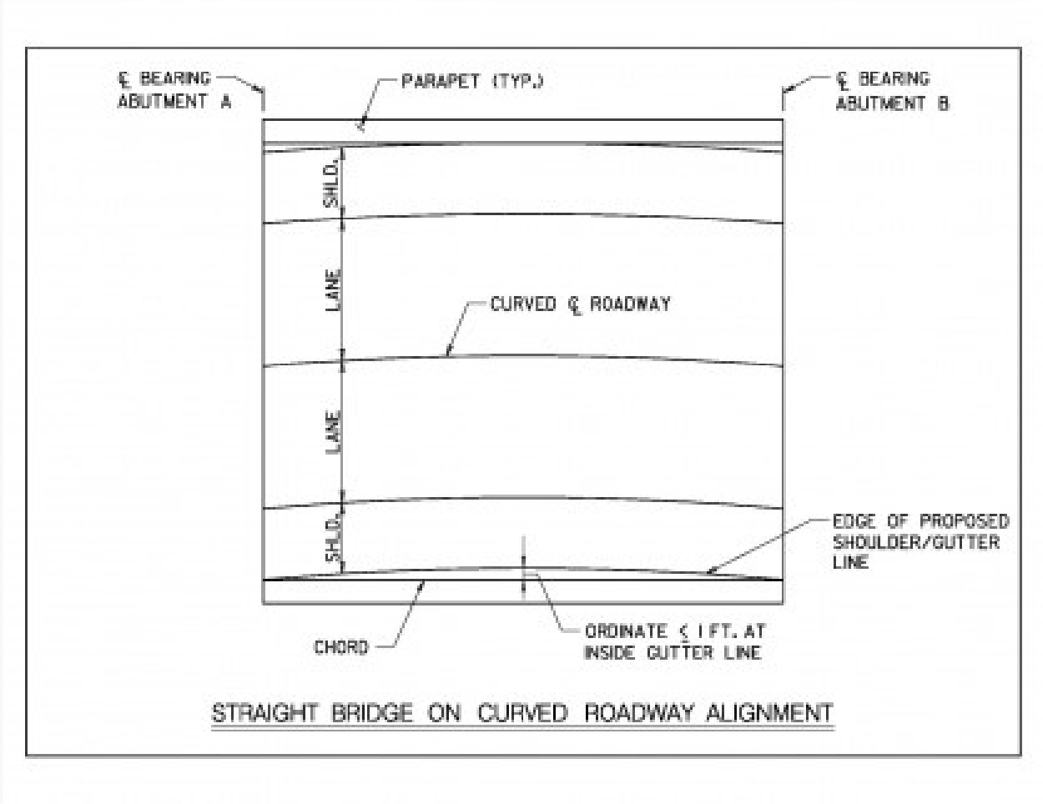
alignment, see if a tangent (straight) section can be introduced into the curve that encompasses the bridge limits. If the curve radius is large enough, consider constructing the bridge with straight girders and deck and variable width shoulders. To determine if this is feasible, determine the ordinate between the inside curve gutter line and the chord created by connecting the gutter line location at the bearing center line at each abutment. If this value is less than 1 ft. 0 inches, the structure should be laid out with straight girders and deck.
Cross Slopes
The preferred minimum cross slope on a bridge deck is 2 percent, which will facilitate travel lanes drainage and help avoid an icy bridge deck. Constant cross slopes are preferred across the entire bridge length to reduce complex deck construction operations. It is possible to accommodate transitional cross slopes in a bridge deck; however, the transition from normal crown (2 percent in each direction from the crown) to plane incline requires a longitudinal joint at the crown/pivot point and complicated camber in the girders to account for the unusual deflections that will occur. It is also possible to have transitioning superelevation across a bridge, which would occur if it was in a reverse curve. This should be avoided when possible, since it will result in a flat area on the deck when the superelevation is 0 percent, which does not facilitate the travel lanes water drainage and can lead to safety and maintenance issues. If it is not possible to adjust the alignment so the bridge is not within the area of transitioning superelevation, scuppers should be placed on either side the flat area to capture bridge deck drainage before it reaches this point.

Estimation of Flood Discharge
Method # 1. Catchment-Run-Off Method:
The catchment area is the command area of a river wherefrom the river gets the supply of water. The catchment area is computed from the contour map and the flood discharge is estimated from the “Run-off ” formula.
The rainfall is measured by rain gauges in millimetre. From the daily record of rainfall, annual rainfall for a zone is determined. The annual rainfall varies from place to place and therefore, the recorded rainfall for a considerable period, say fifty years, is very useful in getting the maximum rainfall recorded during this period.
The estimation of maximum flood discharge shall be based on this maximum recorded rainfall. Table 3.1 gives the rainfall record in different parts of the Indian Union for a period of 15 years (1935-1949).

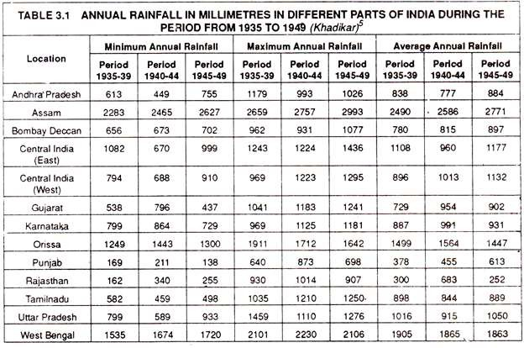

Run-off is defined as the proportion of water out of the total rainfall in the catchment area running to the water course, channel or river. It is needless to mention that the full quantity of rainfall does not reach the water course as some quantity is soaked in the soil to form the sub-soil water strata, some quantity is absorbed by vegetation, some quantity is evaporated and the rest only flows to the channel or river.

How the rain water reaches the channel or the river from the catchment area is shown in Fig. 3.1 and Fig. 3.2.

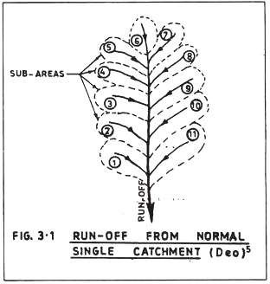

The catchment area of the stream or river upstream of the bridge site is obtained by marking the ridge line of the contour map and measuring the area enclosed by this ridge line with the help of a plan meter or tracing paper graphs.

The possibility of intensive rainfall falling simultaneously over the entire area of a big catchment is less and therefore, a lesser percentage of run- off may be taken. Another important factor which determines the percentage of run-off is the shape of the catchment.
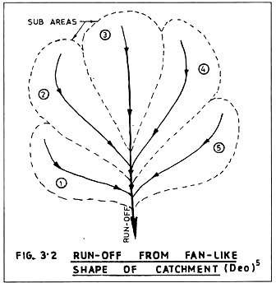
Fig. 3.1 and Fig. 3.2 show two types of catchment. In normal single catchment, the watershed is long and narrow having a number of short tributaries joining the main stream.

In such catchment, storms of shorter duration which cause the maximum flood discharge, will not reach the bridge site nearly at the same time and as such run-off in such catchment area will be less than that in a fan-like shape of catchment. In the latter case, the tributaries are longer and few in number and therefore, their run-off will reach the bridge site almost simultaneously causing thereby concentration of flow during storms of shorter duration. Hence, even if the catchment area, quantity, duration of rainfall etc. are the same for both types of catchment, the run-off at the bridge site will be more for fan shaped catchment than for normal single catchment.
Percentage run-off varies from 20 per cent to 70 per cent depending upon the shape and nature of the catchment. Porosity of soil; that is, whether sandy, clayey or rocky; degree of previous saturation; area covered by forest; presence of lakes, ponds, swamps, artificial reservoir etc.; determine the percentage run-off.
Therefore, while estimating the flood discharge from the catchment area, the aforesaid factors shall be duly taken into consideration.
As discussed before, the run-off depends on the following factors:
- Degree of porosity and degree of saturation of the soil in the catchment area.
- The shape and slope of the catchment area.

ADVERTISEMENTS:

- Obstacles to flow such as roots of trees, bushes etc.

- Degree of vegetation.

- State of cultivation.

- Amount of evaporation.

- Intensity of rainfall; Run-off is more if the same amount of rainfall say 50 mm is within a very short period of, say, two hours than is spread for a larger period of, say, 24 hours in which case it is in the form of drizzling.
- Total quantity of rainfall in the catchment area.

Method # 2. Empirical Formulae:
The flood discharge can be evaluated by using various empirical formulae involving area of the catchment and some coefficient depending upon the location of the catchment.
i) Dicken’s Formula

This formula (originally devised for Northern India but can now be used in most of the states of India with the modification of the value of the coefficient C) is given by:


Illustrative Example 1:
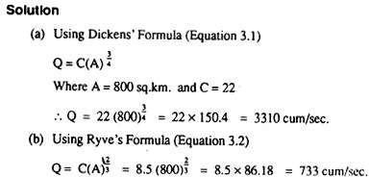
The area of a catchment is 800 sq.km. The area is located in Western India within 150 km. from coast. Estimate the maximum flood discharge by using the various empirical formulae and compare the flood discharges:

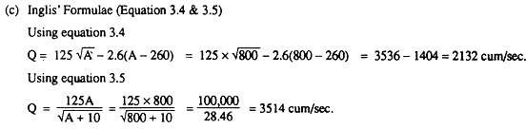
This formula is applicable for Madras (Tamil Naidu) State only and as such gives low value which is not considered

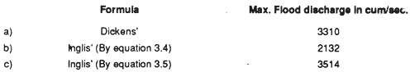
Comparison of flood discharges worked out by various empiral formulae:

Method # 3. Rational Method:
If R is the total rainfall in cm for a duration of T hours then the mean intensity of rainfall, I in cm per hour taken over the total duration of the storm is given by

ADVERTISEMENTS:

I = R/T (3.6)

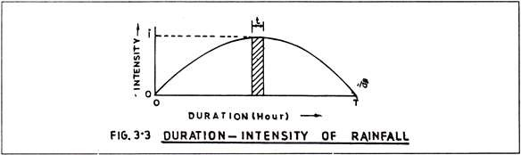
For a small time interval, t, the intensity of rainfall, i, may be more as may be evident from Fig. 3.3 since the mean intensity for a small time interval, t, is more than the mean intensity for the whole time period, T.
The relation between i and I may be shown as:

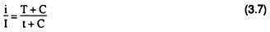
Where C is a constant and may be taken as unity for all practical purpose.
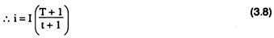
If t = one hour and corresponding i is taken as i„ and the value of I is taken from equation 3.6
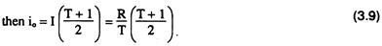
From equation 3.9, io (One hour rainfall) can be worked out if the total rainfall R and duration of the severest storm are known. It is advisable to consider a number of heavy storms spread over a prolonged period and io may be calculated for each case and the maximum value of U shall be taken as the one hour rainfall of the region for the estimation of flood discharge.
From a record of the Meteorological Department, Govt. of India, the values of io for various places of the Indian Union are reproduced in Table 3.2:

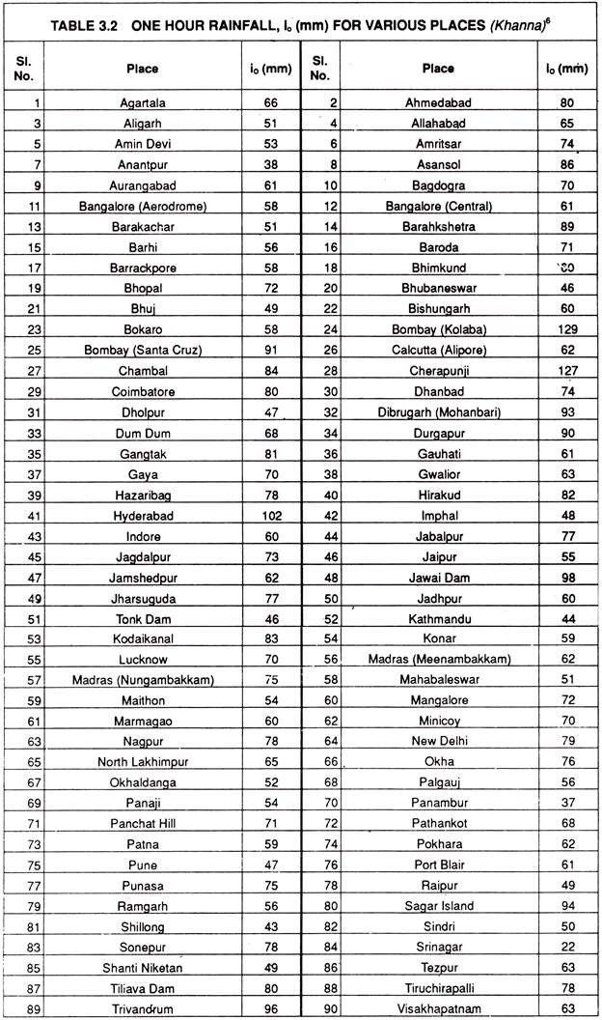

Time of concentration is defined as the time taken by the run-off to reach the bridge site from the furthest point of the catchment which is termed as the critical point.
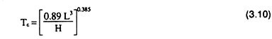
Since the time of concentration is dependent upon the length, slope and the roughness of the catchment, a relationship is established with these factors as below:

Where Tc = Concentration time in hours.
H = Fall in level from the critical point to the site of the bridge in meters. L = Distance from the critical point to site of the bridge in Km.
The values of H and L can be found from the contour map of the catchment area.
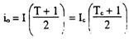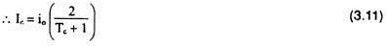The critical intensity of rainfall, Ic, corresponding to the concentration time, Tc, is derived from equation 3.9 considering I = Ic corresponding to T = Tc.

Estimation of Run-off:
One centimeter of rainfall over an area of one hectare gives a run- off of 100 cu. m per hour. Therefore, a rainfall of Ic cm per hour over an area of A hectare will cause a run-off of 100 A Ic cu. m per hour.
If losses due to absorption etc. is considered then the run-off is given by :

Q = 100 PICA cu.m per hour
= 0.028 PICA cu.m/sec (3.12)
Where P = Coefficient depending on the porosity of soil, vegetation cover, initial state of saturation of soil etc.
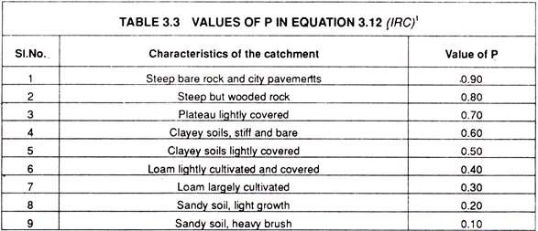
The values of P for various conditions of the catchment area arc given in Table 3.3:

In addition to the coefficient, P, another coefficient, f, is introduced in the formula for calculating the run-off. As the catchment area gets larger and larger, the possibility of reaching the run-off to the bridge site simultaneously from all parts of the catchment is less and less and as such the value of f is gradually reduced as the catchment area is increased.
Table 3.4 gives the value of f in equation 3.13 derived from equation 3.12 with the introduction of the coefficient, f, therein.
Q = 0.028PfIc A cu.m /sec. (3.13)

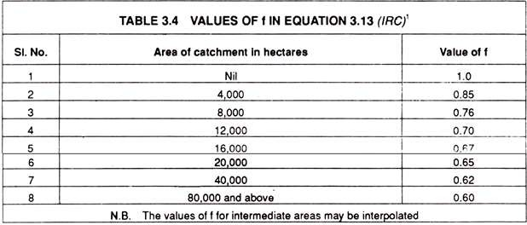

Illustrative Example 2:
The catchment area of a river is 800 Sq. Km. and is composed of sandy soil with thick vegetation cover. The length of the catchment is 30 Km. and the reduced levels of the critical point and the bridge site are 200 m and 50 m respectively.
Find out the peak storm discharge by the Rational Method assuming that the rainfall in 5 hours is 20 cm. What will be the peak discharge if the catchment area is of clayey soil lightly covered or of steep but wooded rock?
Maximum peak run-off, from equation 3.13

Q = 0.028 PflcA cu.m/sec
In the present case for catchment area composed of sandy soil with thick vegetation,
A = 800 sq.km = 80,000 hectares ; P from table 3.3 = 0.10 ; f from table 3.4 = 0.60 ; Ic = 2.98 cm/hour
... Q = 0.028 PfIcA = 0.028 x 0.10 x 0.60 x 2.98 x 80,000 = 400 cum/sec.
When the catchment area is of clayey soil lightly covered, P from table 3.3
= 0.50, values of A, f and Ic remaining as before.
... Q = 0.028 PfIcA = 0.028 x 0.50 x 0.60 x 2.98 x 80,000 = 2003
cum/sec.
In case of catchment area with steep but wooded rock, P from table 3.3 = 0.80

... Q = 0.028 PfIcA = 0.028 x 0.80 x 0.60 x 2.98 x 80,000 = 3204
cum/sec.
Therefore, it may be noted from the illustrative example that the peak run-off is very much dependent on the nature of the catchment, other factors remaining the same and varies from 400 cum/sec to 3204 cum/sec when the degree of porosity and absorption of the catchment area is very high or very low.
The Rational Method is, therefore, very realistic and considers all relevant factors which regulate the peak run-off. The empirical formulae do not consider these factors except some adjustment in the value of the coefficient C and therefore, are not very much realistic.
Method # 4. Cross Sectional Area and Bed Slope:
By this method the discharge is calculated from Manning’s formula,
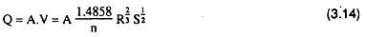
Where A = the area of cross section of the stream measured from H.F.L n = the rugosity co-efficient.
R = the hydraulic mean depth and equal to the ratio of cross-sectional area, to wetted perimeter, P
S = the bed slope of the stream measured over a reasonably long distance.

In a stream having non-erodible banks and bed, the shape and the size of the cross-section remain practically the same during a flood as at normal times and therefore, the normal cross-section and the perimeter may be used in calculating the discharge.

But in a stream flowing through alluvium region, the cross-sectional area and the perimeter may change during highest floods due to the scouring of the banks and the bed and as such in estimating the maximum flood discharge, the depth of scour has to be ascertained first and the values of the cross-sectional area and the perimeter may then be calculated by taking levels of the bed at certain intervals.
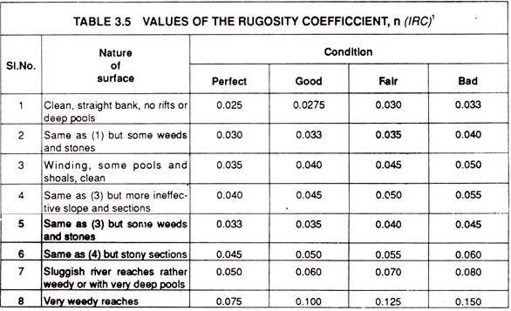
The value of the rugosity co-efficient depends on the nature of the bed and the bank of the stream and proper care is required to be taken in selecting the right value of this co-efficient in order to get the correct discharge. Some values of the rugosity co-efficient, n, are given in table below for various types of surface conditions.
Illustrative Example 3:
A river has the bed levels at the highest flood at certain intervals as shown in Fig. 3.4. The R.L. of the lowest beds at 500 m upstream and 500 downstream are 107.42 m and 105JO m respectively. Calculate the

maximum flood discharge if the river has fairly clean, straight banks but having some weeds and stones.

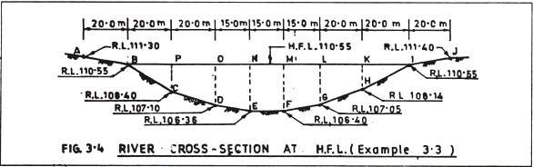
Solution:
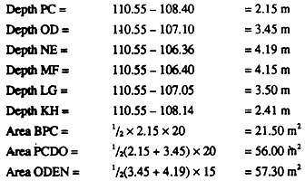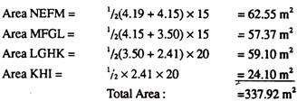Area of cross-section A at H.F.L. may be found out by dividing the area into strips such as BPC, PCDO, ODEN etc.:

The wetted perimeter P at H.F.L. is the bed line BCDEFGHI which is the summation of the length of line BC, CD, DE etc. These length may be worked out as below (See Fig. 3.5):

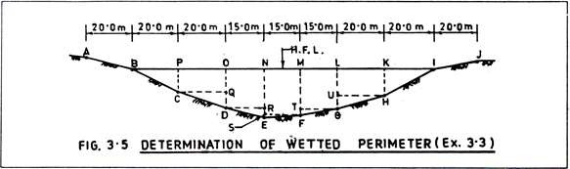
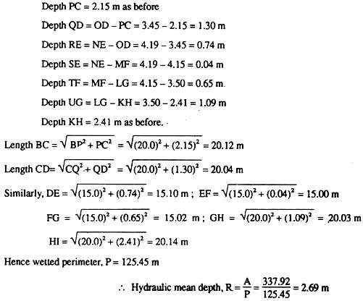
Bed slope, S, is the level difference of the lowest bed at 500 m upstream and 500 m downstream divided by the distance.
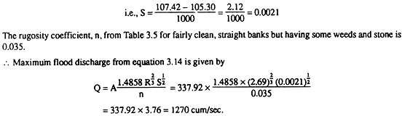
Method # 5. Area of Cross-Section and Velocity as Observed at Bridge Site:

The area of cross-section is measured by taking a series of levels of the river at H.F.L. at certain intervals. The velocity in this case is determined at site by direct measurement of the velocity in place of theoretical calculation from bed slope etc.
To measure the velocity directly, the river is divided into few sections width wise and then the velocity for each section is determined by surface float placed at the centre of each section.
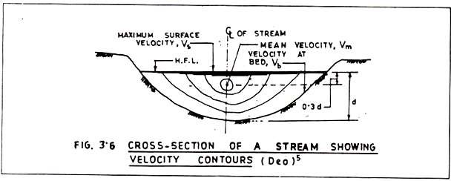
The time taken by the float to cover a fixed distance is noted by a stop watch and the distance travelled by the float divided by the time taken is the surface velocity of the stream. Such surface velocity is to be determined for each section and weightage average value is obtained for the purpose of flood discharge estimation.
The velocity is least in the vicinity of the bed and banks and mean at the centre line of the stream at a point 0.3 d below the surface where, d, is the depth of water (see Fig. 3.6). If V, is the velocity at surface, Vb is the velocity at bottom and Vm is the mean velocity then their relationship may be established in the following equation,
Vm = 0.7 Vs= 1.3 Vb (3.15)

After the determination of the mean velocity of the stream, the flood discharge is obtained by;
Q = AVm (3.16)
Method # 6. Available Records:
In some cases it may be possible to have the maximum flood discharge measured at weir or barrage sites. This value may be compared with the theoretical worked out value and a final value may be selected. The flood discharge thus obtained, though very realistic, suffers from one drawback viz. the age of the record, since the weirs or the barrages are mostly of recent construction.
The flood discharge shall preferably be the maximum of 100 years’ recorded value for important bridges and 50 years’ recorded value for less important bridges. The terms “100 years’ value” and “50 years’ value” are defined as momentary peak discharge which occur “on the average” once in 100 years or once in 50 years.
The phrase “on the average” means all the peak discharges as observed over a period of 100 years or 50 years as the case may be and average of the peaks is taken.
Waterways
Waterways include natural rivers and artificial waterways that may be rivers modified to guarantee navigation. Rivers are the surface expression within each drainage basin of the way in which water from precipitation progresses through the hydrological cycle to seas or lakes. Few rivers are completely natural and unmodified: they have been changed by a range of direct and indirect influences. They are dynamic components of environment because both the water quantity and the quality of the water and also the channel itself can change. Five aspects

which are pertinent in relation to conservation of waterways are: (a) the need to control the quantity of water—managed river channels are modified to a design discharge; (b) the need to control the quality of water—in relation to pollution; (c) the need to manage river channels— many are now being restored to appear as ‘natural’ as possible; (d) the need to identify and conserve areas with special features as exemplars of typical waterways and to educate the public about natural riverscapes; and (e) the need to manage waterways in a holistic way in Integrated Basin Management (IBM).
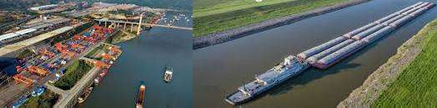

Waterways include natural rivers and artificial waterways that may be rivers modified to guarantee navigation. Rivers are the surface expression within each drainage basin of the way in which water from precipitation progresses through the hydrological cycle to seas or lakes.
Economic Span of a Bridge:
The span of a bridge may be so determined that the total cost of the bridge is a minimum. The span to satisfy this condition is called the economic span. The total cost of the bridge consists of the cost of the substructure and that of the superstructure. Very often it is seen that the cost of the substructure forms nearly 50 per cent of the total cost of the bridge.
The cost of pier will not change appreciably for small change in span. Even the cost of the floor- way is not affected much for small variation in span. But it is seen that the cost of the trusses and bracings is directly proportional to the span of the bridge.

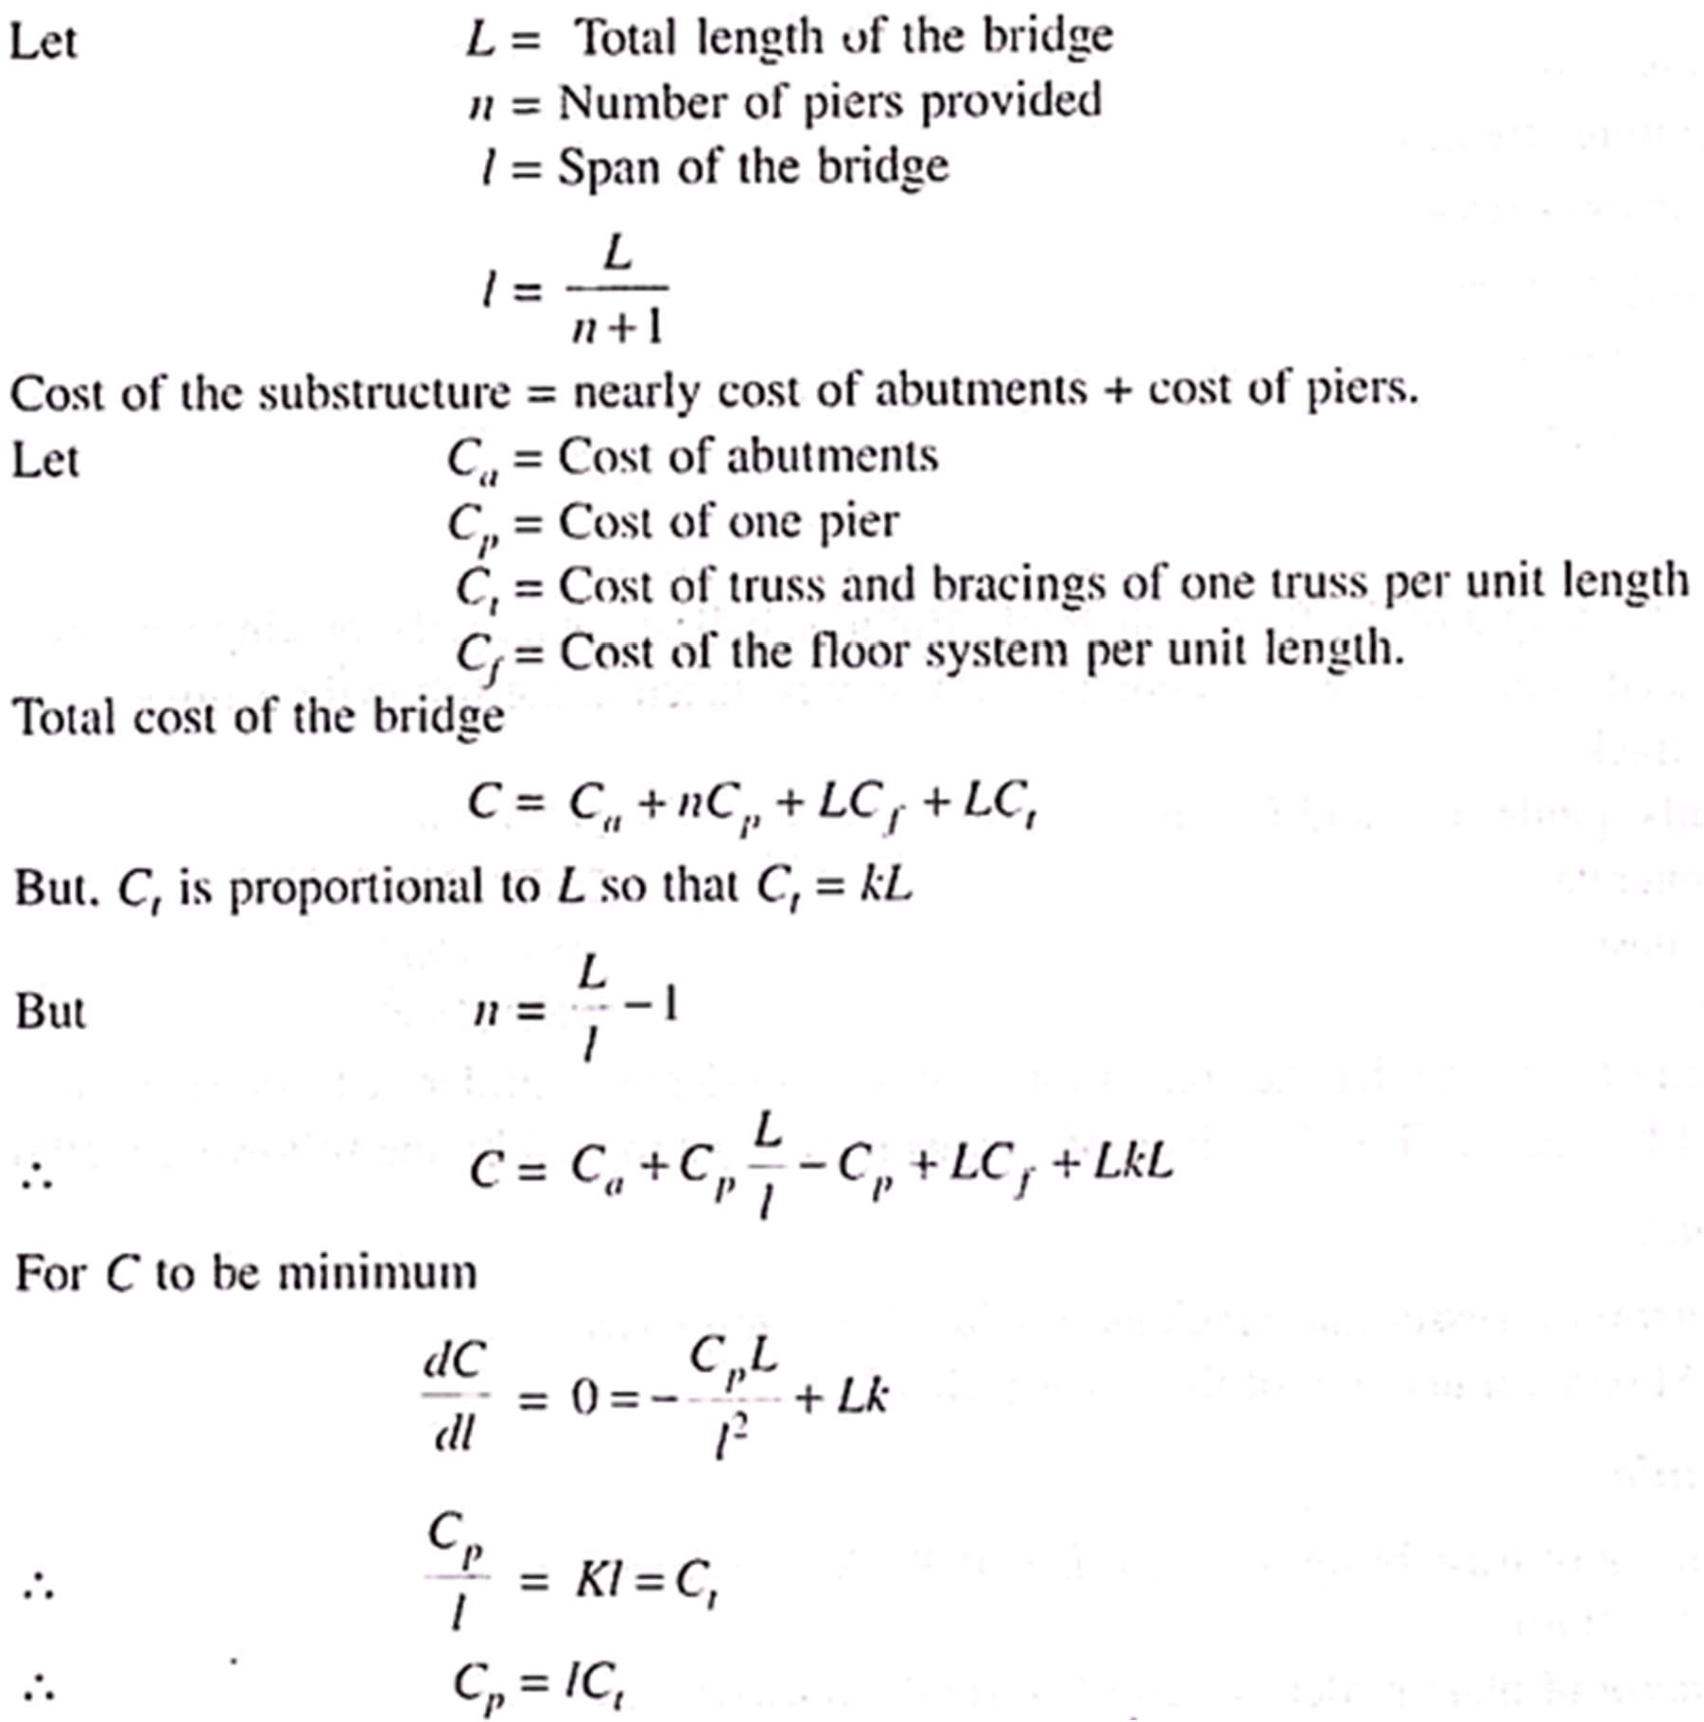
But lCt = cost of the trusses and bracings corresponding to one span
Hence, the cost of the whole bridge is a minimum when the cost of one pier and the cost of trusses and bracings corresponding to one span are equal.

Afflux
Afflux is defined as heading up of water when they hit any obstruction. In bridges the water hit at u/s side. When hiring the water rises.
In design the height of bridge the afflux is taken into consideration with HFL. Hope u will understand. This picture helps u for understanding

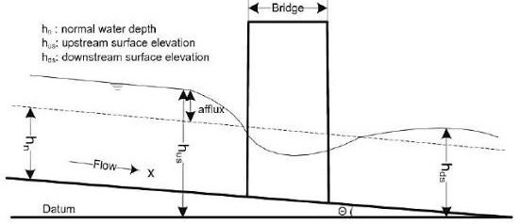
Horizontal Clearance

Horizontal clearance for structures is the distance from the edge of the traveled way to bridge piers and abutments, traffic barrier ends, or bridge end embankment slopes. Minimum distances for this clearance vary depending on the type of structure.
Bridge Medians Designs for bridges on divided multilane highways often include the decision to join parallel bridges as one or build them as independent structures. There are several factors in this decision, such as in new corridor construction, phased construction of corridors, and the general median width of the divided highway.

This section covers some common design considerations related to bridge medians. Advances in crash barriers and their applications have resulted in an expanded set of choices for bridge medians on divided highways.

Modern barrier designs and applications have allowed for longer runs of traffic barrier, different barrier types, and bullnose guardrail designs for shielding the gap between parallel structures.

These tools have reduced collisions with abrupt bridge ends as well as shielded the opening between bridges. Some highway corridors are initially planned as multilane

divided highways but may be developed in logical, affordable phases and individual projects. This could result in an initial phase where a corridor may open as a two-lane rural highway used by both travel directions.

A later phase could convert the facility to a divided highway, bringing with it the need for median separation. Consider the long-range plans when determining median widths for bridges. The photos in Exhibit 720-1 show a completed multilane highway where two separate bridges were ultimately constructed years apart and a new corridor underway where one bridge is now built. Joining two structures may not be the most cost-effective or sustainable solution for all projects.

Coordinate with the Bridge and Structures Office and the local Maintenance Office when discussing options and concerns. For bridges on parallel horizontal and vertical alignments, practical considerations for joining two structures as one include, but are not limited to:

- Phased development where one structure exists and another is planned.

- Old and new structure types and compatibility (with phased corridor construction).
- Median width.

- Median barrier treatment options.

- Environmental contexts and regulations.

- Seismic conditions and load ratings.

- Bridge maintenance and inspection techniques: accessibility options and equipment for terrain in specific contexts. An open area between structures may be needed for bridge inspection.

- Skew angles and/or curvature of waterways or roadways beneath the structures.

- Economics.

- Historical/aesthetic value of existing bridges to remain in place. If structures will not be joined, evaluate the median as described here: When there is a median gap between bridges of 6 inches or more, the Region PEO will evaluate whether or not the median gap needs to be screened.

Address the potential for pedestrians on the bridge and if closing the median gap to less than 6 inches, or installing fencing, netting, or other elements to enclose the area between the bridges would be beneficial. Document this evaluation in the Basis of Design and Alternatives Comparison Table. Exhibit 720-1 Phased Development of Multilane Divided Highway
Vertical Clearance

Vertical clearance is the critical height under a structure that will accommodate vehicular and rail traffic based on its design characteristics. This height is the least height available from the lower roadway surface (including usable shoulders) or the plane of the top of the rails to the bottom of the bridge.

Usable shoulders are the design shoulders for the roadway and do not include paved widened areas that may exist under the structure. In addition to the following vertical clearance guidance, consider whether the corridor experiences overheight loads. Consider a vertical clearance such that it will not create a new “low point” in the corridor.

Vertical Falsework Clearance for Bridges Over Highways Construction of new bridges and the reconstruction or widening of existing structures often requires the erection of falsework across the traveled way of a highway.

The erection of this falsework can reduce the vertical clearance for vehicles to pass under the work area.

The potential for collisions to occur by hitting this lower construction stage falsework is increased.

- On all routes that require a 16.5-foot vertical clearance, maintain this same clearance for falsework vertical clearance.

- On structures that currently have less than a 16.5-foot vertical clearance for the falsework envelope, maintain existing clearance.

- On new structures, maintain the falsework vertical clearance at least to those of the minimum vertical clearances referenced below.

- Any variance from the above must be approved by the Regional Administrator or designee in writing and made a part of the Project File.

Minimum Clearance for New Structures For new structures, the minimum vertical clearances are as follows:

Bridge Over a Roadway The minimum vertical clearance for a bridge over a roadway is 16.5 feet.

Bridge Over a Railroad Track The minimum vertical clearance for a bridge over a railroad track is 23.5 feet (see Exhibit 720-2). A lesser clearance may be negotiated with the railroad company based on certain operational characteristics of the rail line; however, any clearance less than 22.5 feet requires the approval of the Washington State Utilities and Transportation Commission (WUTC) per WAC 480-60. Vertical clearance is provided for the width of the railroad clearance envelope.
Coordinate railroad clearance issues with the HQ Design Office Railroad Liaison.

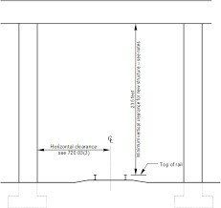
Pedestrian Bridge Over a Roadway The minimum vertical clearance for a pedestrian bridge over a roadway is 17.5 feet.

Bridge freeboard
Bridge freeboard is the clearance between the lower limit of the bridge superstructure or the bottom of the culvert top slab and the Freeboard High Water surface elevation.
An appropriate amount offreeboard allows for the safe passage of ice and debris through the structure (not typically required for culverts).
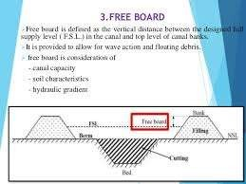

Data needed for designing a bridge:
  - A plan of the site showing all obstacles to be bridged such as rivers, streets, roads or railroads, the contour lines of valleys and the desired alignment of the new traffic route.
  - Longitudinal section of the ground along the axis of the planned bridge with the conditions for clearances or required flood widths. Desired vertical alignment of the new route.

  - Required width of the bridge, width of lanes, median, walkways, safety rails etc.
  - Soil conditions for foundations, results of borings with a report on the geological situation and soil mechanics data. The degree of difficulty of foundation work has a considerable influence on the choice of the structural system and on the economical span length.
  - Local conditions like accessibility for the transport of equipment, materials and structural elements. Which materials are available and economical in that part of the country? Is water or electric power at hand? Can a high standard of technology be used or must the bridge be built with primitive methods and a small number of skilled laborers?
  - Weather and environmental conditions, floods, high and low tide levels, periods of drought, range of temperatures, and length of frost periods.
  - Topography of the environment - open land, flat or mountainous land, scenic country. Town with small old houses or city with high rise buildings. The scale of the environment has an influence on the design.
  - Environmental requirements regarding aesthetic quality. Bridges in towns that affect the urban environment and that are frequently seen at close range - especially pedestrian bridges - need more delicate shaping and treatment than bridges in open country. Is protection of pedestrians against spray and noise needed? Is noise protection necessary for houses close to the bridge
Rough sketch of bridge design:

When the engineer is sure that a design idea has emerged in his mind, he should pick up a pencil and a scale and by the help of sketching, learned at school, he should start from sketching the probable road direction, beam depth(For beam bridge) the piers, the abutments and the bottom edge of the beam is drawn.

For a heavily funded project, high slenderness ratio is preferable otherwise if the decisive factor is the cost then slenderness ratio can be reduced. Analyze the sketch critically for the proportion between the spans, the clearance under the beam, soil conditions around the piers and the abutments, the adaptiveness of the piers to the surroundings, no. of piers and for the curvature of the vertical alignment. More than one sketches may follow after the critical analysis with changes in the design and supporting conditions. Work out the alternatives, discuss with colleagues, architects advisors and the client to draw out a final sketch.

Only now should calculations begin, and in the first place with simple and rough approximations to check whether the assumed dimensions will be sufficient and whether the necessary sectional areas of reinforcing steel or of pre-stressing tendons will leave sufficient space, to allow the concrete to be placed and compacted without difficulty. Then some runs with computer programs can be made, using different depths or other variables in order to find the most economical dimensions; these should, however, only be chosen if no other essential requirements, such as aesthetics, length of approaches, grades etc. are affected.

Once the designer or the design team has made its choice, then the principle design drawings with all dimensions and explanations can be drawn up for approval of the authorities. As the map alone is not sufficient to clearly show the locality and impact on the environment and appearance so a model or some well shot photos can help the citizens, client and critics to realize the existence of bridge.

Finalizing the bridge design:
After the approval of the design, the final design work can begin with rigorous calculations of forces, stresses etc. for all kinds of loads or attacks and then the structural detailing has to be done. The scaffolding and equipment, which will be needed for the construction of the particular type of bridge, also has to be worked out. Numerous drawings and tables with thousands of numbers and figures for all dimensions, sizes and levels must be made with specifications for the required type and quality of the building materials. This phase entails the greatest amount of work for the bridge engineer, and calls for considerable knowledge and skill.

SUB SURFACE INVESTIGATION
Introduction: The Digboi Pengri Bordumsa Namchik Mahadevpur Road connects Lohit District with Changlang, besides catering the interstate connectivity between Assam and Arunachal Pradesh. Hence this road forms the socio economic lifeline of the people of Arunachal Pradesh residing in the two districts. The total length of the road is 70.831 km of which 40.831 km is in Arunachal Pradesh.
The up-gradation proposal of the road includes works of improvement of formation of the road, Pavement, cross drainage and bridge in the road. The scope of this works shall be limited to the subsoil investigation of the bridge site on the road portion in the Changlang District which is within the jurisdiction of the Executive Engineer Jairampur Division.
There are 8 numbers of sites identified for construction of small to medium span bridge for which the subsoil investigation is intended for safety design of foundation. A. Brief scope of work for Sub-Soil Investigation of Bridge Site:
- Selection of Bridge site
- Preparation of Index Plan
- Preparation of Site Plan.
- Preparation of Cross Section and Longitudinal Section of river bed.
- Collection of hydraulic data.
- Calculation of design discharge and Linear Waterway.
- Fixation of approximate span of bridge.
- Sub-soil exploration and determination of engineering properties of soil.
- Determination of bearing capacity of soil.

- Submission of Report. B. Detailed scope of work The detailed descriptions of the scope of works to be undertaken by the consultants in carrying of the works .
Selection of Site for the Bridge The selection for the site of the bridge shall follow the guidelines given the IRC: 5-1998 Clause 102.2. Formal approval of the bridge alignment shall be obtained from the Superintending Engineer in charge of the works before starting of the subsoil investigations.
- Preparation of Index Plan The index plan shall locate the project area with the Capital city of the State and nearly major towns. It should give bird’s eye view of the project area and the overall road network in the State. Small size road map of the State can be used for preparation of the index plan.
- Preparation of Site Plan Site Plan shall be drawn to Scale showing the details of the site extending not less than 100 meters on upstream and downstream from the center of crossing. It should cover approaches to sufficient distant. In case the river is meandering near the site of bridge, the site plan should cover at least two loops on either side. The site plan should also contain direction of flow of water, existing approach, angle of skew if any, location and value of permanent bench mark, location of cross sections and longitudinal sections taken and location of trial pit of boring.
- Preparation of Cross Sections and Longitudinal Sections of river bed At least three cross sections should be taken for small bridge namely one at selected bridge site, one at upstream and another at downstream of the site, all to horizontal scale of not less than 1 cm to 10 m and exaggerated vertical scale of not less than 1 cm to 1 m. However, more numbers of cross sections in upstream and downstream of the site is preferable. Normally the approximate distance in upstream and downstream of the bridge site upto which the plotting of cross sections shall extend shall as below (IRC: SP: 13:2004): 1. Catchment area upto 3.00 sq km – 100m 2. Catchment area 3.00 sq.km to 15.00 sq km – 300 m 3. Catchment area over 15.00 sq km – 500 m Similarly, the longitudinal cross section of the river should also extend upstream and downstream of the proposed site of bridge as shown above.
- Collection of Hydraulic Data The collection of hydraulic data shall include collection of history of flood discharge, maximum HFL, maximum velocity of flood flow, river flow characteristics, rainfall intensity and catchments area and characteristics of catchments area. The general guidelines provided in IRC:5- 1998 Clause 102.3 shall be followed in the collection of the hydraulic data.
- Calculation of Design Discharge and Linear Waterway The design discharge shall be calculated using minimum three methods as per the guidelines given in IRC: 5-1998 Clause 103.Similarly, linear water way shall be calculated based on the methods and the formula given in IRC: 5:1998 clauses 104.

- Determination of span of bridge The span of the bridge shall be fixed based on the provisions of IRC 5-1998 based on the linear waterway or based on the type of river bed and banks. The span arrangement shall be determined considering the suitable type of bridge in the locations in consultations with the Executive Engineer and Superintending Engineer of the Department who are the in charge of the work.
- Determination of borehole locations With the tentative arrangement of span as approved by the Executive Engineer and Superintending Engineer in charge of the works the borehole location for collection of sub-soil sample shall be decided. One boring at each proposed location of abutment and pier shall be done and the engineering properties of the sub-soil at the location shall be worked out as detailed in the next pages.
- Sub-Soil Exploration and Determination of Engineering Properties of Soil The boring for collection of sample shall be done at the proposed location of abutment and pier as per approximate span arrangement fixed. The sub-soil investigation shall broadly consist of two stages, preliminary Investigation and Detailed investigation. In general the investigation procedure and collection of data shall follow the guidelines provided in IRC-78-2000. Thereafter the scope of detailed investigation including the extent of exploration, number of bore holes, type of tests, number of tests etc., shall be decided in close liaison with the design engineer and the exploration team, so that adequate data considered necessary for detailed design and execution are obtained. (ii) The exploration shall cover the entire length of the bridge and also at either end a distance of zone of influence i.e. about twice the depth below bed of the last main foundation to assess the effect of the approach embankment on the end foundations.
Generally the sub-surface investigations should extend to a depth below the anticipated foundation level equal to about one and a half times the width of the foundation. However, where such investigations end in any unsuitable or questionable foundation material, the exploration shall be extended to a sufficient depth into firm and stable soils or to rock. (iii) The scope of the detailed sub-surface exploration shall be fixed as mentioned in B(i) and B(ii). However, as a general guide it shall be comprehensive enough to enable the designer to estimate or determine the following:-
- Engineering properties of the soil / rock
- Location and extent of weak layers and cavities, if any, below hard founding strata
- The sub-surface geological condition, such as, type of rock, structure of rock i.e. folds faults, fissures, shears, fractures, joints, dykes and subsidence due to mining or presence of cavities
- Ground water level
- Artesian conditions, if any;

- Quality of water in contact with the foundation
- Depth and extent of scour
- Suitable foundation level
- Safe bearing capacity of foundation staturm
- Probable settlement and probable differential settlement of the foundations
- Likely sinking or driving effort; and
- Likely construction difficulties.
- Method of taking soil sample The size of the bores shall be predetermined so that undisturbed samples as required for the various types of tests are obtained. The method of taking samples shall be as given in IS:1892 and IS:2132. The tests on soil samples shall be conducted as per relevant part of IS:2720. 4
- Foundations Requiring Shallow depth exploration (Open Foundation) These shall cover cases where the depth of exploration is not deep and it is possible to take samples from shallow pits or conduct direct tests like plate load tests etc. This will also cover generally the foundation soil for approach embankments, protective works etc.
  - Tests shall be conducted on undisturbed representative samples, which may be obtained from open pits. The use of plate load test (IS:1888-Method of Load Test on soils) is considered desirable for ascertaining the safe bearing pressure and settlement characteristics. A few exploratory bore holes or soundings shall be made to safeguard against presence of weak strata underlying the foundation. This shall extend to a depth of about 1½ times the proposed width of foundation.
  - The tests to be conducted at various locations for properties of soil etc., are different for cohesive and cohesionless soils. These are indicated below and shall be carried out wherever required according to soil type. Cohesionless Soils. (a) Laboratory Tests.
    - Classification test, index tests, density determination etc.
    - Shear strengths by triaxial / direct shear etc. (b) Field Tests. (i) Plate Load Test.
    - Standard penetration Tests (as per IS:213) Cohesive Soils. (a) Laboratory Tests. (i) Classification test, index tests, density determination etc. (ii) Shear strengths by triaxial / direct shear etc. (iii) Unconfined compression test (IS:2720 Part X)
    - Consolidation test (IS:2720 Part V) (b) Field Tests. (i) Plate Load Test (ii) Vane Shear Test (IS:4434) (iii) Static Cone Penetration Test (IS:4968 Part
III) Note: Where dewatering is expected, the samples may be tested for

permeability (IS:2720 PartXVII). (E) Foundation Requiring Large Depth of Exploration In this group are covered cases of deep wells, pile foundations.
Where the use of boring equipment, special techniques of sampling, in-situ testing etc., become essential. In addition to the problems of soil and foundation interaction an important consideration can be the soil data required from constructions. Often in the case of cohesionless soils, undisturbed samples cannot be taken and recourse has to be made to in-situ field tests.
- The sub-surface exploration can be divided into three zones:-
  - Between bed level and upto anticipated maximum scour depth (below H.F.L.)
  - From the maximum scour depth to the foundation level and
  - From foundation level to about 1½ times the width of foundation below it. Sampling and testing (in-situ and laboratory) requirement will vary in each case and hence are required to be assessed and decided from case to case . The sub-soil water shall be tested for chemical properties to evaluate the hazard of deterioration to foundations where dewatering is expected to be required, permeability characteristics should be determined.
- For the different zones categorized in para-E(ii), the data required, method of sampling, testing etc., are given in Table-1. Samples of soils in all cases shall be collected at every 1 to 1½ metre or at change of strata. Table-1. Zones Data Required Sampling and Testing Remarks including limitations. Bed level to anticipated maximum scour depth (i) Soil classification (ii) Particles size distribution Sampling for (i) and (ii) disturbed samples may be collected. For (iii) and (iv) undisturbed samples shall be collected. Cohesionless soils – Dynamic Penetration Tests as per details in para-D. Cohesive Soils – (i) Static penetration Test-cone and skin resistance to be obtained. (ii) Field vane shear may be done. Laboratory Test (i) Classification Tests including particle size distribution. (ii) Shearing strength Triaxial tests to be done on undisturbed samples. Unconfined compression tests to be done on undisturbed and remoulded samples. (i) Laboratory tests to be conducted according to the relevant parts of IS:2720. (ii)Undisturbed sampling cohesionless solids are a difficult and expensive process. In general, in such cases, in-situ tests may be adopted. (iii) Boring and sampling tends to cause remoulding of sensitived clays. Disturbance and stress changes for fissured or layered clays may also make the sample not truly representative of the in-situ condition. In such cases use of insitu tests may give results more representative of the actual soil characteristics. Maximum anticipated scour level to the foundation level (i) Soil classification (ii) Shearing strength characteristics (iii) Compressibility (iv) Permeability where dewatering is expected. (v) Moisture content, density, void ratio Same as above Same as above 6 Foundation level to about 1½ times of the width of foundation below it. i) Soil classification (ii) Shearing strength (iii) Compressibility Same as above and consolidation test to be done on undisturbed samples. Same as above 9. Determination of bearing capacityBased on the field test and laboratory test, the consultant shall suggest a tentative

type of foundation to be adopted and calculate the bearing capacity of the soil at various founding level. 10. Submission of reportThe report of the sub-soil investigation results shall be submitted in two stages viz Preliminary Report and Final Report. Preliminary Report : The preliminary report shall consist of the broad background of the soil strata of the area, observation results of preliminary investigations and detailed sub-soil investigations.
Site plan of the bridge site, proposed location of bridge axis and locations of each boreholes shall be indicated in the report. The overall presentation of the report shall conform to guidelines / specification provided in IRC-78-2000. The bore log chart and sub- soil profile shall be presented as per the guidelines in Sheet-1 and Sheet-2 (enclosed) of IRC-78-2000 respectively.
The relevant soil properties for design of foundation shall be listed distinctly supported by calculations wherever required. Final Report : On approval of the preliminary report by the competent authority of the department, the final report shall be submitted covering all the information as required in preliminary report with the modifications or additional data suggested by the department.

BRIDGE FOUNDATION

SCOUR DEPTH

Scour of the soil by flowing water around bridge supports is the number one reason for bridge collapse. Predicting the depth of the scour hole is an integral part of the bridge foundation design, as it impacts the depth of the piles. Indeed, the scour depth must be ignored in the vertical and horizontal resistance of the piles.

This paper presents a method to calculate the maximum depth of the scour hole around bridge supports when subjected to a constant water velocity.

Most existing methods take into account the water velocity and the geometry of the obstacle but not the soil type.

The method presented in this paper keeps those important variables and adds the paramount influence of the soil erosion characteristics. It is developed on the basis of 94 flume tests, some of them very large laboratory-scale tests, as well as dimensional analysis and experience.

It applies to pier scour, contraction scour, and abutment scour. The method is evaluated by comparing the maximum scour depth predictions against measured data from 10 databases of pier, contraction, and abutment scour depths.

MINIMUM DEPTH OF FOUNDATION

Depth of Foundation
Depth of foundation depends on following factors:

- Availability of adequate bearing capacity.
- Depth of shrinkage and swelling in case of clayey soils due to seasonal changes, which may cause considerable movements.
- Depth of frost penetration in case of fine sand and silt.

- Possibility of excavation nearby
- Depth of groundwater table
- The minimum practical depth of foundation should not be less than 50 cm. To allow removal of topsoil and variations in ground level.
Hence the best-recommended depth of foundation is from 1.00 meter to 1.5 meter from the original ground level.

Width of Foundation / Footings
The width of footings should be laid according to structural design. For light loaded buildings such as houses, flats, school buildings, etc, have not more than two storeys, the width of the foundation is given below:
- The width of the footing should not be less than 75 cm for one brick thick wall.
- The width of the footing should not be less than 1 meter for one and a half brick wall.

Procedure for Construction of Foundation
The processes executed in the foundation works are given below:

- Excavation of earthwork in trenches for foundation.
- Layout cement concrete.
- Lay the footing in case of raft or column construction.
- Lay Anti termite treatment.
- Lay Brickwork up to the plinth level.
- Lay damp proof course on the walls.
- Refilling of earth around the walls
- Refilling of earth in the building portion up to the required height according to the plinth level.
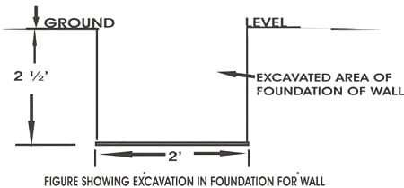
Fig.1: Excavation for Foundation of Wall

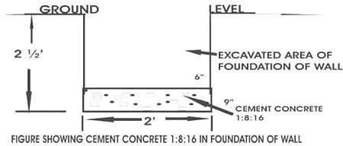
Fig.2: Concrete in foundation
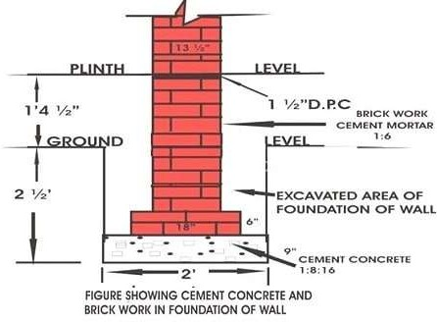
Fig.3: Concrete and Brickwork in Foundation of Wall

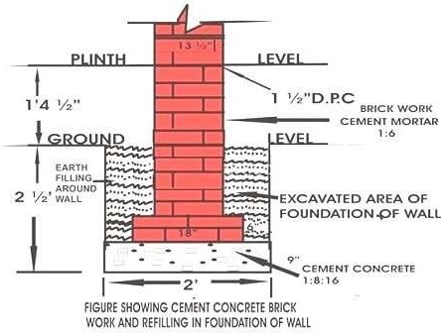
Fig.4: Concrete and Brickwork in Foundation Refilling

Foundation Design Precautions
- A foundation should be designed to transmit combined dead load, imposed load, and wind load to the ground.
- The net loading intensity of pressure coming on the soil should not exceed the safe bearing capacity.
- Foundation should be designed in such a way that settlement to the ground is limited and uniform under the whole of the building to avoid damage to the structure.
- The whole design of the foundation, superstructure, and characteristics of the ground should be studied to obtain the economy in construction work.

Concrete and Mortar Ratio for Foundation
- The cement concrete 1:8:16 is generally used in the foundation of walls in construction work.
- In the case of column raft cement concrete, 1:4:8 is the best-recommended ratio for it in the foundation.
- For brick masonry, cement mortar 1:4 to 1:6 is used as a loading condition.
In the case of column and raft footings up to plinth level, cement concrete 1:2:4 or1:1.5:3 are used.

Safe Bearing Capacity Soil
Dry coarse and well-graded dense sand have maximum shear resistance and maximum bearing capacity. In general, submerged soil and clay have less bearing capacity.

Foundation Excavation Precautions
The depth and width of the foundation should be according to structural design.

- The minimum depth of the foundation is 1 meter in case the design is not available.
- Check the length, width, and depth of excavation with the help of centerline and level marked on the marking pillars.
- Dump the excavated material/ earth at a distance of 1 meter from the edges.
- Start excavation work when the soil is dry.
- Arrange a water pump to pump out rainwater.
- Compact the bottom layer of the foundation.
- There should be no soft places in the foundation due to roots etc.
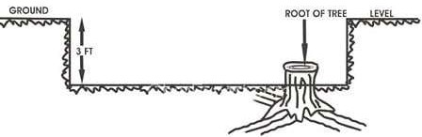
- Dugout any soft/ defective spots, and fill the excavated area with concrete/ hard material
Fig.5: Excavation for Foundation where Root of Tree Exists F
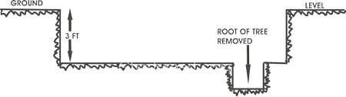
Fig.6: Excavation of Wall in Foundation Foot Removed

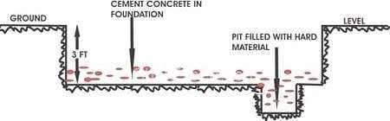
Fig.7: Pit of Root Filled with Hard Material
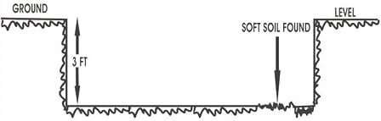
Fig.8: Excavation of Foundation of Wall with a Patch of Soft Soil
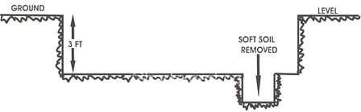
Fig.9: Excavation of Wall Foundation with Soft Soil Removed
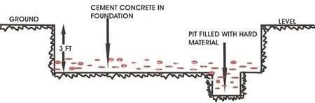
Fig.10: Pit of Soft Soil Filled with Hard Material

Demarcation/layout Procedure
The following procedure is recommended for the demarcation of a building:

- Mark the baseline on the ground from the centerline of the road, or a permanent building nearby. This line helps to mark out the front of a building.
- Use a side structure, road, first baseline, or plot boundary to mark side baselines of the building.
- Fix temporary pegs at the centerline of walls/columns on both sides of walls and columns in front and backside.
- Fix peg at the centerline of walls/columns on both sides of the walls and columns on the left and right side of the building front.
- Check diagonals of the square or rectangle formed after fixing pegs.
- Construct marking pillars with pegs at a distance of 1.5 meters to 2 meters, and plaster their top surface.
- Mark center line on the top of marking pillars with the help of thread (Soot) or with the Theodolite in big projects and the diagonal, and check other dimensions.
- Level marked pillars on all corners of the building.
- Mark the foundation of walls/columns according to drawing on the ground with the help of centerline marked on the marking pillars.
- Use chalk powder to mark the foundation trench on the ground.
- Excavate the foundation of the walls /columns up to the required level, and check the excavation with the help of centerline and level marked pillars to avoid any complication later on.
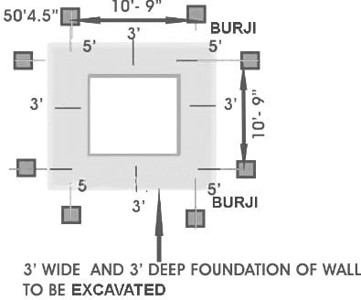
Fig.11: Excavation for Foundation Under Wall

Advantages Marking Pillars to Layout Buildings
- It saves time for measuring and setting the point again and again at the time of construction.
- It increases the efficiency of mason and foreman for doing their jobs.
- Accuracy can be checked at any time at any step.
- If any mistake is found, it can be easily be rectified at an early stage. It is very difficult to rectify the mistake later.
- Cross-check can be done by a senior engineer in minimum time.
- Qualitative work is maintained.

Disadvantages Construction Execution without Layout
At some sites of work the contractor brings steel pieces, erects the same on the ground, and start the work of excavation. In due course these steel pieces are just discarded. Thus no proper reference point is available while doing further jobs.
- It involves extra time for measuring the offset again and again.
- Accuracy can not be checked at an early stage and it will be very difficult to rectify the same in later stages.
- It involves wastage of time and money while doing rectification. This also leads to bad quality of work.

Equipment For Layout Setting
- Leveling Instrument
- Long Nails
- Hammer
- Right Angle
- Steel Tape
- Thin Cotton Thread
- Bricks
- Cement
- Screen Sand
- Lime Powder
- Theodolite

The depth and width of the foundation should be according to structural design. The minimum depth of the foundation is 1 meter in case the design is not available. Check the length, width, and depth of excavation with the help of centerline and level marked on the marking pillars.

Different Types Of Bridges

- Beam bridges
- Cantilever bridges
- Arch bridges
- Tied arch bridges
- Suspension bridges
- Cable-stayed bridges
- Movable bridges

Beam Bridges
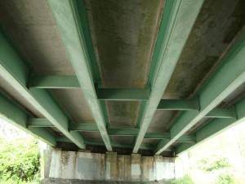
Beam Bridge
Made up of simply supported horizontal Beams I-beams, trusses, or box girders.
End supports are known as abutments and intermediate supports are known as piers. Weight on top of the beam pushes straight down on the abutments at either end of the bridge
Types of construction could include having many beams side by side with a deck across the top of them.

Cantilever bridges
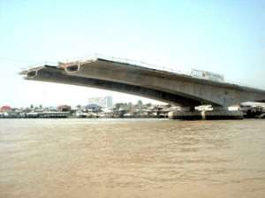
Cantilever bridge

horizontal beams supported on only one Support. simple cantilever
formed by two cantilever arms extending from opposite sides of the obstacle to be crossed, meeting at the center.
balanced cantilever
cantilever spans is to counterbalance each cantilever arm with another cantilever arm projecting the opposite direction.
Arch bridges
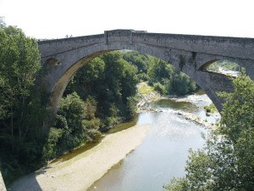
Arch bridge
bridge with abutments at each end shaped as a curved arch.
Arch bridges transfers the weight of the bridge and its loads partially into a horizontal thrust restrained by the abutments at either side.
Tied arch bridges
an arch-shaped superstructure,
Instead of transferring the weight of the bridge and traffic loads into thrust forces into the abutments, the ends of the arches are restrained by tension in the bottom chord of the structure. They are also called bowstring arches.
Suspension bridges

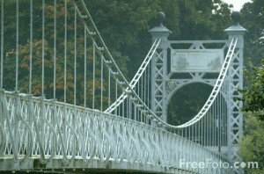
Suspension bridge
Deck, the load-bearing portion, is hung below suspension cables on vertical suspenders. This type of bridge has cables suspended between towers, and vertical suspender cables.
The suspension cables must be anchored at each end of the bridge, since any load applied to the bridge is transformed into a tension in these main cables.
Cable-stayed bridges
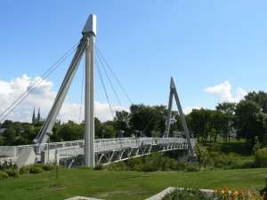
Cable-stayed bridges Fan Design
consists of one or more columns (referred to as towers or pylons), with cables supporting the bridge deck.

Two types of design–
harp design
The cables are made nearly parallel by attaching them to various points on the tower
fan design
the cables all connect to or pass over the top of the tower
Movable bridges
designed to move out of the way of boats or other kinds of traffic
powered by electric motors, whether operating winches, gearing, or hydraulic pistons
Survey for bridge site selection

- Social feasibility survey
- Level of local participation
- Size of area of influence
- Size of traffic flow
- Socio-economic benefits produced by the proposed bridge

Technical survey
It includes Bridge site selection and Topographic Survey of the selected bridge site
Bridge site selection
The bridge site should fulfill a number of general conditions:
- The bridge site should be selected at or near to the traditional crossing point
- minimum free board
- maximum bridge span
- space for the bridge foundations
River condition
River condition
The selected bridge site must have favorable river conditions. Accordingly, a bridge should be located:
  - on a straight reach of the river
  - beyond the disturbing influence of larger tributaries
  - on well defined banks Slope and bank condition
If the slope and bank is soil, potential instability features and failure modes are:
  - bank erosion
  - toppling instability of the bank

  - erosion of the slope
  - land slide
If the slope and bank is rock, potential instability features and failure modes are:
  - plain failures in a rock slide along the slope.
  - wedge failure leading to the fall of rock mass.
  - toppling leading to the fall of rock blocks.
  - rotational slide is similar to the landslide in a soil slope. Such failure is likely when the material of therock is very weak (soft rock) and the rock mass is heavily jointed and broken into small pieces
General data collection
General data is required for needs assessment and construction planning of the proposed bridge. Collect the following general data & information:
- Location of bridge site
- Transportation distance,
- Nature of crossing and fordability
- Availability of local materials
- Availability of local bridge builders

Local participation Traffic volume Width of walkway Temporary crossing
Evaluation of the bridge site
Good – All or most of the features are favorable and if the surveyor is confident about the stability of the slopes. Proceed with further survey work.
Bad – Most of the features are unfavorable. Reject site.
Questionable – Most of the features are favorable and some are unfavorable. The site is questionable. In this case, further detailed investigation by an experienced geo-technical engineer is necessary.

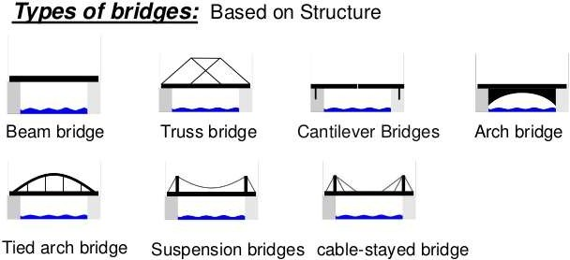
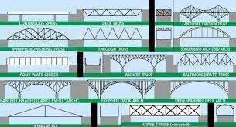
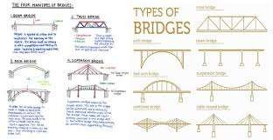

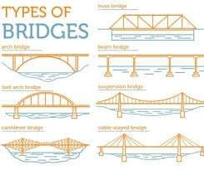

Types of Foundation
Foundations are classified as shallow and deep foundations. Types of foundations under shallow and deep foundations for building construction and their uses are discussed. Following are different types of foundations used in construction:
- Shallow foundation
  - Individual footing or isolated footing
  - Combined footing
  - Strip foundation
  - Raft or mat foundation
- Deep Foundation
  - Pile foundation
  - Drilled Shafts or caissons

Types of Shallow Foundations
- Individual Footing or Isolated Footing
Individual footing or an isolated footing is the most common type of foundation used for building construction. This foundation is constructed for a single column and also called a pad foundation.

The shape of individual footing is square or rectangle and is used when loads from the structure is carried by the columns. Size is calculated based on the load on the column and the safe bearing capacity of soil.

Rectangular isolated footing is selected when the foundation experiences moments due to the eccentricity of loads or due to horizontal forces.

For example, Consider a column with a vertical load of 200 kN and a safe bearing capacity of 100 kN/m2 then the area of the footing required will be 200/100 = 2m2. So, for a square footing, the length and width of the footing will be 1.414 m x 1.414 m.

Combined Footing
Combined footing is constructed when two or more columns are close enough and their isolated footings overlap each other. It is a combination of isolated footings, but their structural design differs.

The shape of this footing is a rectangle and is used when loads from the structure is carried by the columns.

Spread footings or Strip footings and Wall footings
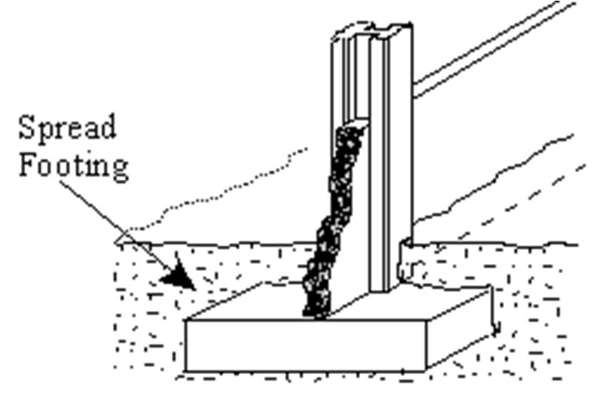
Spread footings are those whose base is wider than a typical load-bearing wall foundations. The wider base of this footing type spreads the weight from the building structure over more area and provides better stability.

Spread footings

Spread footings and wall footings are used for individual columns, walls and bridge piers where the bearing soil layer is within 3m (10 feet) from the ground surface. Soil bearing

capacity must be sufficient to support the weight of the structure over the base area of the structure.

These should not be used on soils where there is any possibility of a ground flow of water above bearing layer of soil which may result in scour or liquefaction.

Raft or Mat Foundations
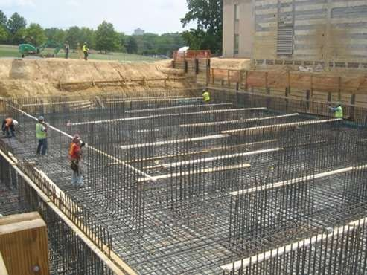
Raft or mat foundations are the types of foundation which are spread across the entire area of the building to support heavy structural loads from columns and walls.
Raft or Mat Foundation

The use of mat foundation is for columns and walls foundations where the loads from the structure on columns and walls are very high. This is used to prevent differential settlement of individual footings, thus designed as a single mat (or combined footing) of all the load-bearing elements of the structure.

It is suitable for expansive soils whose bearing capacity is less for the suitability of spread footings and wall footings. Raft foundation is economical when one-half area of the structure is covered with individual footings and wall footings are provided.

These foundations should not be used where the groundwater table is above the bearing surface of the soil. The use of foundation in such conditions may lead to scour and liquefaction.

Types of Deep Foundation
- Pile Foundations
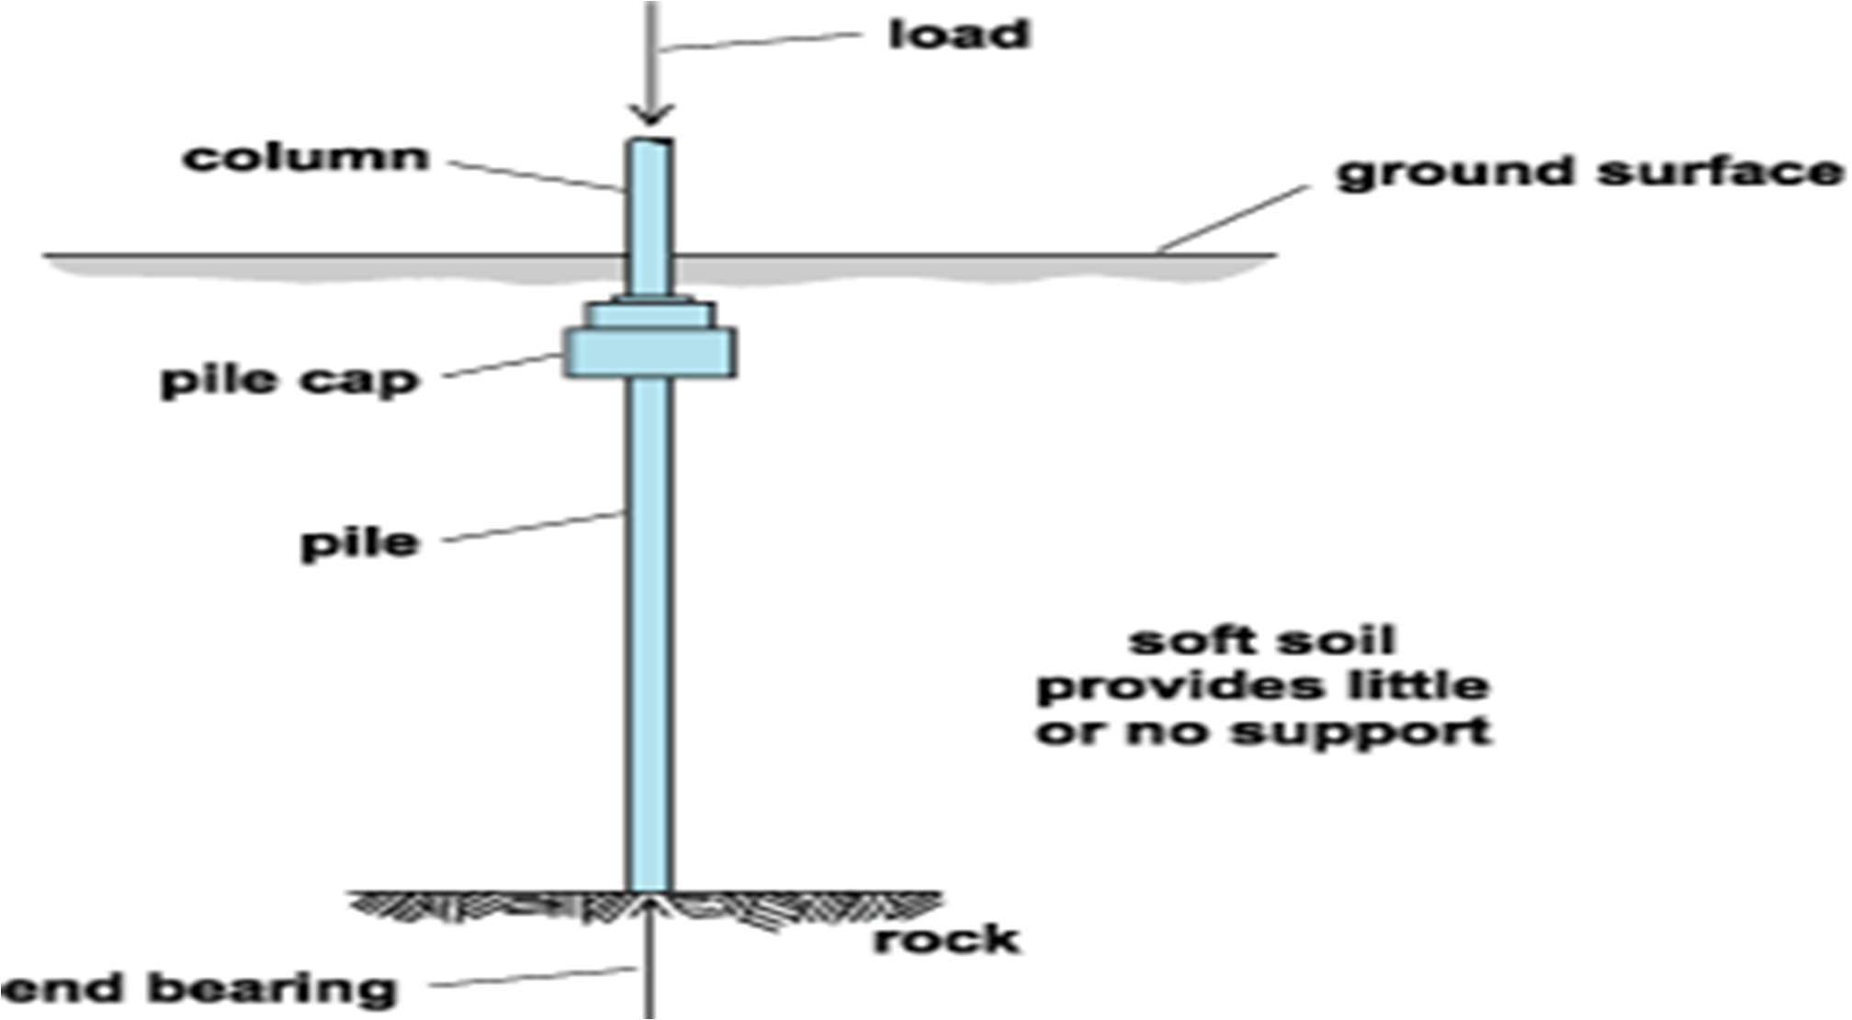
Pile foundation is a type of deep foundation which is used to transfer heavy loads from the structure to a hard rock strata much deep below the ground level.
Pile Foundation

Pile foundations are used to transfer heavy loads of structures through columns to hard soil strata which is much below ground level where shallow foundations such as spread footings and mat footings cannot be used. This is also used to prevent uplift of the structure due to lateral loads such as earthquake and wind forces.

Pile foundations are generally used for soils where soil conditions near the ground surface is not suitable for heavy loads. The depth of hard rock strata may be 5m to 50m (15 feet to 150 feet) deep from the ground surface.

Pile foundation resists the loads from the structure by skin friction and by end bearing. The use of pile foundations also prevents differential settlement of foundations.

Drilled Shafts or Caisson Foundation
Drilled shafts, also called as caissons, is a type of deep foundation and has an action similar to pile foundations discussed above, but are high capacity cast-in-situ foundations. It resists loads from structure through shaft resistance, toe resistance and/or combination of both of these.
The construction of drilled shafts or caissons are done using an auger.
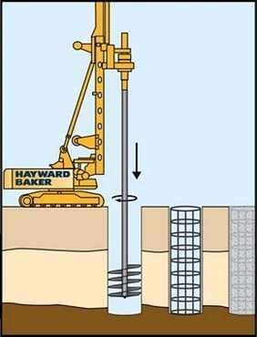
Fig: Drilled Shafts or Caisson Foundation (Source: Hayward Baker)

Drilled shafts can transfer column loads larger than pile foundations. It is used where the depth of hard strata below ground level is located within 10m to 100m (25 feet to 300 feet).

Drilled shafts or caisson foundation is not suitable when deep deposits of soft clays and loose, water-bearing granular soils exist. It is also not suitable for soils where caving formations are difficult to stabilize, soils made up of boulders, artesian aquifer exists.

What is Spread foundation and their type?

Spread foundation
The spread foundation is a type of shallow foundation. The Spread foundations are common to use in the building industry. The base of the structure enlarges or spread to provide individual support. Since spread foundations construct is open excavation, therefore, they are termed spread foundations. There are many types of spread foundations like wall footing, Isolated footing, Combined footing, Strap footing, continuous footing, Inverted arch footing, Grillage footing, Raft foundation.

Types of Spread Foundation
  - Wall footing
  - Isolated footing or column footing
  - Combined footing
  - Strap footing or cantilever footing
  - Continuous footing
  - Inverted arch footing
  - Grillage footing
  - Raft foundation or mat foundation.

Wall footing
Wall footing can be either simple or steeped. Simple footings use to carry light loads, whereas stepped footings used to carry heavy loads. Simple footing has only one projection on either side of the wall whereas stepped footings have numbers of projection of either side of the wall.

Isolated or column footing
They use to support individual columns. They can be either of stepped type or have projections in the concrete base. In the case of heavily loaded columns, steel reinforcement is provided in both the directions in a concrete bed. Generally, a 15 cm offset is provided on all sides of the concrete bed. In the case of brick masonry columns, an offset of 5 cm is provided on tall thee four sides in regular layers. The footing of the concrete column maybe a slab, stepped or sloped type.

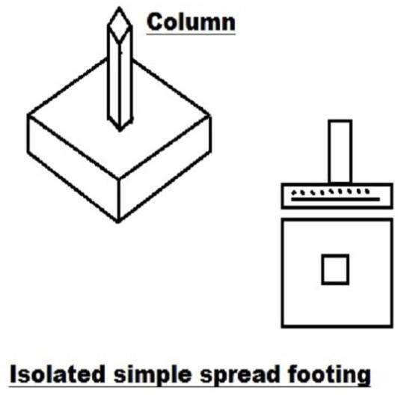

Combined footing
A combined footing supports two or more columns in a row. The combined footing can be rectangular in shape if both other columns carry equal loads, or can be trapezoidal if there are space limitations and they carry unequal loads.

Strap footing or cantilever footing
Strap footing consists of two or more individual footings connected by a beam called a strap. It is also sometimes called as cantilever footing or pump handle foundation.

Continuous footings
In this, a single continuous R.C.C. slab provides as the foundation for more than two columns in the row. The resultant of the column loads W1, W2, W3 must pass through the centroid of the footing in the plan. This type of foundation is suitable in the earthquake area and also prevents differential settlement.

Inverted arch footing
The inverted arch footing is not a common type of foundation. This type of foundation used in places where the bearing capacity of the soil is very poor and the load of the structure is concentrated over the walls and deep excavations are not possible. In this case, arches constructed between the two walls of the base. The walls must be sufficiently thick and strong to withstand the outward horizontal thrust cased by the arch action.

Grillage spread foundation
A grillage footing uses to transmit heavy loads from the steel column to the soils having low bearing power. This type of arrangement avoids deep excavations and provided a necessary area at the base to reduce the intensity of pressure. Grillage footing makes up of rolled steel joints known as grillage beams provided in single or double tiers. In the double tier arrangement, the top tier laid perpendicular to the bottom one.

Raft foundation or Mat spread foundation
Raft foundation is a combined footing that covers the entire area beneath a structure and supports all the walls and columns. In this foundation, an R.C.C. slab with a beam or without the beam of suitable thickness with suitable reinforcement provides. Over which wall and column constructed.

What is Pile Foundation?
Pile foundation, a kind of deep foundation, is actually a slender column or long cylinder made of materials such as concrete or steel which are used to support the structure and transfer the load at desired depth either by end bearing or skin friction.

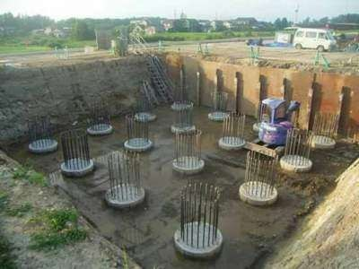
Pile foundations are deep foundations. They are formed by long, slender, columnar elements typically made from steel or reinforced concrete, or sometimes timber. A foundation is described as 'piled' when its depth is more than three times its breadth.
Atkinson, 2007
Pile foundations are usually used for large structures and in situations where the soil at shallow depth is not suitable to resist excessive settlement, resist uplift, etc.

When to Use Pile Foundation
Following are the situations when using a pile foundation system can be

- When the groundwater table is high.
- Heavy and un-uniform loads from superstructure are imposed.
- Other types of foundations are costlier or not feasible.
- When the soil at shallow depth is compressible.
- When there is the possibility of scouring, due to its location near the river bed or seashore, etc.
- When there is a canal or deep drainage systems near the structure.
- When soil excavation is not possible up to the desired depth due to poor soil condition.
- When it becomes impossible to keep the foundation trenches dry by pumping or by any other measure due to heavy inflow of seepage.

Types of Pile Foundation
Pile foundations can be classified based on function, materials and installation process, etc. Followings are the types of pile foundation used in construction:

- Based on Function or Use
  - Sheet Piles
  - Load Bearing Piles
  - End bearing Piles
  - Friction Piles

  - Soil Compactor Piles
- Based on Materials and Construction Method
  - Timber Piles
  - Concrete Piles
  - Steel Piles
  - Composite Piles

The following diagram is representing pile foundation types discussed above.
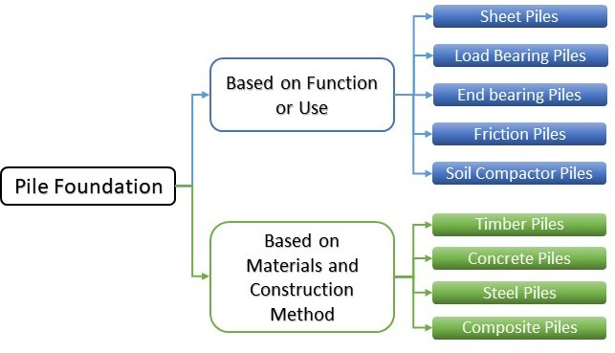

These piles are briefly discussed below.

Classification of Pile Foundation Based on Function or Use
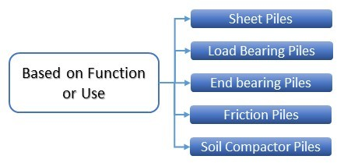

Sheet Piles
This type of pile is mostly used to provide lateral support. Usually, they resist lateral pressure from loose soil, the flow of water, etc. They are usually used for cofferdams, trench sheeting, shore protection, etc. They are not used for providing vertical support to the structure. They are usually used to serve the following purpose-

- Construction of retaining walls.
- Protection from river bank erosion.
- Retain the loose soil around foundation trenches.
- For isolation of foundation from adjacent soils.
- For confinement of soil and thus increase the bearing capacity of the soil.

Load Bearing Piles
This type of pile foundation is mainly used to transfer the vertical loads from the structure to the soil. These foundations transmit loads through the soil with poor supporting property onto a layer which is capable of bearing the load. Depending on the mechanism of load transfer from pile to the soil, load-bearing piles can be further classified as flowed.

End Bearing Piles
In this type of pile, the loads pass through the lower tip of the pile. The bottom end of the pile rests on a strong layer of soil or rock. Usually, the pile rests at a transition layer of a weak and strong slayer. As a result, the pile acts as a column and safely transfers the load to the strong layer.
The total capacity of end bearing pile can be calculated by multiplying the area of the tip of the pile and the bearing capacity of at that particular depth of soil at which the pile rests. Considering a reasonable factor of safety, the diameter of the pile is calculated.

Friction Pile
Friction pile transfers the load from the structure to the soil by the frictional force between the surface of the pile and the soil surrounding the pile such as stiff clay, sandy soil, etc. Friction can be developed for the entire length of the pile or a definite length of the pile, depending on the strata of the soil. In friction pile, generally, the entire surface of the pile works to transfer the loads from the structure to the soil.
The surface area of the pile multiplied by the safe friction force developed per unit area determines the capacity of the pile.
While designing skin friction pile, the skin friction to be developed at a pile surface should be sincerely evaluated and a reasonable factor of safety should be considered. Besides this one can increase the pile diameter, depth, number of piles and make pile surface rough to increase the capacity of friction pile.

Soil Compactor Piles
Sometimes piles are driven at placed closed intervals to increase the bearing capacity of soil by compacting.

Classification of Piles Based on Materials and Construction Method
Primarily piles can be classified into two parts. Displacement piles and Non-displacement or Replacement piles. Piles which causes the soil to be displaced vertically and radially as they are driven to the ground is known as Displacement piles. In case of Replacement piles, the ground is bored and the soil is removed and then the resulting hole is either filled with concrete or a pre- cast concrete pile is inserted. On the basis of materials of pile construction and their installation process load-bearing piles can be classified as follows:

- Timber Piles
  - Untreated
  - Treated with Preservative
- Concrete Piles
  - Pre-cast Piles
  - Cast-in-place Piles
- Steel Piles
  - I-Section Piles
  - Hollow Piles
- Composite Piles

Timber Piles
Timber piles are placed under the water level. They last for approximately about 30 years. They can be rectangular or circular in shape. Their diameter or size can vary from 12 to 16 inches. The length of the pile is usually 20 times of the top width.
They are usually designed for 15 to 20 tons. Additional strength can be obtained by bolting fish plates to the side of the piles.
Advantages of Timber Piles-

- Timber piles of regular size are available.
- Economical.
- Easy to install.
- Low possibility of damage.
- Timber piles can be cut off at any desired length after they are installed.
- If necessary, timber piles can be easily pulled out.

Disadvantages of Timber Piles-

- Piles of longer lengths are not always available.
- It is difficult to obtain straight piles if the length is short.
- It is difficult to drive the pile if the soil strata are very hard.
- Spicing of timber pile is difficult.
- Timber or wooden piles are not suitable to be used as end-bearing piles.
- For durability of timber piles, special measures have to be taken. For example- wooden piles are often treated with preservative.

Concrete Piles
Pre-cast Concrete Pile
The precast concrete pile is cast in pile bed in the horizontal form if they are rectangular in shape. Usually, circular piles are cast in vertical forms. Precast piles are usually reinforced with steel to prevent breakage during its mobilization from casting bed to the location of the foundation. After the piles are cast, curing has to be performed as per specification. Generally curing period for pre-cast piles is 21 to 28 days.
Advantages of Pre-cast Piles

- Provides high resistance to chemical and biological cracks.
- They are usually of high strength.
- To facilitate driving, a pipe may be installed along the center of the pile.
- If the piles are cast and ready to be driven before the installation phase is due, it can increase the pace of work.
- The confinement of the reinforcement can be ensured.
- Quality of the pile can be controlled.
- f any fault is identified, it can be replaced before driving.
- Pre-cast piles can be driven under the water.
- The piles can be loaded immediately after it is driven up to the required length.

Disadvantages of Pre-cast Piles

- Once the length of the pile is decided, it is difficult to increase or decrease the length of the pile afterward.
- They are difficult to mobilize.
- Needs heavy and expensive equipment to drive.
- As they are not available for readymade purchase, it can cause a delay in the project.
- There is a possibility of breakage or damage during handling and driving od piles.

Cast-in-Palace Concrete Piles

This type of pile is constructed by boring of soil up to the desired depth and then, depositing freshly mixed concrete in that place and letting it cure there. This type of pile is constructed either by driving a metallic shell to the ground and filling it with concrete and leave the shell with the concrete or the shell is pulled out while concrete is poured.
Advantages of Cast-in-Place Concrete Piles

- The shells are light weighted, so they are easy to handle.
- Length of piles can be varied easily.
- The shells may be assembled at sight.
- No excess enforcement is required only to prevent damage from handling.
- No possibility of breaking during installation.
- Additional piles can be provided easily if required.

Disadvantages of Cast-in-Place Concrete Piles

- Installation requires careful supervision and quality control.
- Needs sufficient place on site for storage of the materials used for construction.
- It is difficult to construct cast in situ piles where the underground water flow is heavy.
- Bottom of the pile may not be symmetrical.
- If the pile is un-reinforced and uncased, the pile can fail in tension if there acts and uplifting force.

Steel Piles
Steel piles may be of I-section or hollow pipe. They are filled with concrete. The size may vary from 10 inches to 24 inches in diameter and thickness is usually ¾ inches. Because of the small sectional area, the piles are easy to drive. They are mostly used as end-bearing piles.
Advantages of Steel Piles

- They are easy to install.
- They can reach a greater depth comparing to any other type of pile.
- Can penetrate through the hard layer of soil due to the less cross-sectional area.
- It is easy to splice steel piles
- Can carry heavy loads.

Disadvantage of Steel Piles

- Prone to corrosion.
- Has a possibility of deviating while driving.
- Comparatively expensive.

Well foundation
Wells and Caissons are large-diameter foundations adopted in an underwater situation such as bridge foundations in rivers. Caissons are large width foundations which carry the load of the superstructure through a layer of weak soil to firm

stratum at considerable depth.

Unlike pile foundations, which rarely have diameters greater than 2 meters, caissons can have a width ranging from 10-30 meters and can be founded at depths of 40m or more.

Caissons are used extensively in the river and marine underwater construction. in particular, they are used as foundations for bridges. Caissons are usually prefabricated above the ground level and above the water level and sunk to the bearing level as one single unit. when the process of fabrication and sinking proceed simultaneously they are referred to as well foundation.

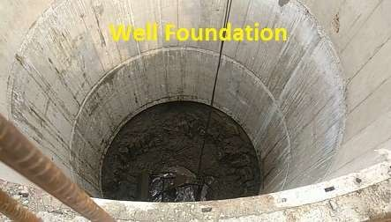
Types of Caissons

- Box Caisson

A caisson which is closed at the bottom but can be open or

closed at the top.

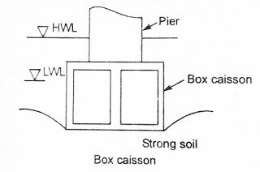

- Open Caisson or Well

A caisson which is open at the bottom as well as at the top.

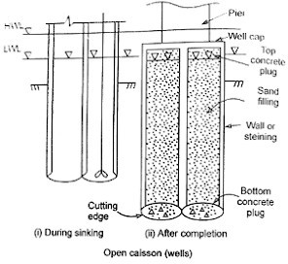

- Pneumatic Caisson

An open caisson with a chamber at the bottom for maintaining high air pressure.

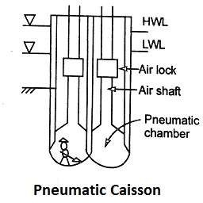

Shape or Types of Well foundation

Different shapes of wells that are commonly used are as follows:


- Circular Well - These are more commonly used shape is circular, as it has high structural strength and is convenient in sinking. the chance of tilting is also minimum in this type.

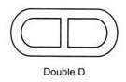
- Double-D Wells - They are generally used for the piers and abutments of bridges which are too long to be accommodated on a circular well of 9m diameter.

- Double Octagonal Wells - These are better than the

double-D wells in many respects. The square corners are eliminated and bending stresses are considerably reduced. However, they offer greater resistance than double-D well against sinking on account of increased surface area.
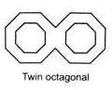
Moreover, the construction is more difficult.

- Twin-Circular wells - These are two independent wells placed, very close to each other and having a common well cap. the wells are sunk simultaneously. These wells are suitable where the length of the pier is considerable, which cannot be accommodated on a double -D or double- octagonal well.
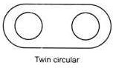

- Rectangular Wells - They are generally used for bridge foundations having depth up to 7-8 m. for large foundations, double-rectangular wells are used. for piers and abutment of very large size, rectangular wells with multiple dredge holes are used.
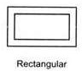

A Well foundation can be constructed on the dry bed or after

making a sand island. At a location where the depth of water is greater than 5m to 6m and the velocity of water is high.
Well can be fabricated on the river bank and then floated to the final position and grounded. Once the well has touched the bed, sandbags are deposited around it to prevent scour. The well may sink into the river bed by 50 to 60 cm under ists on weight. Further sinking operation is similar to the sinking of a well in a dry bed. The well is sunk into the ground to the desired level by excavating through the dredge holes.

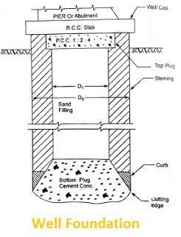

Component of Well Foundation

- Cutting Edge - It provides a comparatively sharp edge to cut the soil below during sinking operation. It usually consists of mild steel equal angle of side 150 mm.

- Curb - It has a two-fold purpose. During the sinking, it acts as an extension of cutting edge and also provides support to

the well steining and bottom plug while after sinking it transfers the load to the solid below. it is made up of reinforced concrete using controlled concrete of grade M200.

- Steining - It is the main body of well. It also serves a dual purpose. It acts as a cofferdam during the sinking and a structural member to transfer the load to the soil below afterwards. The steining may consist of brick masonry or reinforced concrete. The thickness of staining should not be less than that given by equation.

t = K( H/100 + D/10)
Where,

t = minimum concrete steining thickness H = Well depth below the bed
D = External diameter of well K = A constant

For soft clay 1.25 for hard clay and 1.3 for hard soil with the boulder. The brickwork steining should be about 10cm more than that the corresponding concrete steining.

- Bottom Plug - After the well has been sunk to the final position, the bottom plug is formed by concreting. The bottom plug functions as the base of the well.

- Sand Filling - It utility is doubtful. It is supposed to afford some relief to the steining by transferring directly a portion of the load from well cap to the bottom plug.

- Top Plug - The opinion is divided about the top plug. It at least functions as a shuttering for laying well cap.

- Reinforcement - It gives strength to the structure during sinking and service.

- Well Cap - It is needed to transfer the loads and moments from the piers to the well or wells below. The shape of the well cap is similar to that of well with a cantilevering of about 15 cm. Whenever 2 or 3 wells of small diameter are needed to support the substructure the well cap should be extended to cover the wells. The well cap is designed as a slab resting over the well or wells with partial fixity at the edge of the wells
Cofferdams
Cofferdam can be defined as the temporary structure that is built to keep the water away from the execution site, so that the structure can be built on the dry surface. The cofferdams should have walls that exclude water from building site. For this the walls must be water proof and the height of the wall must be more than the maximum water level. These types of cofferdams are preferred where the area of building site is large and the dry soil bed is at reasonable depth.

Types of Cofferdams

Considering the material used in their
construction, cofferdams may be divided into the following categories.
  - Earthen cofferdam

  - Rockfill cofferdam

  - Single-walled cofferdam

  - Double-walled cofferdam

  - Braced cofferdam

  - Cellular cofferdam (Circular or diaphragm type)

Earthen Cofferdam

Earthen cofferdams are constructed at the place where the height of the water is less say 3m and the current velocity is low. These dams are built using the local available material such as clay, fine sand or even soil.
The height of the dam is kept 1m more than that of max water level. Freeboard of the dam or the top of the dam is kept 1m so that the water doesn’t enter the other side even when waves arise.
The slope is usually given but 1:1 or 1:2. The slope of the water side is pitched with rubble stones so the water action doesn’t score the embankment. Even sheet piles are driven in

the center of the dam to resist water seepage. After the construction of earthen cofferdam, the water from the other site is pumped out and construction is executed.
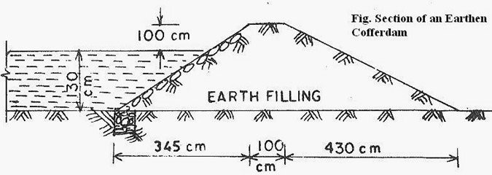
Fig: Cross-Section of an Earthen Cofferdam Rockfill Cofferdam
Rock-fill cofferdams are better than that of earthen dams. These dams are preferred when the rock is available easily at the construction site. These dams are very pervious, to prevent water from seeping an impervious membrane of soil is provided in the dam.
The height of the dam is can be up to 3m. The slope can be maintained at 1:1.5 to 1:125. The slope on the water side is pitched so as to protect dam from wave action.

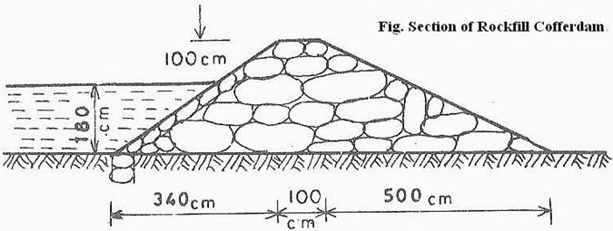

Fig: Cross-Section of Rockfill Cofferdam Single-Walled Cofferdam
This type of cofferdam is preferred when the depth of the water is more than 6m and area of construction is less.
Usually this is used in construction of bridges.

Wooden or timber sheets are driven into the river bed on the perimeter of the area of construction. On the inside steel or iron sheets are driven into the river bed. This inside sheets are placed at equal distance with the help of wales which are bolted to both sheets for either sides.
To improve the stability of this types of dam, half-filled bags of sand are placed on the both side of the walls. The water from the inside is pumped out and the construction process is undertaken.

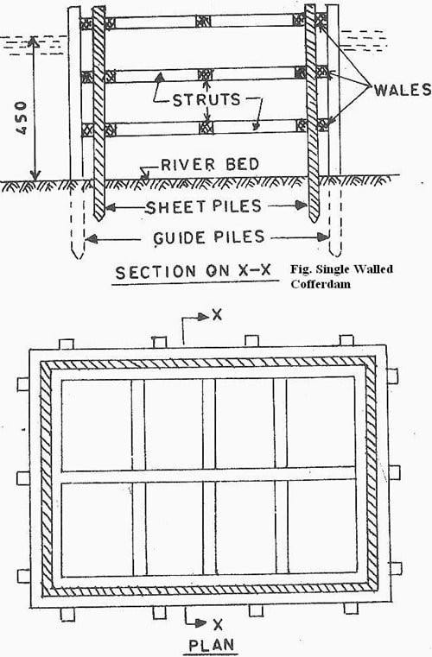

Fig: Construction Details of Single Walled Cofferdam
Double-Walled Cofferdam

Double-walled types of cofferdams are used when the area of construction site is large and depth of water is high. In this place use of single walled cofferdam becomes uneconomical as the supports are to be increased. So double walled cofferdam is used.
The difference in one wall and double wall dam is that her it has two walls instead of walls for extra stability. This type of dams can hold water up to 12m high.
Two piles are driven inside the water bed with a space in between and attached each other with wales with bolted connection. As the water depth increases the space between the walls increases.
The space between the walls are filled with soil. To prevent the leakage from the ground below, the sheet piles are driven to a good depth in the bed.

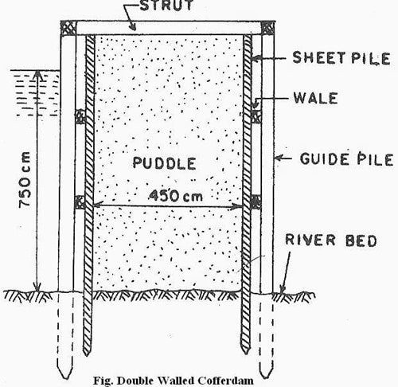

Fig: Construction Details of Single Walled Cofferdam
Braced Cofferdam

When it’s difficult to drive piles inside the bed in the water, then this type of cofferdam is used. In braced cofferdam two piles are driven into the bed and they are laterally supported with the help of wooden cribs installed in alternate courses to form pockets.
The empty pockets here are filled with stone and earth. The framework of the cofferdam (made from, logs of wood) is

prepared on ground and then floated to the site where the cofferdam is to be constructed.
The layers of sand and the other loose material overlying the impervious hard bed is dredged out. Crib is then sunk to the position, the bottom of each crib is given a shape to fit in the variation in the surface of bedrock. After the pit is dewatered, the structure is concreted. When concreting has been completed above the water level, the cofferdam is removed.
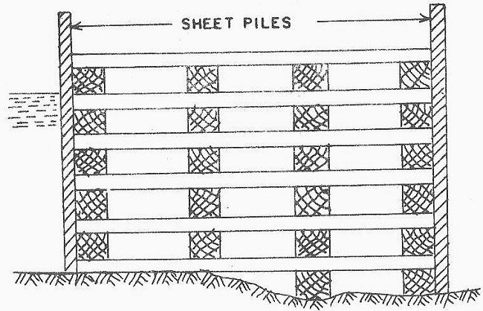
Fig: Braced Cofferdam Construction Details Cellular Cofferdam
When the water layer is more than 20m, common types of cofferdams are uneconomical to use. In this situations

cellular cofferdams are used. This type of dam is used in construction of dams, locks, weirs etc.
Cellular cofferdam is made by driving straight web steel sheet piles, arranged to form a series of interconnected cells. The cells are constructed in various shapes and styles to suit the requirements of site.
Finally, the cells are filled with clay, sand or gravel to make them stable against the various forces to which they are likely to be subjected to.
The two common shapes of the cellular cofferdam are,
- Circular type cellular cofferdam.
- Diaphragm type cellular cofferdam.

- Circular Type Cellular Cofferdam

This type of cellular cofferdam consists of circular arcs on the inner and outer sides which are connected by straight diaphragm walls. The connection between the curved parts and the diaphragms are made by means of a specially fabricated Y-element.
The cofferdam is thus made from interconnected steel sheet piles. The empty spaces are filled with non pervious materials like clay or sand. Due to the filling material the self weight of the membrane increases and leakage is reduced.

One advantage of the diaphragm type is that the effective length of the cofferdam may be increased easily by lengthening the diaphragm. Hence in case, from design consideration it is necessary to have effective width of the cofferdam more than 21 meter, diaphragm type of cofferdam must be used.
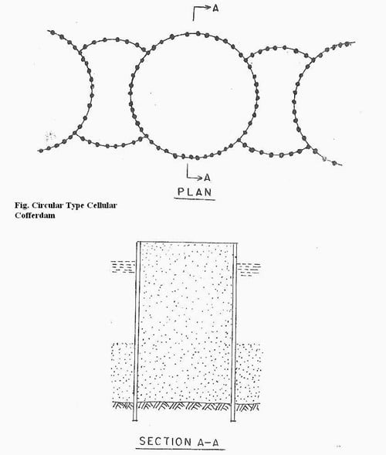
Fig: Plan and Section Details of Circular Type Cellular Cofferdam

- Diaphragm Type Cellular Cofferdam

It consists of a set of large diameter main circular cells interconnected by arcs of smaller cells. The walls of the connecting cells are perpendicular to the walls of the main circular cells of large diameter.
The segmental arcs are joined by special T-piles to the main cells. The circular type cellular cofferdams are self- sustaining, and therefore independent of the adjacent circular cells. Each cell can be filled independently.
The stability of such cells is much greater as compared with that of the diaphragm type. However, the circular cells are more expensive than the diaphragm type, as these require more sheet piles and greater skill in setting and driving the piles.
Because the diameter of circular cells is limited by interlock tension, their ability to resist lateral pressure due to high heads is limited.

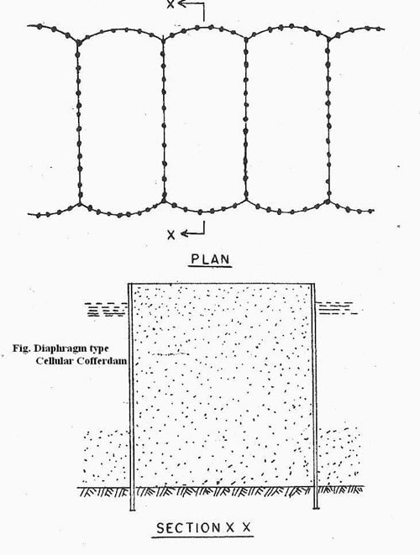

Fig: Plan and Section Details of Diaphragm type Cellular Cofferdam

BRIDGE SUB STRUCTURE AND APPROACHES
What is Bridge Pier?

A bridge pier is a type of structure that extend to the ground below or into the water. It is used to support bridge superstructure and transfer the loads to the foundation. The bridge piers can be constructed to be substantially attractive and strong in order to withstand both vertical and horizontal loads. It also does not hinder water flow or tide if the bridge spans the water.
Bridge piers may be built using concrete, stone, or metal. Concrete is commonly specified as construction materials provided that the pier is submerged in water since metal is prone to rust in water. It is constructed in many locations like waterways, dry lands on which highway systems are built as overpasses.
It can vary in size and shape (Fig. 1 and Fig. 2) Based on aesthetics, site, space, and economic constraints such as beam and V shapes. The designer must specify appropriate pier shape for specific application.
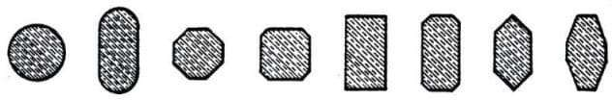
Sometimes, bridge piers are designed to guarantee proper load bearing of roadway, and in other cases, it can be constructed in such a manner that it would not prevent proper river water flow. Additionally, the design of bridge pier can be modified based on the other forces that act on the bridge such as high winds that may enforced certain design over another one.
Fig. 1: Pier Cross-section Shapes for Over Crossings or Viaducts on Land

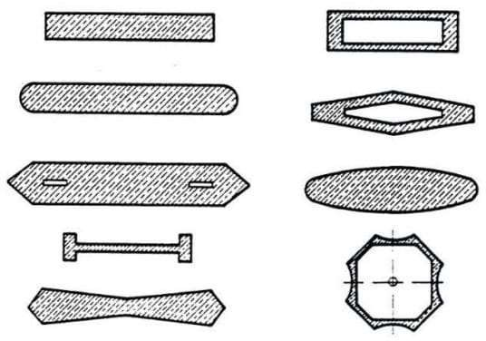
Fig. 2: Pier
Cross-section Shapes for River and Waterway Crossings

Contents: [show]

Types of Bridge Piers

Based on the Structure of Piers

Piers are categorized into two major types based on its structure which include solid piers and open piers. These types are further classified into several types:
- Solid Piers

Solid piers possess solid and impermeable structure, and usually constructed from bricks, stone Masonry, mass concrete or reinforced concrete. Solid piers are categorized into solid masonry piers and solid reinforced concrete piers

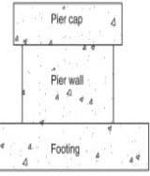
Fig. 3: Solid Piers

  - Solid Masonry Piers

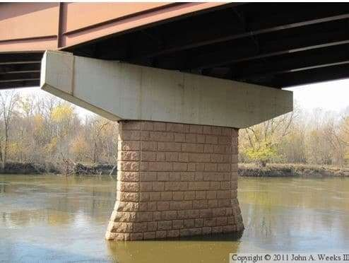
It is constructed from brick masonry, stone masonry, and concrete. For economic reasons, the outer part of solid masonry pier is built from stone masonry and the inner part is filled with the help of mass concrete.
Fig. 4: Solid Masonry Piers

  - Solid Reinforced Concrete Piers

Solid reinforced concrete piers are mostly constructed from reinforced concrete and commonly rectangular in cross-section. It is used in the case where the height of the piers is more and the solid masonry piers would not be strong enough to bear the load and can be uneconomical.

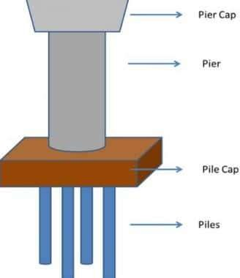
Fig. 5: Solid Reinforced Concrete
Pier

- Open Piers

Open piers permit the passage of water through the structure and classified into the following types:
  - Cylindrical Piers

Cylindrical pier is constructed from cast iron or mild steel cylinder which are filled with concrete. This type of pier is suitable for bridges with

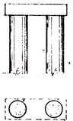
moderate height. In certain cases, horizontal and diagonal steel bracing may be used to improve stability.

Fig. 6: Circular Reinforced Concrete Shaft

  - Column Piers or Column Bent

This type of pers is suitable for bridge with significant height. It consists of a cap beam and supporting columns forming a frame. Column bent piers can either be used to support a steel girder superstructure or be used as an integral pier where the cast-in-place construction technique is used.
The columns can be either circular or rectangular in cross section. They are by far the most popular forms of piers in the modern highway system.
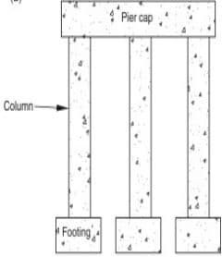 Fig. 7: Column Bent Piers
  - Multicolumn or Pile Bent

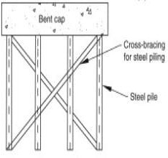
Multicolumn or pile bent or frame bent piers are composed of two or more column that supports a cap. Isolating footing is used for this type of piers if the spacing between columns are large otherwise combined footing would be more suitable. There is a problem of debris collection when the water is allowed to flow between the columns.

Fig. 8: Pile Bent

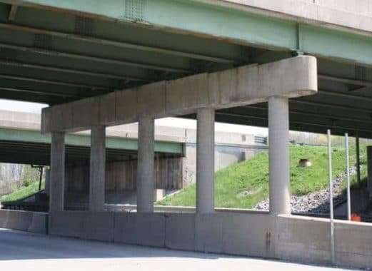
Fig. 9: Pile Bent Pier

  - Pile Pier or Pile Bents

Pile pier is the modification of multicolumn bent and used for the type of bent on low height and short span structure. So, pile pier or pile bents are specified when the ground is unstable and the low piers are required.
  - Trestle Pier or Trestle Bent

Trestle pier is composed of column with bent cap at the top. It is suitable for bridges in locations where river bed is firm and water current is slow. It is also employed for flyovers and elevated roads.

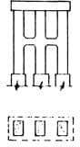
Fig. 10: Pile Trestle

Based on Construction Materials

- Masonry Piers

This may include stone masonry and brick masonry. Masonry piers are generally massive that may lead to obstruction of linear waterway and increase the loads on foundations.
Masonry solid shaft piers are built on open raft foundation where the possibility of scour is nil. Pile foundations are also possible for such type of piers.
- Mass Concrete Piers

Similar to masonry piers, Mass concrete piers massive which in turn obstruct linear waterway and increase loads on foundation. Pile foundations can be used for mass concrete piers.
Additionally, open raft foundation is used for mass concrete solid shaft piers provided that scouring is not anticipated. In mass concrete piers, no reinforcement is required from structural considerations but nominal reinforcement is provided for temperature and shrinkage effect.

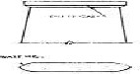

Fig. 11: Mass Concrete Piers

- Reinforced and Prestressed Concrete Piers

Reinforced concrete or prestressed concrete piers have small cross- sectional area compare with masonry and mass concrete piers. That is why such pier require much less foundation area in addition to offering less obstruction to waterway.
Reinforced concrete or prestressed concrete cellular piers arc suitable for major bridges where both the span and the depths are considerable and the self-weight of the piers should be as minimum and the section modulus as maximum as possible.
For reinforced concrete piers, the percentage of longitudinal reinforcement should neither be less than 0.8 nor more than 8 per cent of the gross cross-sectional area. Where brick and stone materials arc costly, it is generally found economical to use reinforced concrete or prestressed concrete piers.

Based on Load Transfer Mechanism

- Fixed Piers

Fixed piers support a fixed bearing and subjected both to transverse and longitudinal forces
- Free Piers

Free piers support free bearings and transfer only axial forces from the bearing to the foundations.
Others

- Hammerhead or Cantilevered Piers

Hammer head pier, which is also termed as solid shaft pier, has a single solid concrete cross section upon which a cap is placed. This type of pier is used to support steel girder or precast prestressed concrete superstructures. It is mostly constructed in urban areas where space limitation is a concern. Not only does it aesthetically pleasing but also occupy small spaces, thereby providing more room for the traffic underneath.
Generally, spread footing are recommended as a foundation for hammerhead piers. The major axis of solid shaft pier shall be in the direction of the stream flow otherwise circular or small rectangular cross section need to be selected. Standards for the use of hammerhead piers are often maintained by individual transportation departments.

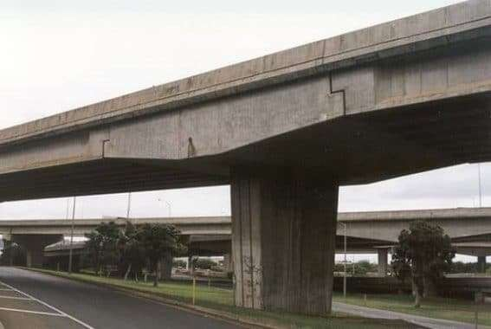
Fig. 12: Hammerhead Pier

- Special Shaped Bent

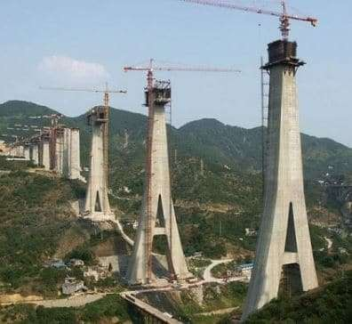
Fig. 13: Special Shaped Bent

- V Shaped Concrete Pier

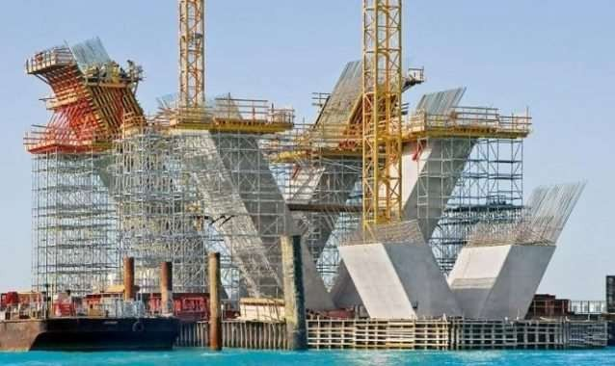
Fig. 14: V shaped Concrete Piers

- V Shaped Steel pier

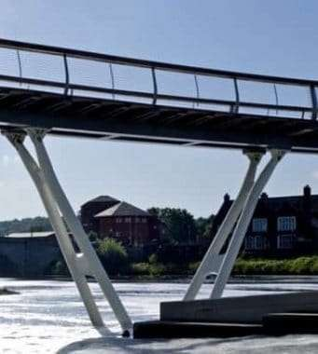
Fig. 15: V Shaped Steel Pier

bridge abutment

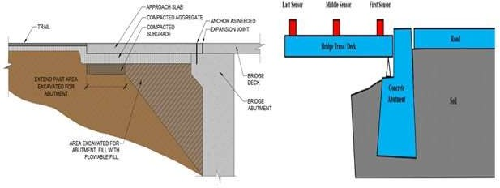

The abutment of bridge belongs to a support structure. The purpose of abutment is to dispense the weight and attach it to an embankment.

Main Function of Abutment

Bridge abutments attach the deck, or surface of the bridge, to the ground and facilitate supporting its weight both horizontal and vertical directions. On short bridges, one abutment is provided at either end of the bridge and jointed with the embankment, sometimes along with a retaining wall.

Longer bridges comprise of extra abutments which are provided along the length, or extent of the bridge to deliver required support at uniform spaces. They provide support to vertical direction without any retaining wall. The selection of abutment is based on the existing

space, geologic features of the bridge site, and existing budget for the project.

Also Read : SOME VITAL COMPONENTS OF PRE- STRESSED BRIDGE
Elements of an Abutment

Normally, the abutments are arranged at either end of a bridge along with the components given below :

Bridge Seat: This horizontal shelf provides supports to the bridge deck and is adjacent to or on the top of an abutment. On the embankment, these will retain the end of a span, whereas those provided along a span will give support to minimize expanded stress.

Wing Walls: These are found in abutments which are attached with the embankment. They belong to short retaining walls which can resist corrosion and provide durability.

Backwall: It is contained in embankment abutments, backwalls remain over the seat to arrange a horizontal brace from the bridge deck and minimize corrosion at the connecting point.

Pile: The pile of an abutment can either belong to a vertical wall that joins the seat with the foot or a row of columns to fulfill the same objective. On an embankment, the vertical wall structure produces a retaining wall, whereas mid-span abutments make use of more affordable columns.

Footing: This part of an abutment joins the vertical, load-bearing section of the abutment to the ground and is normally hidden under the soil. It comprises of a horizontal surface, sometimes broader than the bridge, to spread the weight.

Four Types of Bridge Abutments

The following types of abutments are commonly found :-

- Typical Gravity Abutment
The typical gravity abutment is frequently utilized and it comprises of the bridge seat, backwall, footing, and wing walls to retain the bridge deck and at the same time contains a retaining wall for the embankment. Normally, the wing walls are provided parallel to the bridge seat or at a slight, backward angle into the embankment.

- U-Abutment
This U-abutment is a type of abutment that has dissimilarity with gravity abutment in the angle of the wing walls. These are provided at a perpendicular angle to the bridge seat, expanding around the embankment and far from the bridge.

- Spill-Through Abutment
Spill-through abutments normally support the bridge at intervals through its span. The deck stands on a beam supported with columns or a short wall without any wing walls or a back wall to hold the embankment. Water or roadways can move through the supports.
The length of the support structure differs to adjust the distance among the level bridge and the changing terrain underneath.

- Pile Bent Abutment
The pile bent abutment stands for a variant on a spill-through abutment that substitutes the wall-like supports with a range of piles, or columns, to retain the support beam.
Components of an Abutment
Abutments placed at either end of a bridge typically include the following five components, while those placed along the bridge span will lack both the wing walls and the backwall.

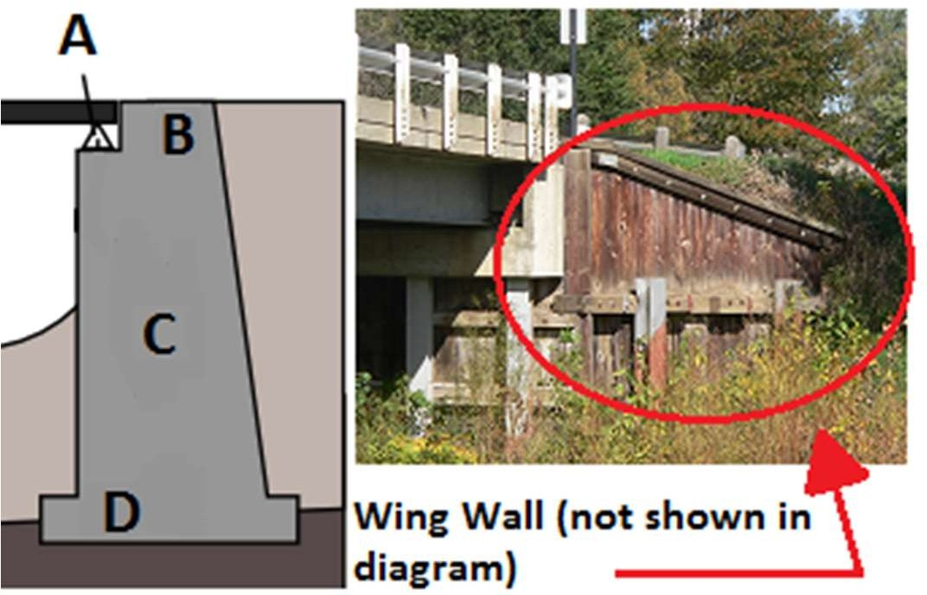

Diagram of Bridge Abutment

Bridge Seat: This horizontal shelf supports the bridge deck and is near, or on, the top of an abutment. On the embankment, these will hold the end of a span, while those placed along a span will provide support to reduce extended stress. In the diagram, the shelf is represented in the diagram by the letter A.
Wing Walls: These are only included in abutments that connect to the embankment. They are short retaining walls to prevent erosion and add stability. Wing walls are visible in the right half of the image and are not included in the diagram.
Backwall: Also only included in embankment abutments, backwalls rise above the seat to provide a horizontal brace from the bridge deck and reduce erosion at the connecting point. The backwall is represented in the diagram by the letter B.
Pile: An abutment's pile can either be a vertical wall connecting the seat with the foot or a row of columns that serve the same purpose. On an embankment, the vertical wall structure provides a retaining wall, while mid-span abutments use more cost-effective columns. The pile of an embankment abutment is represented by the letter C in the diagram.
Footing: This part of an abutment connects the vertical, load-bearing portion of the abutment to the ground and is usually buried beneath the earth. It consists of a horizontal surface, sometimes wider than the bridge, to distribute the weight. Finally, the foot is represented by the letter D in the diagram.

Four Types of Bridge Abutments
Let's take a few moments to look at the four types of bridge abutments.

- Typical Gravity Abutment
The typical gravity abutment is the most common type of abutment, and it includes the bridge seat, backwall, footing, and wing walls to hold the bridge's deck while including a retaining wall for the embankment. Usually, the wing walls are placed parallel to the bridge seat or at a slight, backward angle into the embankment.
- U-Abutment
This U-abutment is a form of abutment that differs from a gravity abutment in the angle of the wing walls. These are placed at a perpendicular angle to the bridge seat, extending toward the embankment and away from the bridge.
- Spill-Through Abutment
Spill-through abutments usually support the bridge periodically through its span. While they do not include wing walls or a backwall to retain the embankment, the deck rests on a beam supported by columns or a short wall. Water or roadways are able to pass between the supports. The length of the support structure varies to accommodate the distance between the level bridge and the changing terrain below.
- Pile Bent Abutment
The pile bent abutment is a variant on a spill-through abutment that replaces the wall-like supports with a series of piles, or columns, to hold the support beam.
WING WALL

In a bridge, the wing walls are adjacent to the abutments and act as retaining walls. They are generally constructed of the same material as those of abutments. The wing walls can either be attached to the abutment or be independent of it. Wing walls are provided at both ends of the abutments to retain the earth filling of the approaches. Their design depends upon the nature of the embankment and does not depend upon the type or parts of the bridge.[1]

The soil and fill supporting the roadway and approach embankment are retained by the wing walls, which can be at a right angle to the abutment or splayed at different angles. The wing walls are generally constructed at the same time and of the same materials as the abutments.
Classification of wing walls[edit]

Wing walls can be classified according to their position in plan with respect to banks and abutments. The classification is as follows:
  - Straight Wing walls: used for small bridges, on drains with low banks and for railway bridges in cities (weep holes are provided).
  - Splayed Wing walls: used for bridges across rivers. They provide smooth entry and exit to the water. The splay is usually 45°. Their top width is 0.5 m, face batter 1 in 12 and back batter 1 in 6, weep holes are provided.
  - Return Wing walls: used where banks are high and hard or firm. Their top width is 1.5 m and face is vertical and back battered 1 in
4.[2] Scour can be a problem for wing walls and abutments both, as the water in the stream erodes the supporting soil.
Bridge Approach

Bridge approaches typically experience two types of settlement, global and local. Global settlement consists of a consolidation of the underlying natural foundation soils, and is evidence of possible long-term differential settlement between the bridge structure and the bridge embankment. Local settlement consists of compression of fill materials directly beneath the approach pavement, and is evidence of possible embankment consolidation within the upper 10 to 20 feet of the bridge embankment. It is the combination of global and local settlements adjacent to the bridge end piers that forms the characteristic “bump” in the pavement at the bridge ends. The purpose of the bridge approach slab is to significantly reduce local settlement and to accommodate global settlement by providing a gradual transition between the roadway and the bridge deck.

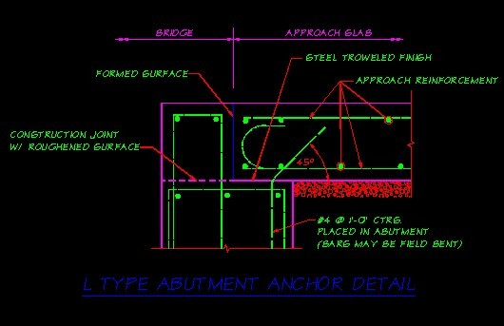
Bridge approach slabs are required for all new and widened bridges, except when concurrence is reached between the Materials Laboratory Geotechnical Branch, the Region Design Project Engineer Office, and the Bridge and Structures Office, that approach slabs are not appropriate for a particular site. In accordance with WSDOT Design Manual Chapter 1120, the State Geotechnical Engineer will include a recommendation in the geotechnical report for a bridge on whether or not bridge approach slabs should be used at the bridge site. Factors considered while evaluating the need for bridge approach slabs include the amount of expected settlement and the type of bridge structure.

PARMANENT BRIDGES

Masonry Bridge

a bridge whose main load-
bearing structures are made of natural stone, brick, or concrete blocks. S uch a bridge is always arched, with massive supports. The main load- bearing element of a masonry bridge is the arch, over which is built the sp andrel, which in turn supports the bridge roadway. The spandrel is made from a gravel or crushed stone backing held in by lateral (side) walls mad e of concrete masonry or stonework or in the form of an open structure of small arches resting on crosswalk.
The advantages of a masonry bridge are its architectural at-
tractiveness and its durability. Masonry bridges are known thathave been in use for more than 1,000 years. The basic shortcom-
ings that limit the use of masonry bridges are their complexityand labor- intensiveness of construction. A variation of a ma-
sonry bridge is the concrete bridge, which has an arch made ofcast concre te.
The first masonry bridges had only modest span lengths, with partially or completely underground foundations that used the land as an abutment. With the advent of Roman bridges, robust and elegant new constructions were developed; preference were on odd number of arches, and on cicrcle arch profiles arc profile circle . The construction of these periods reached longer spans, to use the land ground instead of the riverbed, to erect foundations on a soil with superior mechanical properties and avoiding at the same time avoiding the undermining danger. Of course this solution was applied whatever the total length could be covered with a single span. In the Pont-Saint-Martin in the Aosta Valley, Italy (Figure 12.1a), which has a span of 31.4 m, the low vault is made of big blocks of

cube-shaped stone (90 cm wide) of five rings parallel, the space between the rings is filled in conglomerate. A typical structure of Roman masonry arches was the aqueduct, generally built with one, two, or three levels of rounded arches; For example, the Pont du Gard (Figure 12.1b), which carried water to Nimes, has three rows of arches whose width decreased as they moved upward: the lights of the higher arches are 4.4 m, while in the lower orders, they range from 15.5 to 24.4 m. In the early Middle Ages, the construction of bridges stops almost completely because of the lack of commercial movement. In constructions during this period in Sicily and Spain, a strong influence came from Eastern culture (lancet vaults, often with polycentric profiles). In France, however, different forms were used; for example, in the bridge of Avignon (Figure 12.1e), built in the 12th century, the arch approximates an arch of parabola, with 20–25 m span length and thickness of 70 cm.
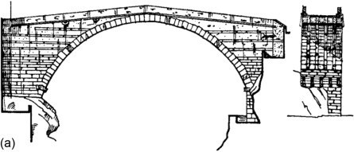

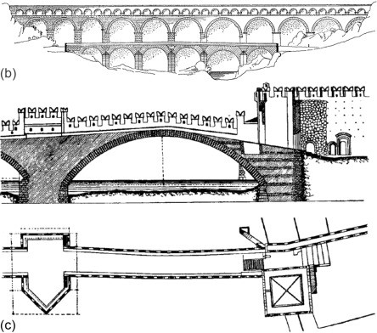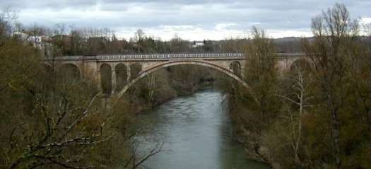

Steel Bridges
a bridge with a steel span. Steel bridges are constructed for highways when large spans, that is, spans of more than 100–200 m, are involved The
principal designs of steel bridges are the girder, which is the most common, the arch, and the suspension.
The principal designs of steel bridges are the girder, which is the most commo n, the arch, and the suspension. The roadway is made up of steel plates or rei nforced-
concrete slabs; in the latter case, the slabs bear the load integrally with the ste el span, and the structure is called a steel-reinforced-
concrete bridge. The end supports are usually massive and are most often of

plain or reinforced concrete. In high bridges and overpasses, the above- ground part of the end support is sometimes made of steel.
In the construction of steel bridges, standardized structural members produced by the metallurgical industry are used in most cases. These members include plates, angles, H beams, and channels, as well as high-
strength wire ropes and cable. Structures that must withstand great loads are usually made from high-
strength steel, that is, steel to which alloying elements have been added. The components used in bridge construction are prefabricated at special plants an d are assembled at the construction site. The advantages of steel bridges over bridges of other materials—
light weight and the mechanization of production and assembly processes— account for the wide use of steel bridges; in many countries, most large moder n bridges are made of steel. The structures, however, must be protected from corrosion. This protection is afforded by periodic multilayer painting and by the application of protective coatings.
TYPES OF STEEL BRIDGE
The types are: 1. Rolled Steel Beam Bridges 2. Plated Beam Bridges 3. Plate Girder Bridges 4. Trussed Girder Bridges.
Type # 1. Rolled Steel Beam Bridges:
This is the simplest type steel bridge having RSJ as the girder and steel trough plate filled with concrete or reinforced concrete slab as the bridge deck as shown in Fig. 14.1.

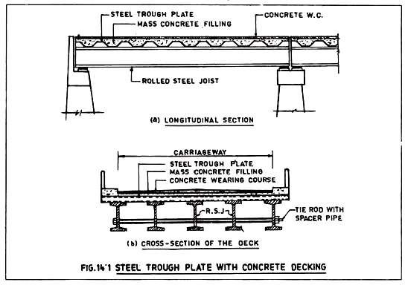
These bridges have very small spans and are constructed over canals or small channels where scour is negligible and shallow foundations are possible to reduce foundation cost. Since the load carrying capacity of these bridges is limited, these bridges are suitable for village roads where both the laden weight and frequency of the vehicular traffic are less.
Type # 2. Plated Beam Bridges:
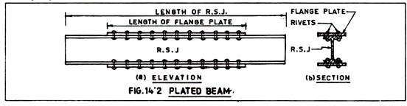
Plated beam bridges can cover comparatively larger spans than the RSJ bridges since their section modulus is increased by increasing the flange areas with additional plates fixed to the flanges by rivetting or welding (Fig. 14.2).
Type # 3. Plate Girder Bridges:

When the span of the bridge is beyond the spanning capacity of plated beam bridges, plate girder bridges are adopted. In such bridges, the depth of the girder from bending and deflection consideration is such that rolled steel joists are not suitable and therefore, the girders are fabricated with plates and angles either by rivetting or by welding.
If the bridge is through type then only two girders can be used one on either side but in case of deck type bridges, any number of girders can be used depending upon the economic consideration.
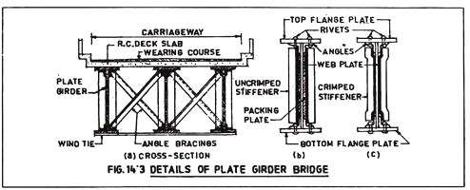
The section modulus required for the plate girder at various sections such as mid-section, one-third section, one fourth sections etc. varies depending upon the moment at these sections and as such the flange plates may be curtailed at the point of less moments such as at the ends for simply supported girders.
The components of a plate girder are as given below (Fig. 14.4)::
- Web plate

- Flange plates

- Flange angles

- Rivets or welds connecting flange angles with the flange plates and web plate.
- Vertical stiffeners fixed to the web plate at intervals along the length of the girder to guard against buckling of web plate.
- Horizontal stiffeners fixed to the web plate depth wise, one or more in numbers, to prevent buckling of web plate.
- Bearing stiffeners at the ends over the centre line of bearing and at intermediate points under the point loads.
- Web splice-plates used to join the two web plates.

- Flange splice-plates used to join the two flange plates.

- Angle splice-plates used to join the two flange angles.

- Bearing plates at the ends resting on the piers/abutments.
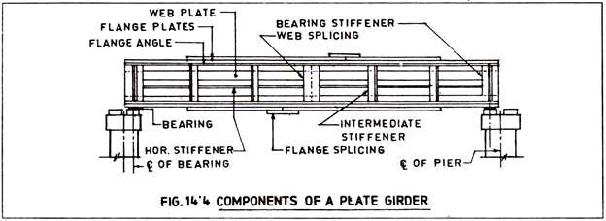
Full length of plates and angles for the fabrication of the plate girder may not be available for which splicing is necessary. The flange plates are normally spliced near the ends for simply supported spans while the web plate is spliced at or near the centre.

To guard against buckling of the web plate, vertical and horizontal stiffeners are provided by use of m.s. angles. At each end and also at the point of concentrated heavy loads, bearing stiffeners are necessary for transmission of loads. The bearing stiffeners are un-crimped and packing plate is used in between the web and the stiffening angle but intermediate angle stiffeners are usually crimped.
The design of a plate girder involves the following steps:
- Computation of B.M. and S.F. at various sections say one-fourth, one- third and one-half span.
- Estimation of required section moduli at various sections.

- Design of web from shear consideration.

- Design of flange angles and flange plates to obtain the required section moduli at various sections.
- Curtailment of flange plates and flange angles in consideration of reduced values of required section moduli near the end sections.
- Design of rivets or welds connecting various members such as flange angles with web plate and flange angles with flange plates.
- Design of splices such as flange splice and web splice.

ADVERTISEMENTS:

- Design of stiffeners.

- Design of bearing plates.

ADVERTISEMENTS:

Example 1:
A simply supported plate girder bridge of 20 metres span carries a dead load of 50 KN/m excluding self-weight of the girder and also a live load of 60 KN/m per girder. Design the plate girder at the centre of the span considering the impact allowance as per IRC code.
Solution:
Dead load = 50 KN/m.
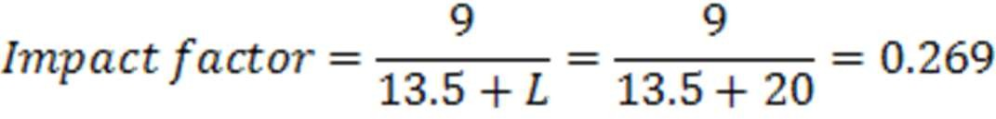

Live load with impact = 60 x 1.269 = 76.14 KN/m. Total superimposed load with impact excluding self-weight of girder = 50 + 76.14 = 126.14 KN/m.
Self-weight of plate girder per meter length is approximately given by WL/300, where W is the total superimposed load per meter and L is the span in m.
... Self-weight of plate girder = WL/300 = (126.14 x 20)/300 = 8.41 KN/m
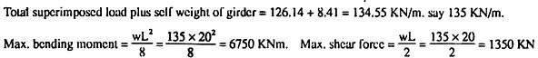

Design of web plate:
Assume thickness of web plate, tw = 12 mm. Economical depth of a plate girder is given by

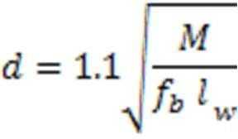
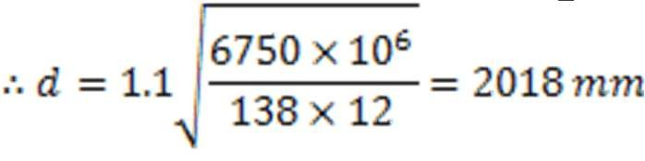
Where, M = Maximum bending moment; fb = Allowable bending stress; tw = Thickness of web plate.

Adopt depth of web = 2000 mm.

Design of flange plates:
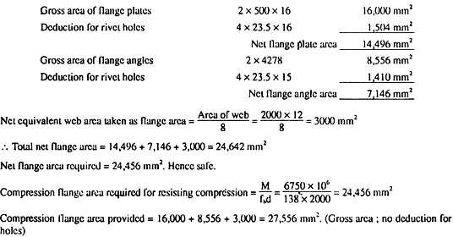
Net flange area required for tension flange, At = M/fbd = 6750 x 106/138 x 2000= 24,456 mm2. If 4 Nos. 22 mm. dia rivets are used for connecting flange plates to flange angles and 4 Nos. rivets for connecting flange angles to web plate and if 2 nos. 500 mm x 16 mm. flange plates and 2 nos. 200 mm x 100 mm x 15 mm flange angles are used to fabricate the plate girder then the net flange area available are as follows:

The
details of the plate girder are shown in Fig. 14.5.

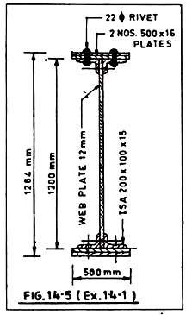
Check for bending stress:
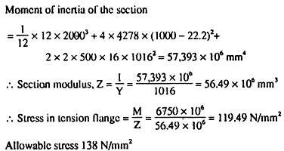

Check for shear stress:
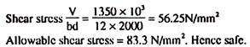

Type # 4. Trussed Girder Bridges:
Trussed girder or truss bridges have an upper or top chord, lower or bottom chord and web members which are vertical and diagonals. For a

simply supported truss bridge, the upper chord is subjected to compression and the lower chord is subjected to tension.
The web members may be only diagonals as in Warren Truss (Fig. 14.6a) or a combination of verticals and diagonals as in modified Warren Truss (Fig. 14.6b) or Pratt Truss (Fig. 14.6c & 14.6d) or Howe Truss (Fig. 14.6e) or Parker Truss (Fig. 14.6g).
For larger spans, the panels are again subdivided from structural considerations as in truss with diamond bracing (Fig. 14.6f), Pettit Truss (Fig. 14.6h) or K-truss (Fig. 14.6i). The span range for a simply supported truss bridge is 100 to 150 metres.

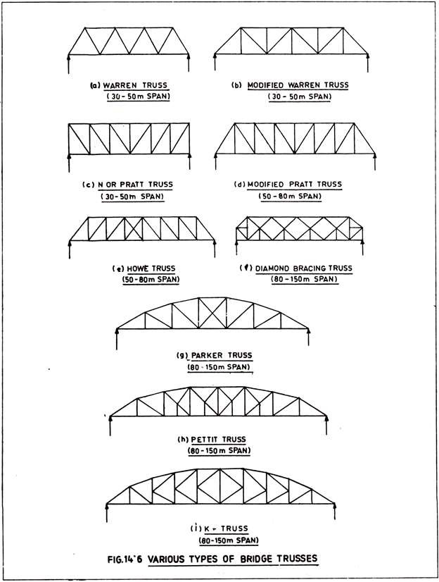

The truss bridges may be either of deck type or of through type (Fig: 14.7)
i.e. the bridge deck will be near the top chord in the former type and near the bottom chord in the latter type.
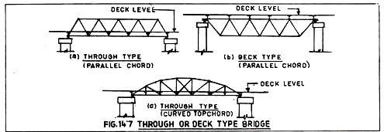
It is, therefore, needless to say that parallel chord trusses which are shown in Fig. 14.6a to 14.6c may be either of deck type or through type as in Fig. 14.7a and 14.7b but trusses with curved lop chord as shown in Fig. 14.6g to 14.6i are invariably of through type (Fig. 14.7c).
The bridge deck is on longitudinal girders resting on cross-girders which transfer the loads to the trusses at each panel joints. Details of a truss bridge are shown in Fig. 14.8. Since no load comes on the truss members except at panel joints, the truss members are subjected to direct stress only, either tensile or compressive, and no bending moment or shear force occurs in the truss members.
The panel joints where members meet are assumed as hinged and therefore, no bending moment in the truss members is developed even due to the deflection of the truss.

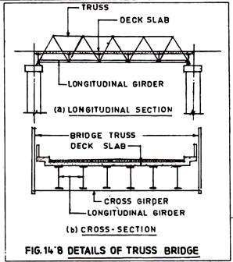
Determination of Forces in Statically Determinate Trusses: The forces in the truss members are determined by the following methods when the trusses are statically determinate:
- Graphical Method by Stressor Force Diagrams.

- Method of Sections.

- Method of Resolutions.

The above methods are explained by one illustrative example.

Example 2:
A simple equilateral triangular truss with a load of 30 KN at joint 2 of the truss is shown in Fig. 14.9a. Calculate the forces in the members of the truss by the above mentioned three methods, one by one.
Graphical Method:
The members are numbered with 0 at the centre of the truss and A, B, C at the outside and counted clockwise. Therefore, reactions are AB and

CA. The members are OB, OC and OA. Reaction AB = Reaction CA = 15 KN.
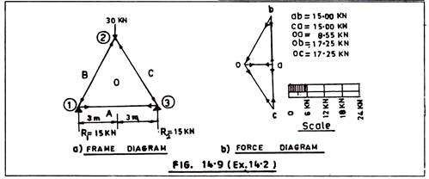
Since the loads and reactions are vertical, a force diagram in a suitable scale is drawn (Fig. 14.9b) which is also vertical. In this diagram, bc downwards represents W, ca upwards represents R2 and ab upwards represents R1. Since R1 + R2 = 30 KN, in the force diagram also bc = ca + ab = 15 + 15 = 30 KN.

Now the force diagram is drawn. Considering the joint 1 of the frame, a line, bo, is drawn on the force diagram parallel to BO and a line, ao, is drawn on the force diagram parallel to AO. The triangle, oab, is the triangle of force diagram for the joint 1 and ab, bo, oa, represent to scale the reaction R1 and internal forces in BO, OA respectively.
Similarly in joint 2, W is the external load or force represented by, bc, in the force diagram. Lines ob and oc are drawn parallel to member OB and OC.
The triangle, bco, is the triangle of force diagram for the joint 2 and bc, co, ob represent to scale the reaction W, and internal forces in OC & OB respectively. The triangle of force diagram for joint 3 viz. cao, is similarly drawn; ca, ao and oc representing to scale the reaction R2 and internal forces in the member AO and OC respectively.

The values of the internal forces in the members are known from the force diagram as illustrated above. The nature of the force viz. whether the force is tensile or compressive can also be determined from the same force diagram.
In any triangle of force diagram, the path of the forces starting from the known force is followed in the same direction and these directions are indicated in the frame diagram. For example, in the triangle of force diagram a b o, ab (= reaction R1) is known to act upwards.
Following this path, the direction of force bo and oa will be as shown in the force diagram and is also shown in the frame diagram. A force towards a joint in the frame diagram indicates a compressive force and a force away from the joint is a tensile force.
Thus, in joint 1, the known force is ab = R1 acting upwards and following this path, the directions of forces for bo and oa in the force diagram and for member BO and OA in the frame diagram are shown. The direction of force BO is towards the joint and therefore, is a compressive force.
Similarly, the direction of force OA is away from the joint and is therefore, a tensile force. In the same way and starting from the force whose direction is known, the directions of all the forces are shown in the frame diagram and thus the nature of all the forces are known.
Method of Sections:
In this method, the member whose force is to be determined is cut by a line which also cuts some other members of the frame. Start shall be made from a point where only one force is unknown. The frame will remain balanced even by the cut if external forces act in the cut members as shown in Fig. 14.10 in the same simple frame as in Fig. 14.9.

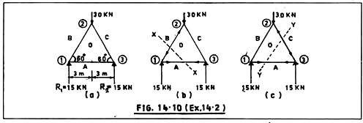
The forces may be determined by taking moment about a convenient joint so that only one known and one unknown forces are involved. For example in Fig. 14.10b, a cut X-X is made in the frame cutting member AO and BO.
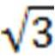
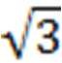
Taking moment about joint 2, fOA x /2 x 6 = 15 x 3 or, fOA = 8.66 KN i.e. away from the joint Taking moment about joint 3, fOB x /2 x 6 = 15 x 3 ... fOB = 17.32KN i.e. towards the joint, i.e. compressive force.
Similarly, the force fOC may be known by a cut Y-Y and taking moment- about joint 1.
Therefore, the forces in the members determined by the method of sections are as below:
fOB = fOC = 17.32 KN (Compressive), fOA = 8.63 KN (tensile)
Method of Resolutions:
In this method, all the forces and the external loads at a joint are resolved in horizontal and vertical direction and equated to zero since the joint is in equilibrium. Start shall be made from the joint where external load is acting and no more than two unknowns are there.
The same numerical example as shown in Fig. 15.9 is taken to illustrate this method also. The force towards a joint is compressive and the force away from the joint is tensile.
Considering joint 1 and resolving fOB in the horizontal and vertical direction and equating to zero, fOB sin 60° + 15 = 0 or fOB = (-){[15 x2]/√3}

= (-) 17.32 KN i.e., compressive and fOB cos 60° + fOʌ = 0 or fOʌ = (-) fOB cos 60° = (-) 17.32 x ½ = (-) 8.66 KN i.e. tensile.
Considering joint 3, fOC cos 60° + fOʌ = 0 or fOC = (-) 8.66 x 2 = (-) 17.32 KN compressive.
The forces in the frame as obtained by Method of Resolution are : fOB = fOC = 17.32 KN compressive. fOʌ = 8.66 KN tensile.
Therefore, it may be noted that the forces in the frame are the same as worked out by the Method of Sections and the Method of Resolution. The values as worked out by the Graphical Method slightly differ as they are to be sealed and as such error in measurement occurs. However, for all practical purposes, these values are acceptable and the design may be proceeded with without any hesitation.
Determination of Forces in Trusses with one Redundant Member:
Therefore, some other methods are to be applied in finding out the forces in such trusses, two of which are discussed below:
- Method based on Principle of Least Work.

- Maxwell’s Method.

Method Based on Principle of Least Work:
A corollary of Castigliano’s theorem is that the work done in stressing a structure under a given system of loads is the least possible consistent with the maintenance of equilibrium. Therefore, the differential coefficient of the work done with respect to one of the forces in the structure is equal to zero. This is the “Principle of Least Work” which is utilised in evaluating the forces in statically indeterminate trusses.
The strain energy stored or work done in any member of length, L and cross sectional area, A, under a direct force, P, is given by

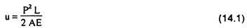

And the work done in the whole structure is:

In evaluating the forces in the truss member, the procedure is as follows:
- Remove the redundant member and calculate the forces in the remaining members of the truss (which is now statically determinate) due to external loading. The forces in the members due to above are F1, F2, F3 (say).
- Remove the external loading and apply a unit pull in the redundant member and find out the forces in the truss members.
- If K1, K2, K3 etc. are the forces in the members due to unit pull in the redundant member and if the actual force in the redundant member of the truss due to external loading is T then the total force in the members will be, T for the redundant member (since F = 0) and (F1 + K1T), (F2 + K2T), (F3 + K3T) etc. for other members.
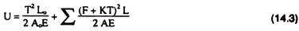
- Total work done in the structure including that in the redundant member will be:

- The differential coefficient of the work done with respect to the force T in the redundant member is therefore given by:

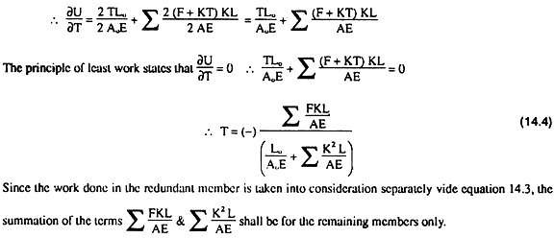

Maxwell’s Method:
This method is also based on the total work done in stressing the structure but the basic difference of this method with the previous one is that instead of inducing an internal force T, in the redundant member, this force is applied as an external load.
This means that in the previous method based on Principle of Least Work, the strain energy of the redundant member is also included in the total work done since the force T in the redundant member is an internal one but in Maxwell’s method, the force T is an external one and therefore, does not contribute towards the total work done due to stressing of the structure.
In Maxwell’s Method, the first theorem of Castigliano is utilised in evaluating the forces in the redundant member as described below:
- Step 1 to step 4 same as in the previous method. However, in step 3, unit load and T are external loads along the redundant member.

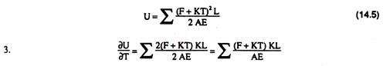
- Total work done excluding that in the redundant member will be:

As per Castigliano’s first theorem, the differential coefficient of the total strain energy in a structure with respect to any load gives the deformation of the structure along the direction of the load.
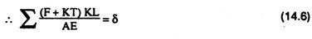
Therefore, ∂U/∂T gives the deformation of the redundant member in the direction T.
4. But as a result of the force T in the redundant member, the deformation of the member is also given by the following relationship:

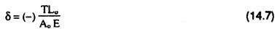
Where Lo and Ao are the length and area of cross section of the redundant member.
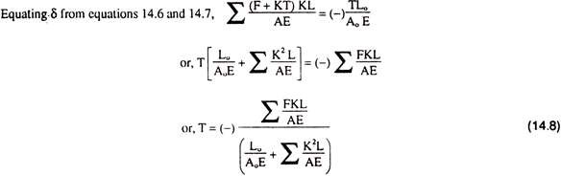
Minus sign in equation 14.7 is used as the deformation in equation 14.6 gives the value of δ in the direction of T but as a result of the pull, T, the deformation in the member will be in the opposite direction.

The values of T can be determined from equation 14.8 since all other values except T are known. Knowing the value of T, the forces in all the members of the truss can be determined such as T in the redundant member and (F1 + K1T), (F2 + K2T), (F3 + K3T) etc. in other members.
It may also be noted that although the truss with redundant member is analysed by two different methods, the result is the same as may be seen from equations 14.4 and 14.8.
Example 3:
A bridge truss with a redundant member at the central panel and with 200 KN vertical and 100 KN horizontal loads acting at one of the top panel nodes is shown in Fig. 14.11. Find the forces in all the members of the truss.
The truss is hinged at one support and has roller bearing at the other sup- port. It may be assumed for the convenience of computation that the ratio of length to the cross-sectional area for all the members is the same.
Solution by Method of Least Work:
- The redundant member BE is removed and the forces in all the remaining members of the truss which is now statically determinate is determined by any of the following methods:
- Graphical Method by Stress or Force Diagram

- Method of Sections

- Method of Resolution.

This is tabulated in Table 14.1. Fig. 14.12a shows external loads and reactions.

- 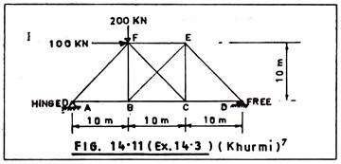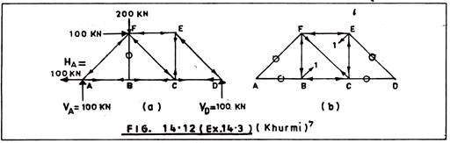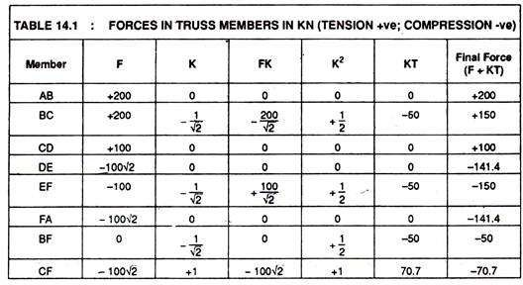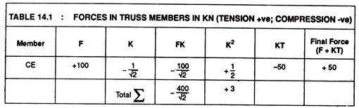The external loads are removed, a unit pull is applied in the redundant member (Fig. 14.12b) and the forces, K1, K2, K3 etc. in various members are found. This is shown also in Table 14.1.

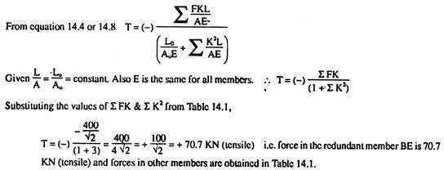

Determination of Forces in Trusses with Two or More Redundant Members:
The procedure for determining the forces in truss with two or more redundant members are the same with some modification due to presence of more than one redundant member and the Principle of Least Work may also be utilised in this ease.
This is explained below:
- Remove the redundant members such that the truss becomes perfect and does not get distorted after the removal of the redundant members. The truss in Fig. 14.13a has two redundant member BG and DG which are removed as shown in Fig. 14.13b. This latter truss is statically determinate and the forces in the members with the external loads are determined. The forces in the members are say F1, F2, F3 etc.
- Remove the external loading and apply a unit pull in the redundant member BG (Fig. 14.13c). If K1, K2, K3 etc. are the forces in the members due to unit pull in the redundant member BG and if the actual force in the redundant member BG is T due to external loading, then the total forces in the other members will be (F1 + K1T), (F2 + K2T) etc.
- Next apply a unit pull in the redundant member DG (Fig. 14.13d), if K’1, K’2, K’3 etc. are the forces in the members due to a unit pull in the redundant member DG and if the actual force in the redundant member

DG is T’ due to external loading then the forces in the other members will be K’1T, K’2T’ etc. due to force T in the redundant member DG.
- Actual forces in the other members due to step 1 to 3 are (F1 + K1T + K’1T), (F2 + K2T + K’2T) etc.
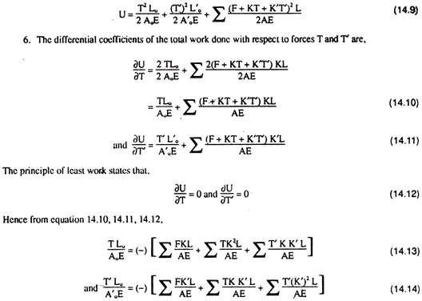
- Total work done in the structure including that in the redundant members will be,
All terms in equation 14.13 and 14.14 are known except T and T’ and as such by solving these two simultaneous equations the values of T and T’ can be computed. By knowing the values of T and T’, the forces in other members are determined from step 4, i.e. (F1 + K1T + K’1T), (F2 + K2T + K’2T) etc. as done in the Example 3.

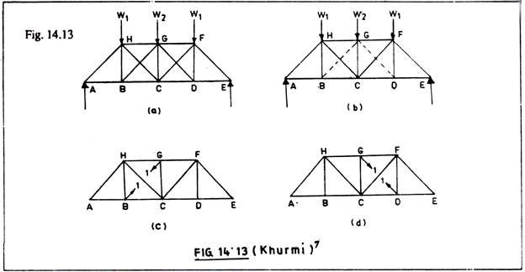
Influence Lines for Trussed Bridges:
The bridge trusses are subjected to moving loads and as such the forces in the truss members cannot be evaluated unless the assistance of the influence lines is taken.
Therefore, it is essential to draw the influence lines for forces in the various truss members and the maximum value for each truss member is thus determined after placing the moving loads for maximum effect. The moving loads from the roadway comes on each truss on either side of the roadway at panel joints only.
Total load is shared by each truss equally. The influence line diagram for the top and bottom chords are drawn for the BM whereas the influence lines for the diagonal and vertical members are drawn for the S. F.
The types of bridge trusses usually used are shown in Fig. 14.6 and the influence lines will vary depending upon the type of truss and location of the member in the truss. However, the principle of drawing the influence line is explained for a parallel chord Pratt truss by an illustrative example.

Example 4:
Draw the influence lines for force in the bottom chord AB, top chord LK, diagonals AL & LC and vertical BL of the Pratt truss bridge shown in Fig.
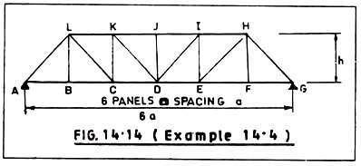
14.14. Also calculate the maximum force in diagonal AL and bottom chord AB if single lane of IRC class AA load crosses the bridge. Panel length = 6m and height of truss = 8 m.
Influence Line for Force in Diagonal, AL:
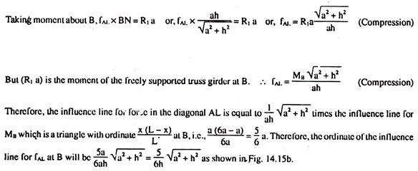
Cut bottom chord AB and diagonal AL by a section line 1-1 as shown in Fig. 14.15a. Draw a perpendicular line BN from B on AL. When a unit load moves from one end of the bridge to the other, let the reactions at A and G are R1 and R2 respectively. The left portion of the cut truss will be in equilibrium for any position of the unit load in the bridge deck.

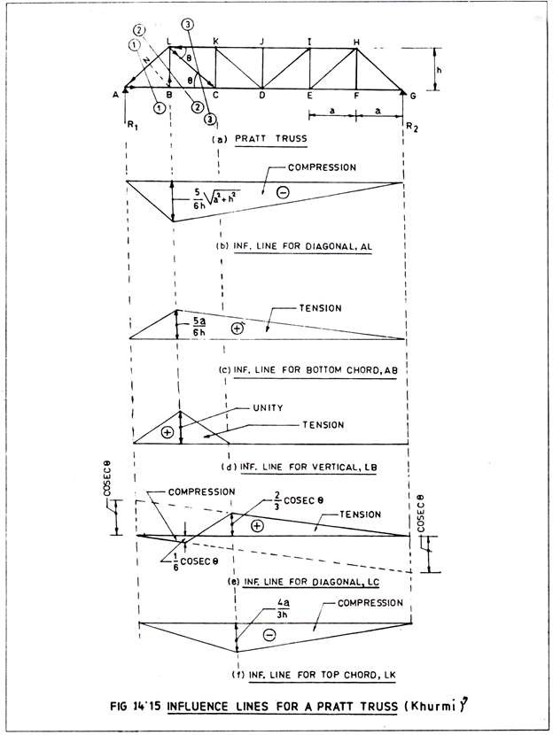

Influence Line for Bottom Chord AB:

Consider Section line 1-1 same as before.

Taking moment about L, fAB x h = R1 a or, fAB = R1a/h = M1/h (Tension) Therefore, the influence line for force in the bottom chord AB is equal to 1/h times the influence line for ML which is a triangle with ordinate equal
to x (L — x)/L i.e. 5a/6. Therefore, the ordinate of the influence line for fAB at L is equal to 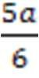 x = 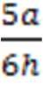 as shown in Fig. 14.15c.
Influence Line for Vertical BL:
When a unit load moves from A to B, the tension in the vertical member BL becomes from zero to unity. Again, the tension in BL decreases from unity to zero as the unit load moves from B to C. Thereafter, the tension in BL is always zero when the unit load moves from C to G. therefore, the influence line for vertical member. BL is a triangle having maximum ordinate equal to unity as shown in Fig. 14.15d.
Influence Line for Diagonal LC:
Consider cut line 3-3 and that the unit load is moving from A to B. In such case if the equilibrium of the right of cut-line 3-3 is considered, it is found that the force in the diagonal LC near the joint C will be downwards since the external force i.e., the reaction R2 to be balanced by the force in LC is upwards.
Therefore, the force in LC will be compressive and its magnitude is given by, fLC sin θ = R2 or, fLC = R2/Sin θ = R2 cosec θ (Compression)
Next the equilibrium of the truss left of cut-line 3-3 is considered when the unit load moves from C to G. Arguing as before, the force in LC near the joint L will be downwards since reaction R1 acts upwards. Therefore, diagonal LC will be in tension and the magnitude is given by, fLC sin θ = R1 or, fLC = R1 cosec θ (Tension)

The influence line for R1 and R2 are triangles having ordinates unity and zero at A and G respectively for R1 and having ordinates zero and unity at A and G respectively for R2. Therefore, the influence line for LC will be cosec θ times the influence line for R2 from A to B and compressive in nature.
The influence line for LC will be cosec θ times the influence line for
R1 from C to G and tensile in nature. The influence line for LC between B to C will be a line joining the ordinates at B & C which are 1/6 cosec θ (compressive) and 2/3 cosec θ (tensile) respectively. The influence line for LC is shown in Fig. 14.5c.
Influence Line for Top Chord LK:
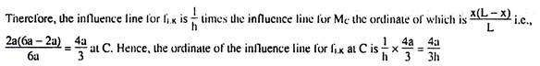
Consider the truss left of cutline 3-3. Taking moment about C, fLK x h = R1 x 2a or, fLK = 1/h x 2 aR1 (Compression). But 2aR1 is the moment of the freely supported truss at C fLK = Mc/h (Compression).

Maximum Forces in Members due to Movement of IRC Class AA Loading:
Length of truss = 6a = 6 x 6 = 36 m Height of truss = h = 8m.
Total load on each truss = 35 tonnes Length of loading = 3.6 m.
Load intensity per metre length = 9.72 tonnes.

Distribution factor due 10 eccentricity of loading = 1.2 (say) Impact factor = 10 per cent.

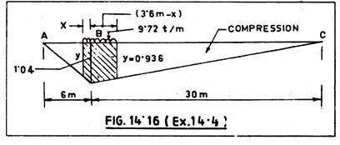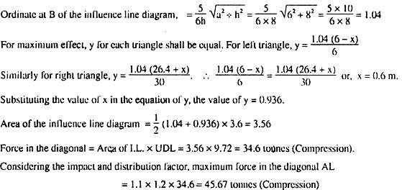Force in Diagonal AL:
Force in bottom chord AB:
